[Identifier-second line]

Direct Booking System (DiBS)
  - Direct Spaces – Installation and Login

Table of Contents
Introduction 3
Direct Spaces System Requirements 4
Downloading and accessing the Direct Spaces app for iOS devices 5
Downloading and accessing the Direct Spaces app for Android devices 7

Introduction

About Direct Spaces
Direct Spaces is the mobile app version of the Enterprise Resource Booking/ DiBS/ EMS that provides basic space management functionality inherited from the University's web-based system. While not replicating all features of the web version, the app allows you to search for and book available spaces using your mobile device. It offers a simplified interface for accessing core space booking capabilities on-the-go.

Direct Spaces System Requirements

Supported Platforms
Android | 5.0 and later
iOS | 10 (64 bit) or later

Downloading and accessing the Direct Spaces app for iOS devices
Step 1: Go to the Apple App Store on your iOS device.
Step 2: Search for "Direct Spaces" in the App Store.
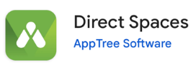
Step 3: Tap the "Get" button to download and install the app.
Step 4: Open the app from your home screen, not the App Store page.
Step 5: On the "Welcome to Direct Spaces" screen, enter your University of Melbourne email address ending in “@student.unimelb.edu.au” if you are a student or “@unimelb.edu.au” if you are a staff under "Enter your organization email or team identifier" field, then hit “Continue".
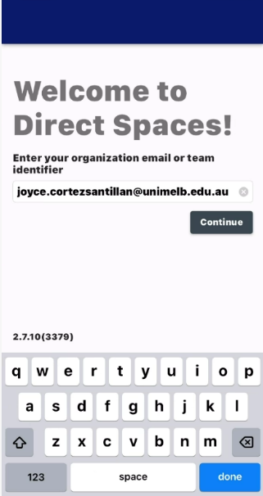
Step 6: Upon entering your email, you will be redirected to the University's Single Sign-On (SSO) login web page. Login using your University SSO credentials.
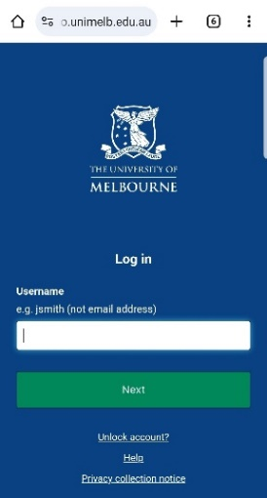
Step 7: Once logged in, you may need to refresh the app or wait a few moments for the homepage to load.
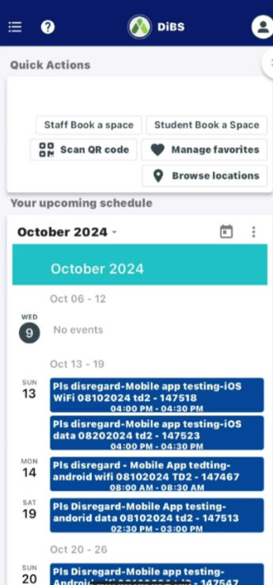

Downloading and accessing the Direct Spaces app for Android devices
Step 1: Open the Google Play Store on your Android device.
Step 2: Use the search bar to look for “Direct Spaces”.
Step 3: Tap the "Install" button to download and install the app.
Step 4: Open the app from your home screen, not the Play Store page.
Step 5: On the "Welcome to Direct Spaces" screen, enter your University of Melbourne email address ending in “@student.unimelb.edu.au” if you are a student or “@unimelb.edu.au” if you are a staff under "Enter your organization email or team identifier" field, then hit “Continue".
Step 6: Upon entering your email, you will be redirected to the University's Single Sign-On (SSO) login web page. Login using your University SSO credentials.
8 Once logged in, you may need to refresh the app or wait a few moments for the homepage to load.

