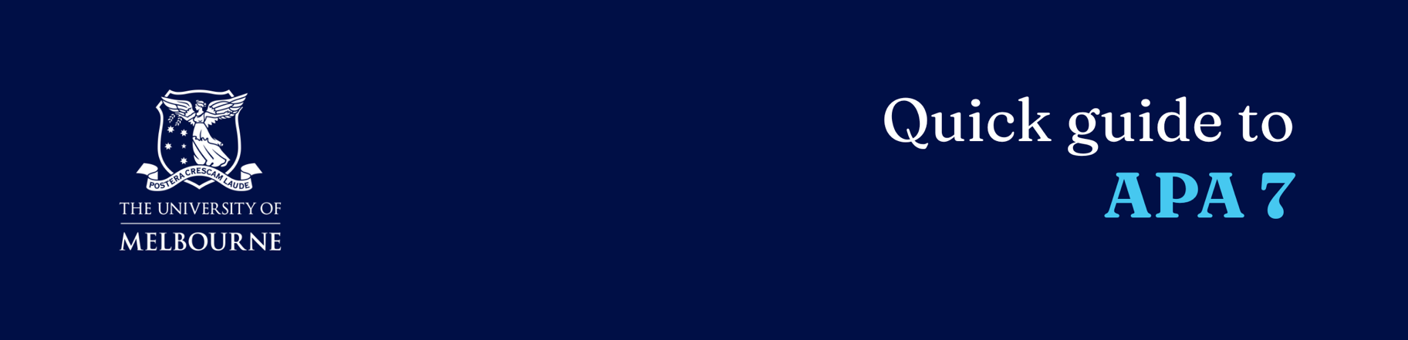

Quick guide to APA 7

  - Further examples can be found in the APA 7 referencing guide on Re:cite.

About APA 7
APA is an author date style. It has two key components:
- Citations in the text (Author family name, year of publication)
- A Reference List at the end of the paper, alphabetically (by family name) listing all references used in the text

Basic Principles
- Consistency in your citations is essential. Each in-text citation and reference list entry should be checked prior to submission.
- Punctuation differs between in-text citations and reference list entries.
- Page numbers or location markers should be included for all direct quotations, or where the reader should be directed to a precise point in the text.
- The format of names differs between in-text citations and reference lists. In-text citations include family name only. Reference lists include family name followed by initials.
- When citing a work with three or more authors, cite the family name of the first author followed by et. al. and then the publication year.
- Works with up to 20 authors should have all names listed in the reference list. For 21 or more authors, list the first 19 names, an ellipsis (…) and the final name.
- The reference list should be formatted with a hanging indent. This is usually applied using the paragraph function in your word processor.
- Citations of online resources should always include an identifier as the final part of the citation. The order of preference is DOI (Digital Object Identifier) > Permanent URL > Name of database.
- Access dates for online resources are not required, unless there is no other date listed in the resource. However, if your lecturer has indicated that access dates are required, you should include them.

Templates and examples for common source types

Books and chapters

In text citation
(Author family name, Year) or if a page reference is required for a direct quotation or to direct the reader to a particular passage (Author family name, Year, p.# or pp.#-#).
For example: (Singh, 2025, p.43)

Reference list (books)
Author Surname, Initials. (Year of publication). Book Title. Publisher.

Reference list (chapters)
Author, A. A., & Author, B. B. (Year of publication). Title of chapter or section. In A. Editor, B. Editor & C. Editor (Eds.), Title of book (p.#-#). Publisher.

Journal articles

In text citation
(Author Surname, Year).
Or if a page reference is required : (Author family name, Year, p.# or p.#-#).

Reference list
Author Surname, First name. Year of publication. Title of article. Journal Title vol, no. #: p.#-#. DOI/URL/Database name.

Websites

In text citation
(Author Surname, Year).
If there is no author, use the title of the webpage.
If there is no date of publication, use n.d.
For example: (Alliance for Linguistic Diversity, n.d.).

Reference list
Author Surname, Initials. (Year of publication or update). Title/description of page. Title/description of website. URL.

Images and figures

Caption above image
Figure number. Descriptive phrase that serves at the title and description.

Below image
Note. From/Adapted from Title of Book by Author first initial, Author Surname. Copyright year. Name of Copyright Holder.

