User Guide for Staff
Direct Booking System (DiBS)

About DiBS
Direct Booking System (DiBS) is a cloud-based platform that allows staff and students to reserve a space on campus to meet, work and study.

What is changing?
Previously there were multiple different platforms used to book a space on campus, including Resource Booker and BookIT (for library spaces). We are gradually migrating the majority of campus spaces to DiBS, to give a consistent experience for staff and students.

When is it changing?
DiBS is expected to launch on 17 July, with bookings available from 24 July onwards.

What do I have to do?
Familiarise yourself with this User Guide, which covers the main functions of DiBS.

Where do I go for help?
If you need support using DiBS, please contact the following:
Chat with an IT support officer or log a request through Service Now or call the Service Centre (+61 3 834 40888) 7:30am - 7:30pm weekdays
For support with library spaces, you can also speak to the Library Service Desk staff.

Contents
1. Logging in 3
2. Reserve a space using ‘My Reservation Templates’ 4
3. Browse for a space: to find a space that meets your requirements 11
4. Edit reservation details (eg Event name, Event type, Booker details only) 17
5. Cancelling a reservation 20
6. Checking in 22
7. Recurring bookings (Outdoor spaces and Law spaces only) 25

1. Logging in
1.1 | LOGGING IN:  You can access DiBS by opening a web browser and entering the following URL: https://go.unimelb.edu.au/dibs  You will see the Single sign on page below.
1.2 | Once you have logged in with your username and password, you will be taken to the homepage.  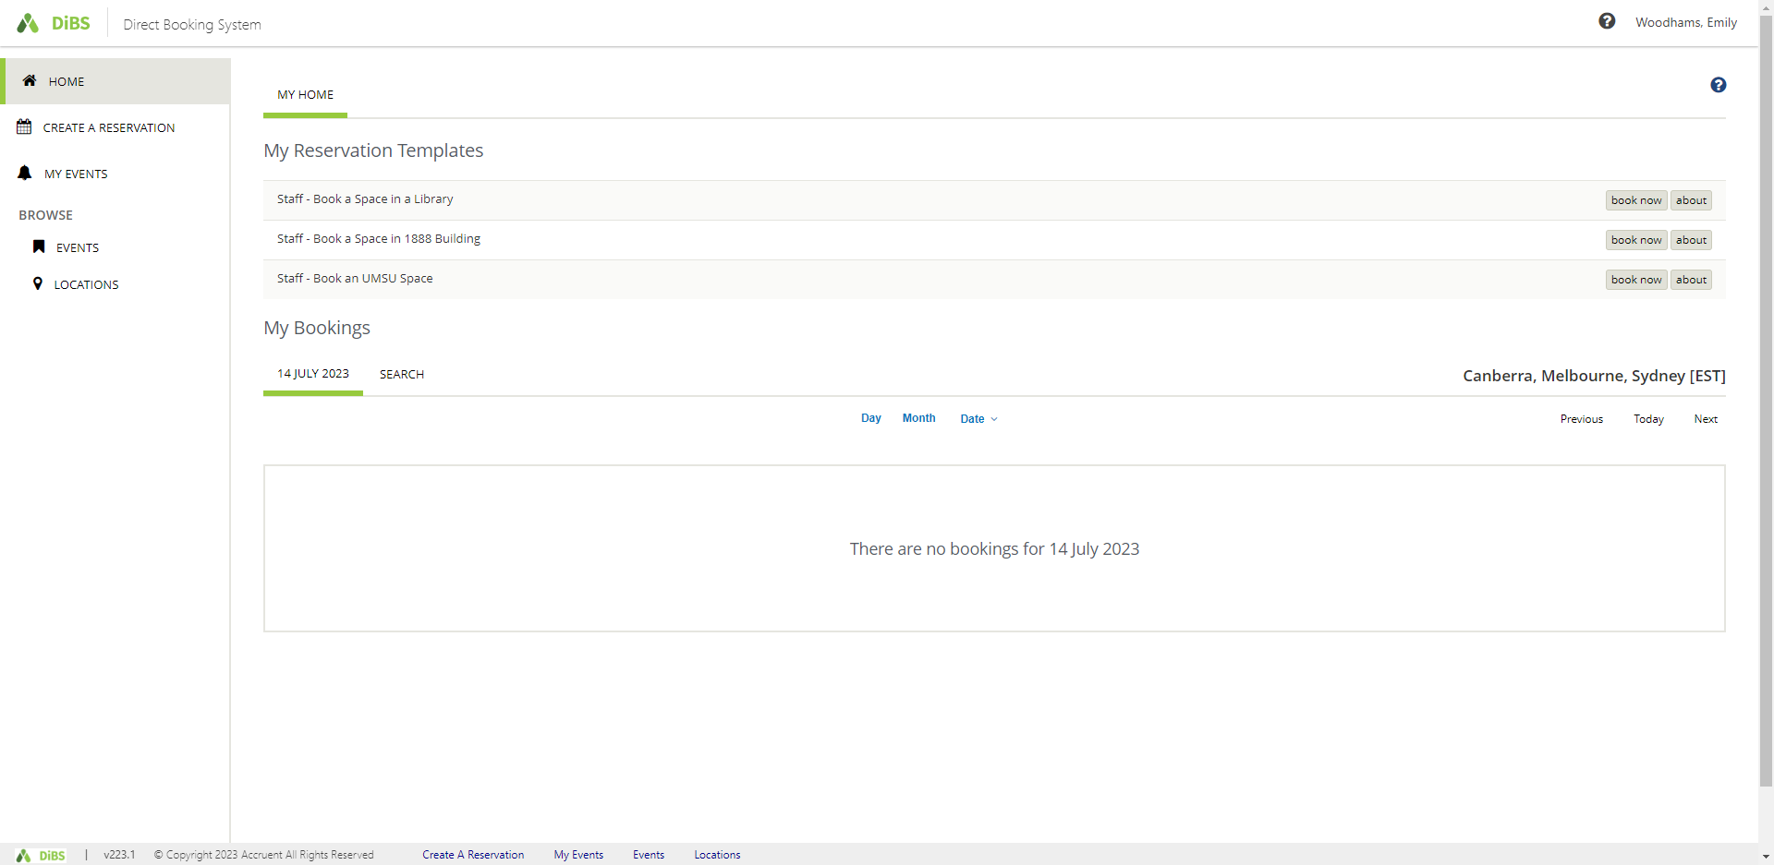

2. Reserve a space using ‘My Reservation Templates’
2.1 | To reserve a space using My Reservation Templates, click on the Book Now button for the  building in which you wish to book.  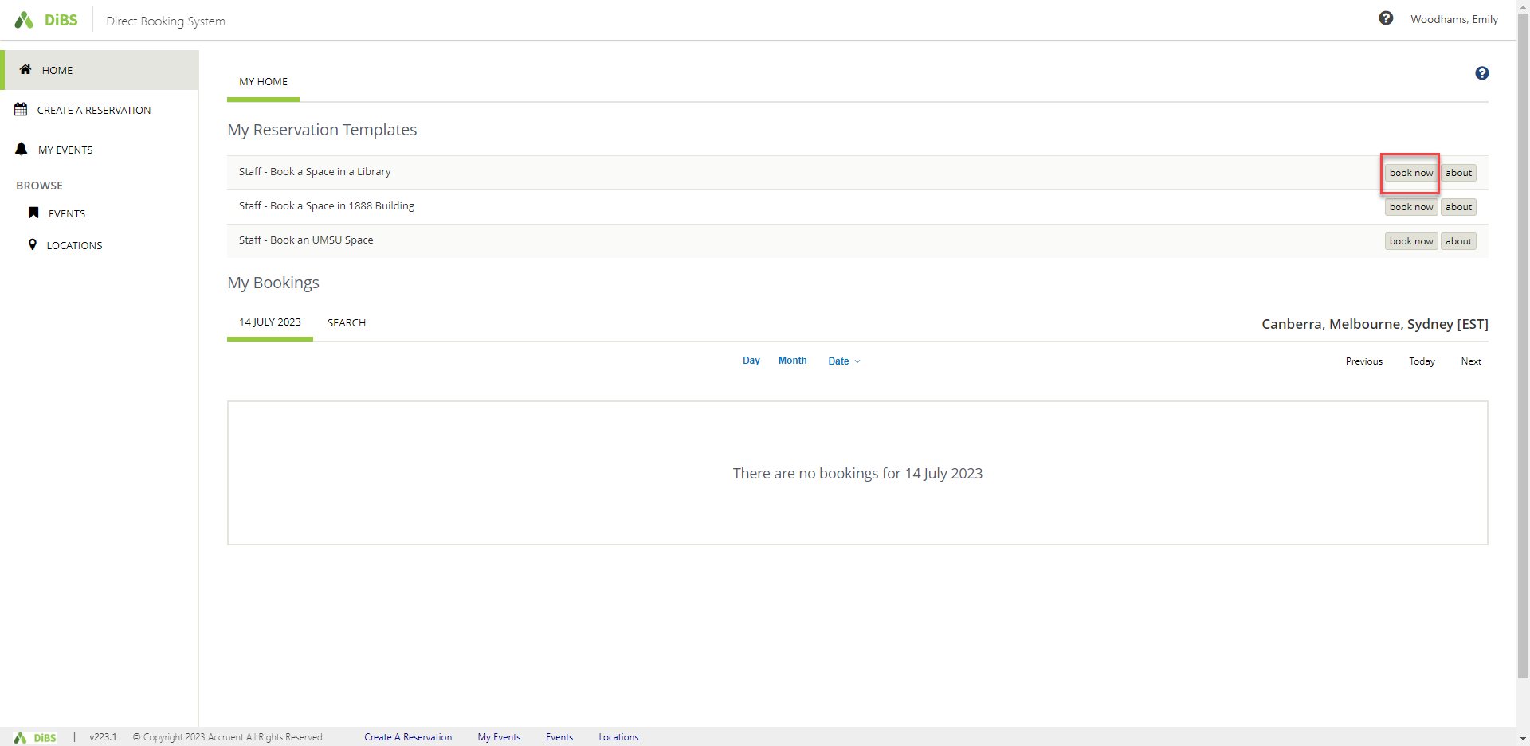
2.2 | Alternatively, you can click on the About button to find out the rules for booking a space with this template.  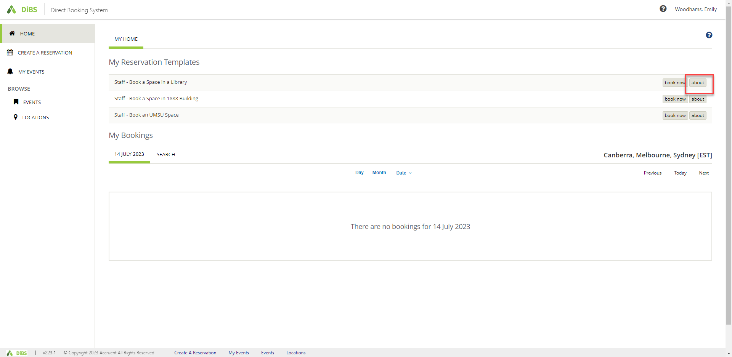

2.3 | When you click on About, the rules for the template are displayed. Select Book Now With This Template to proceed with your booking.  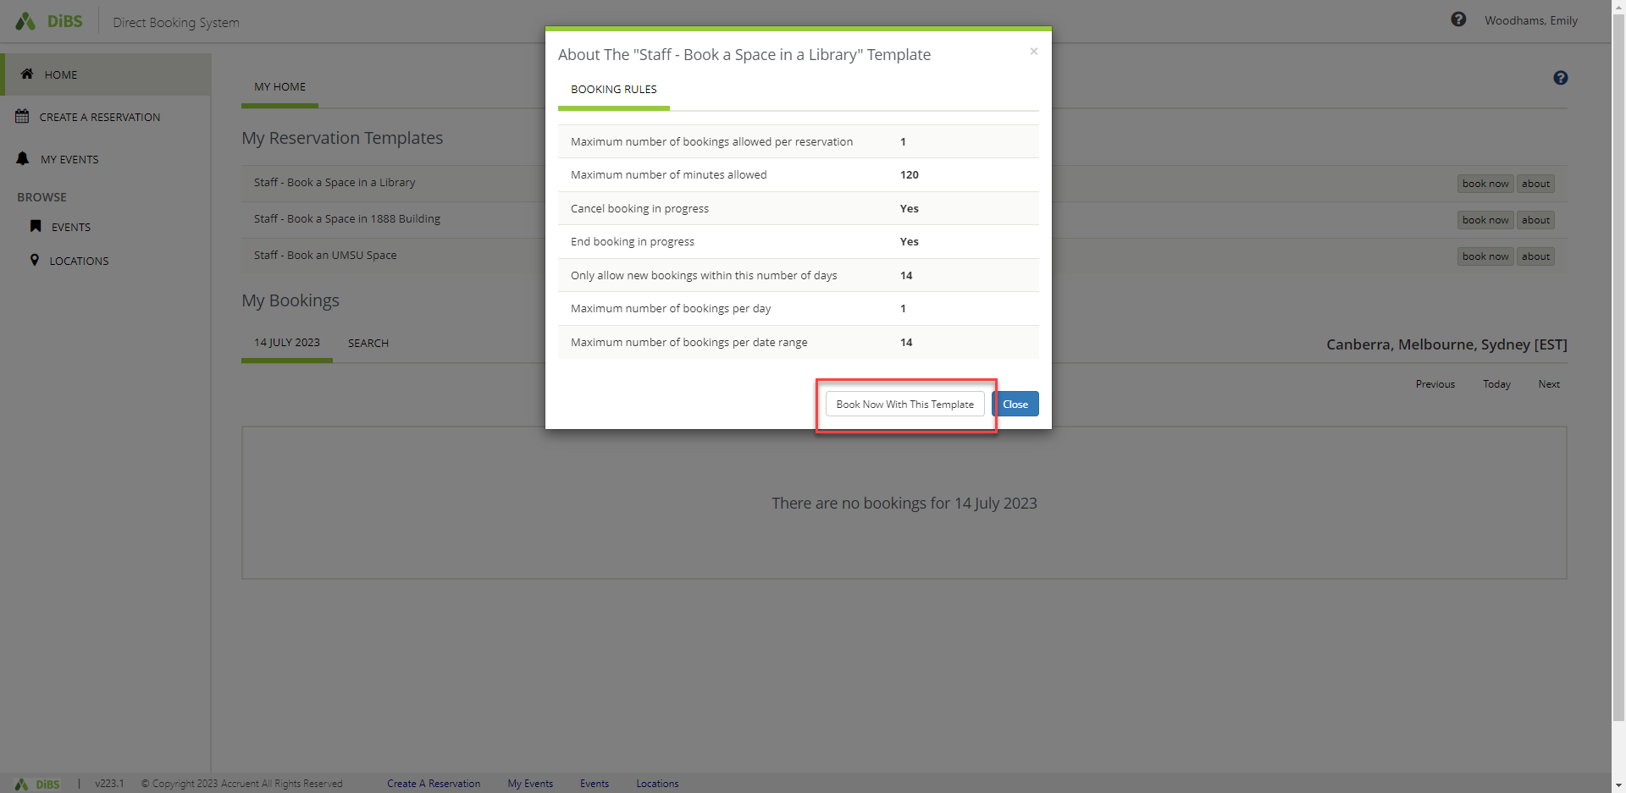
2.4 | When you click either of the Book Now buttons, you are taken to the New Booking page. Select the date, start time and end time for your booking. You can also narrow the search to a particular building if you wish. You will notice that your own availability (as per your Outlook calendar) will display under the Attendees heading.  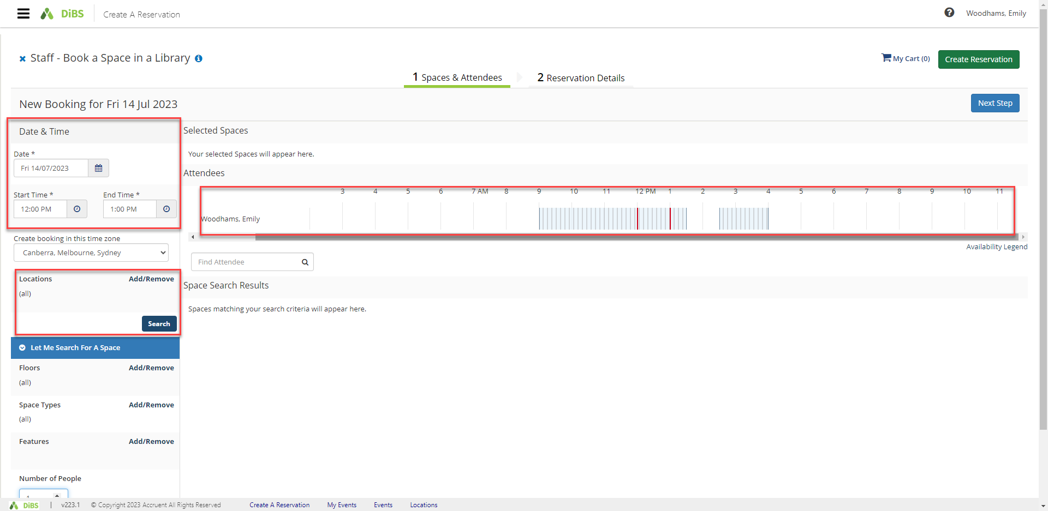

2.5 | Once you hit Search, available spaces for your chosen date and time appear in a list view automatically.  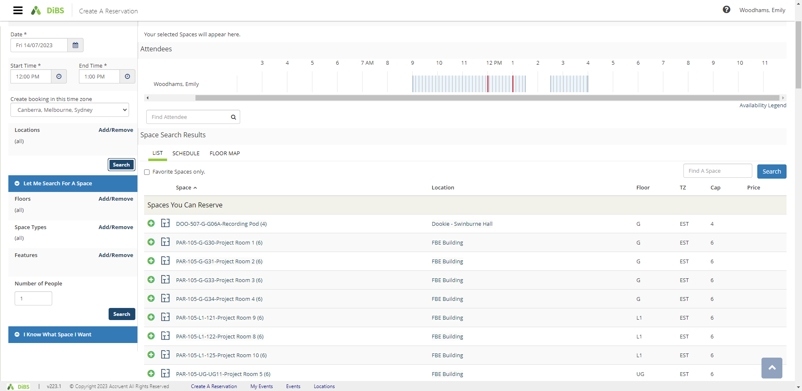
2.6 | You can also choose to view the available rooms by Schedule view or Floor Map view.  Schedule view:  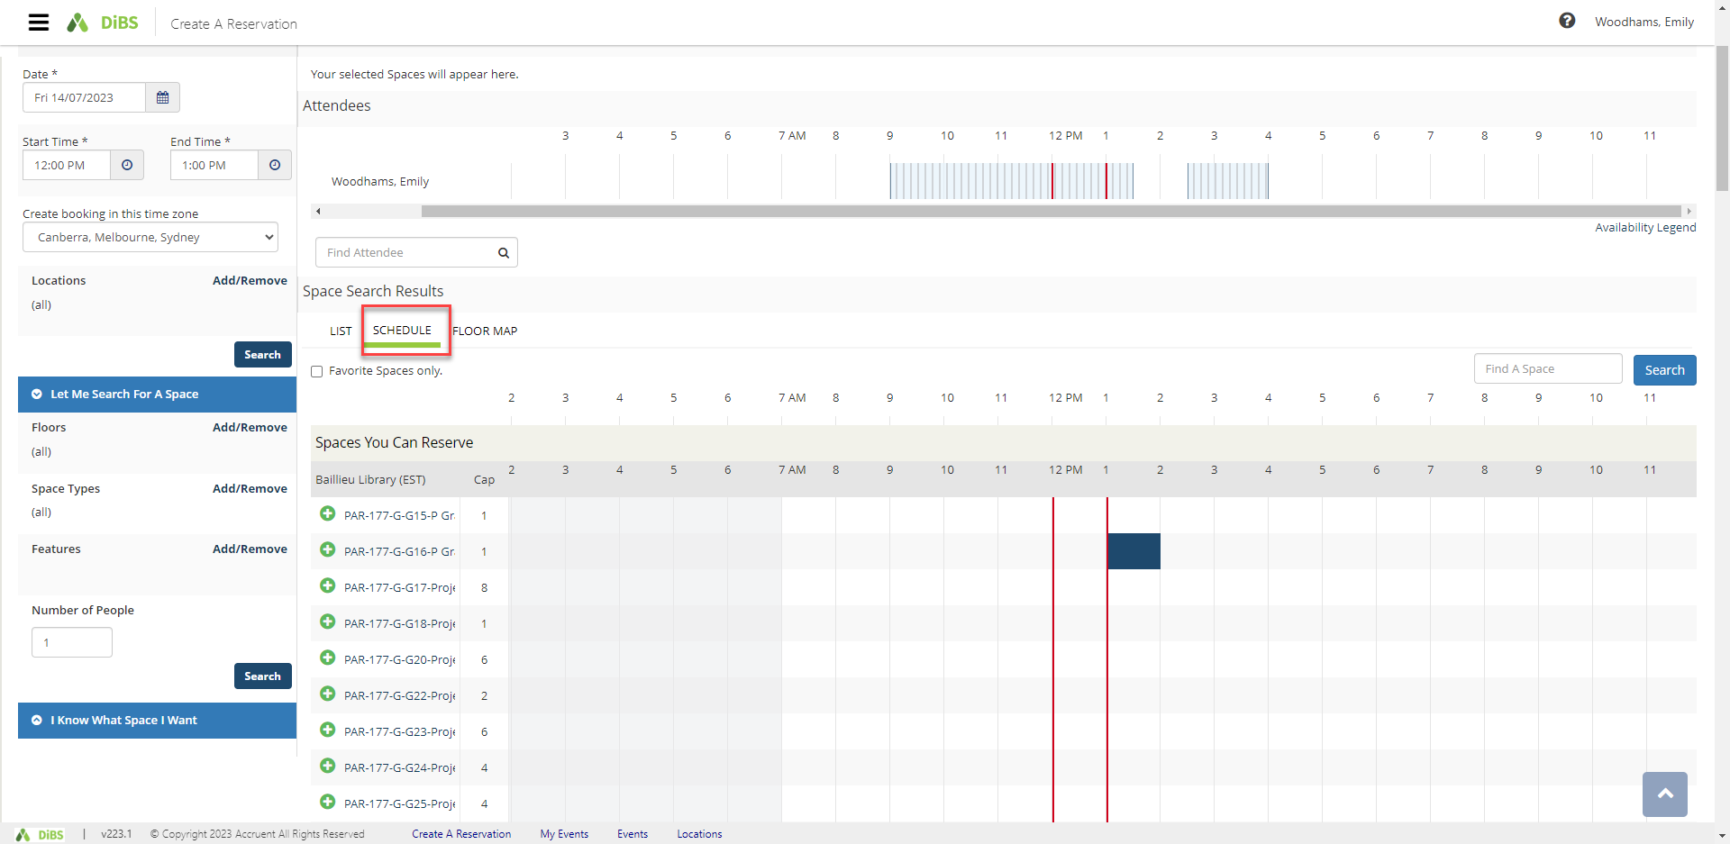  Floor Map view: (you must select a floor and building for this view)  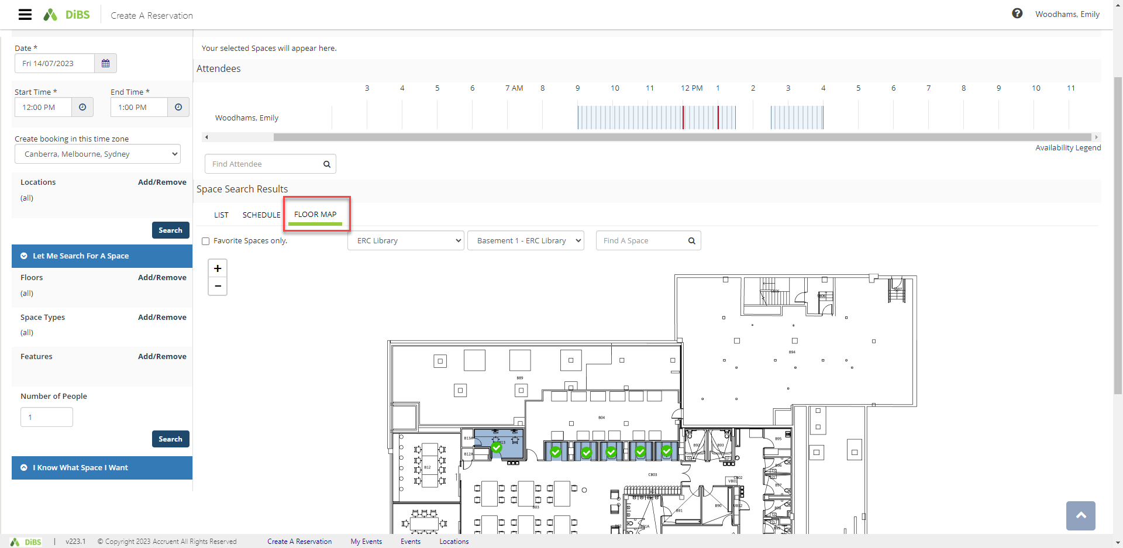
2.7 | Select the room you would like to book. Click the plus button (green and white).  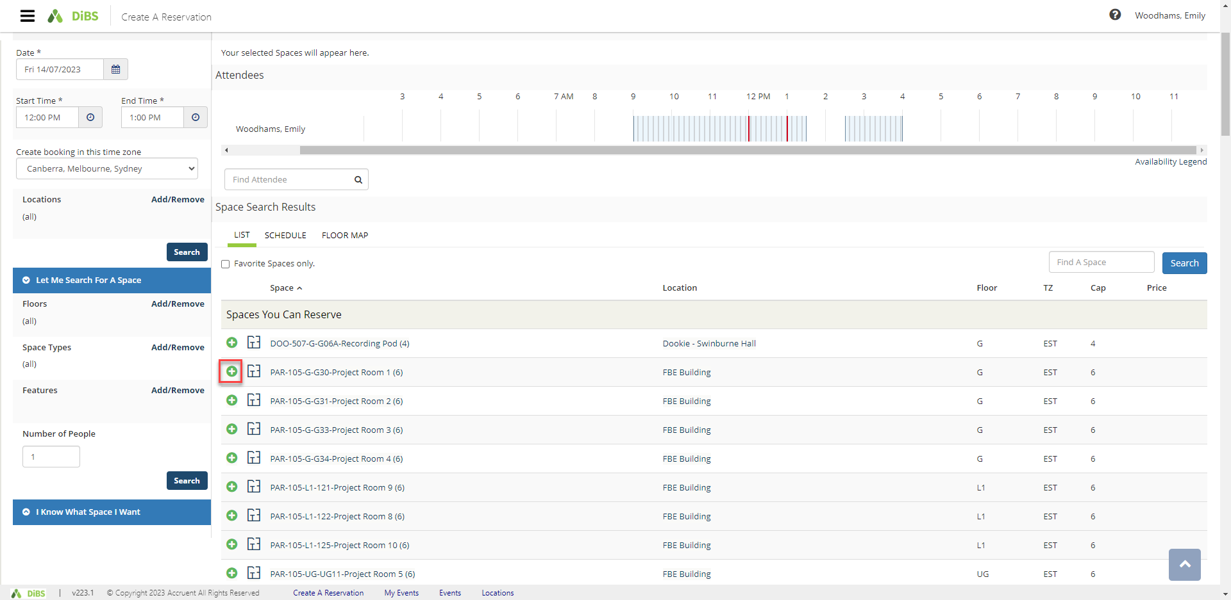
2.8 | Enter the number of attendees and click Add Space  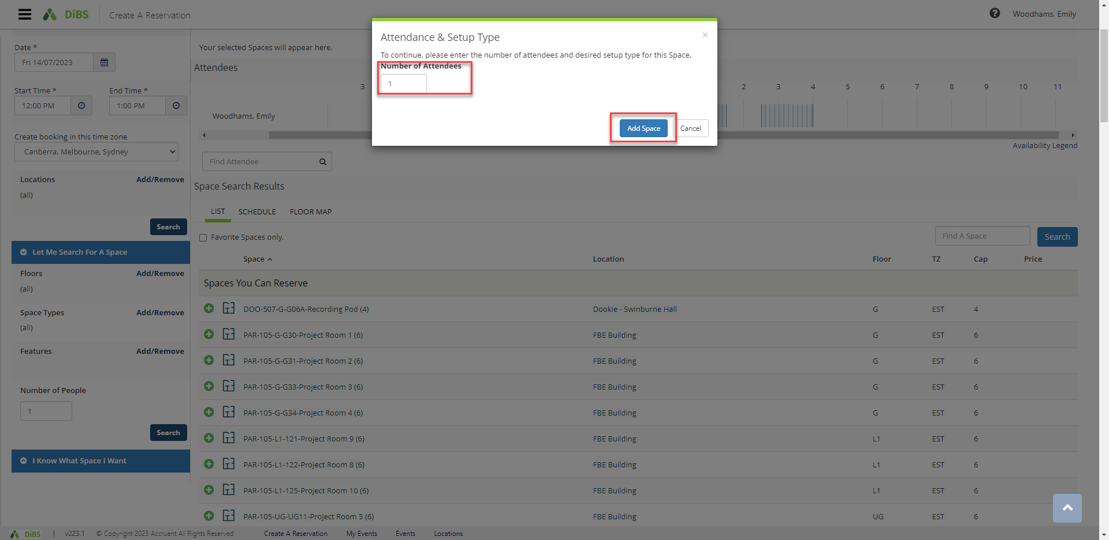
2.9 | Selected room has now turned red (unavailable) and a pop-up message tells you that the date/time cannot be edited once the booking has been added to My Cart. Proceed to click Next Step.  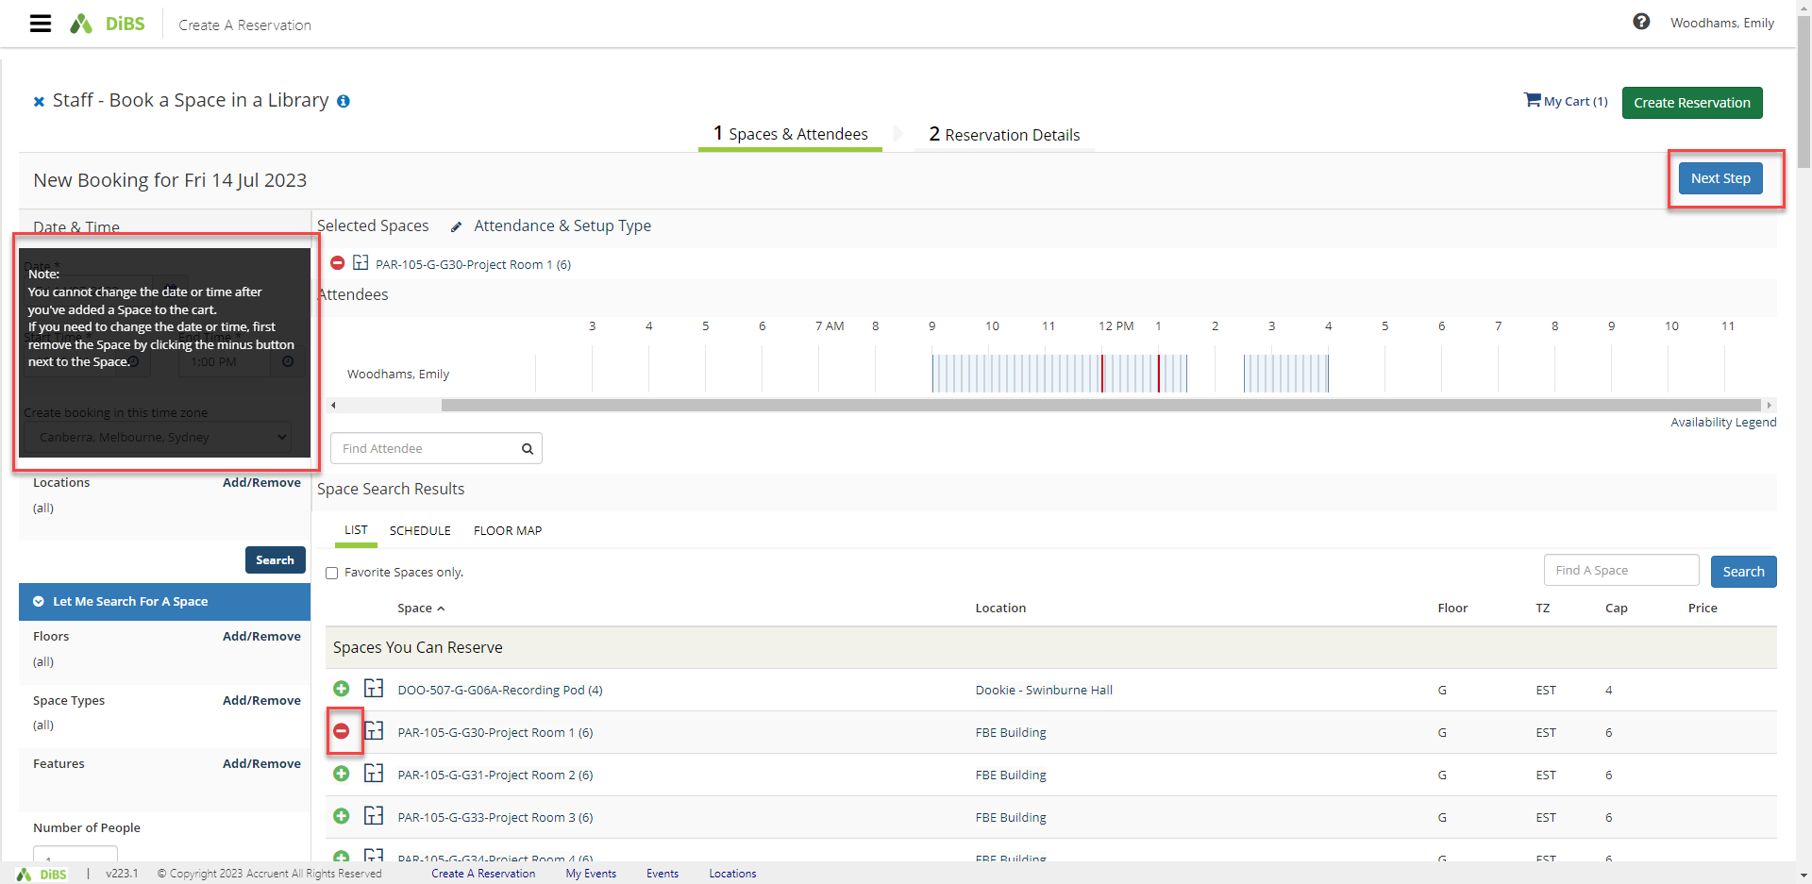
2.10 | On the Reservation details screen, enter Event Name, select Event Type from the drop down menu.  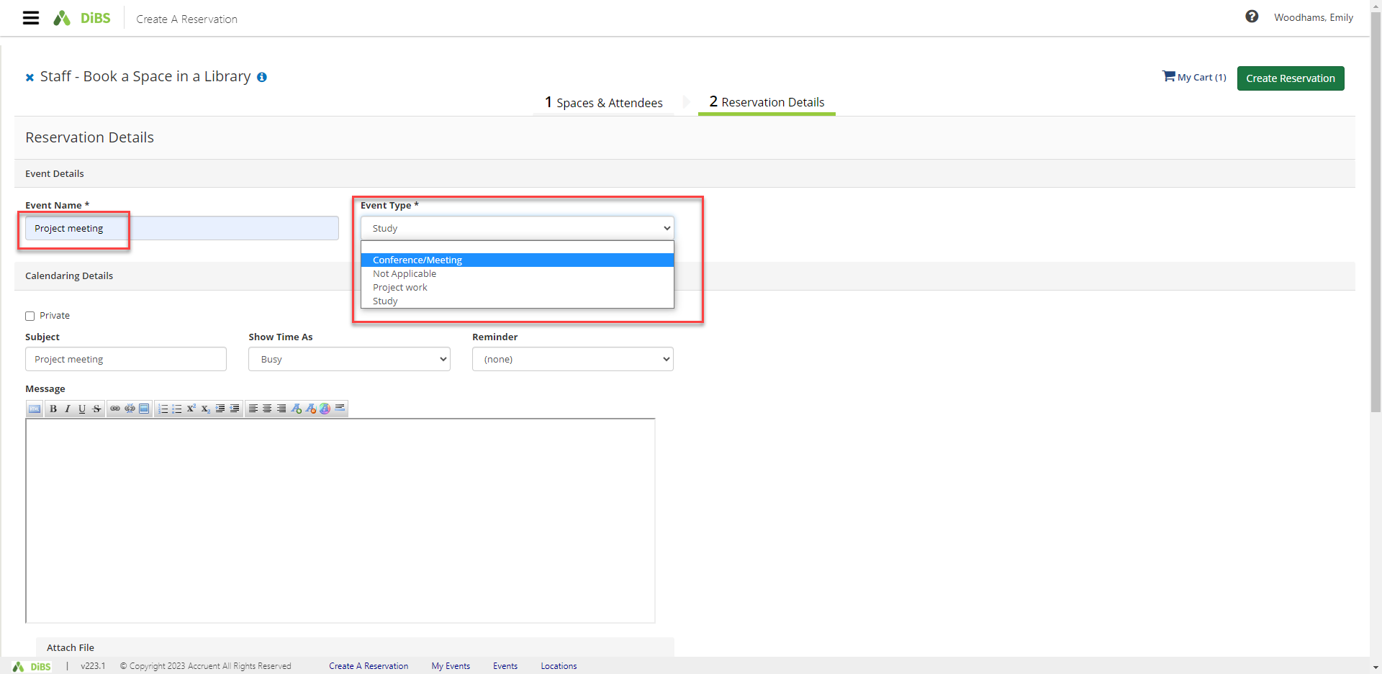  Confirm the event details for the calendar invitation. You can set a reminder, the ‘busy/available’ state and the Subject line for the meeting. You can also include a message in the free text box and attach any relevant files.  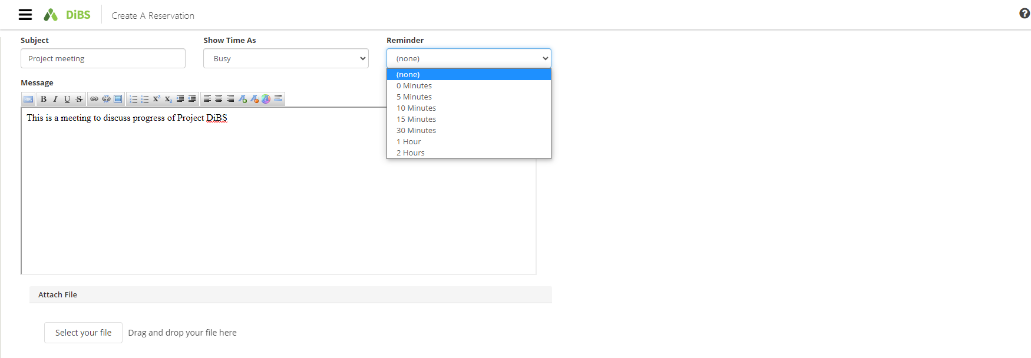  Confirm your contact details and read and agree to the Terms and Conditions. The click Create Reservation.  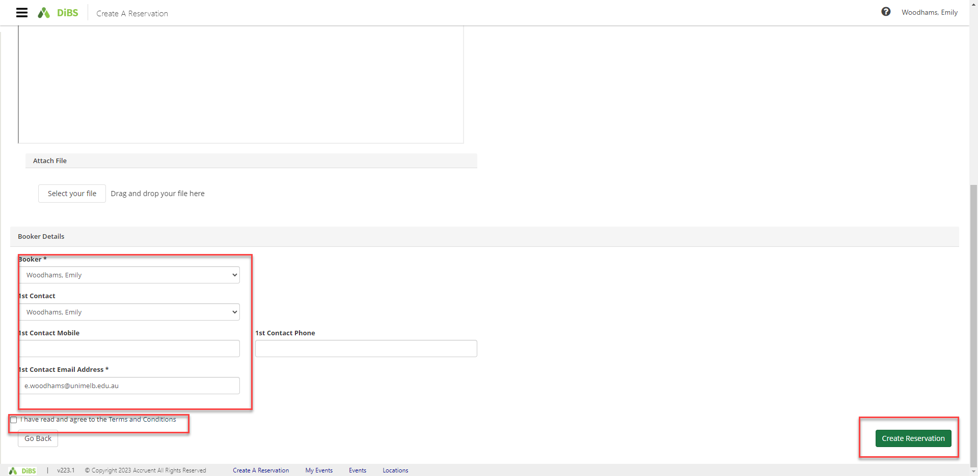
2.11 | Your booking is confirmed. An email notification will be sent to your nominated email address within a few minutes.  Email notification:  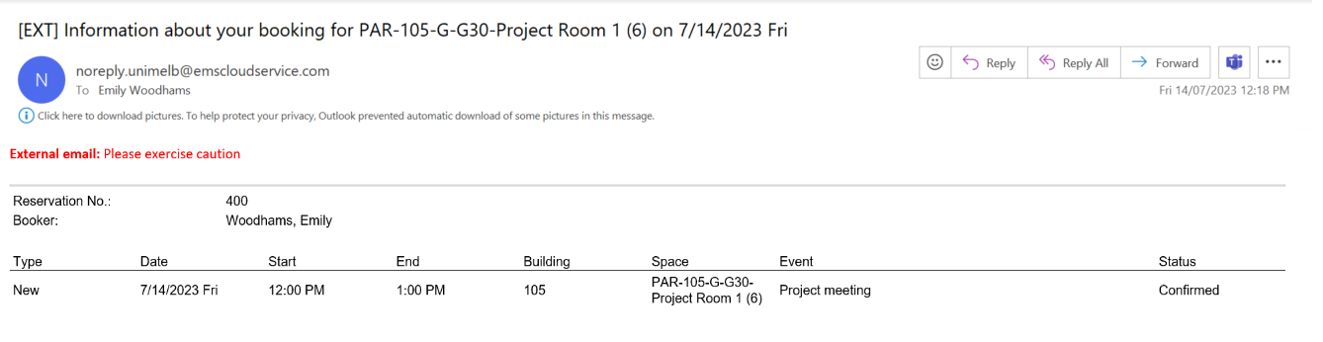
2.12 | Your booking will appear under My Events  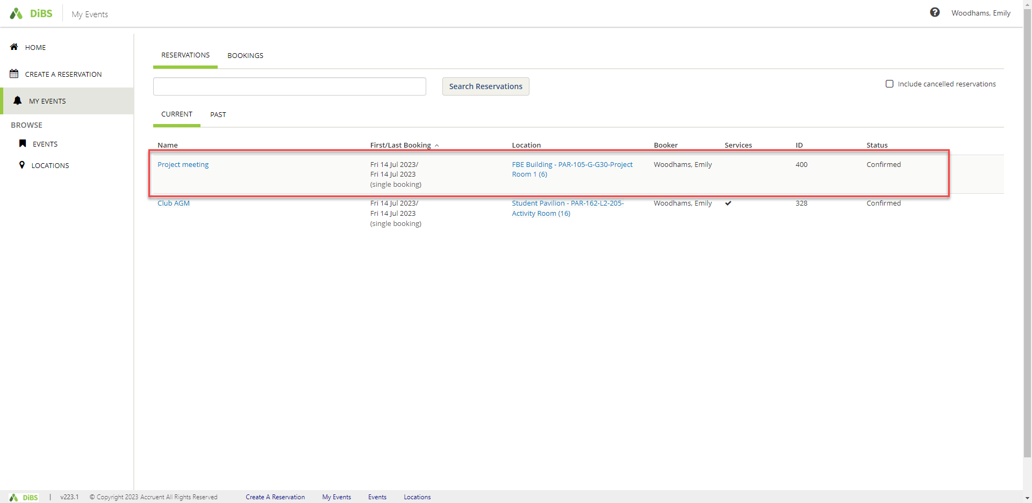

- Browse for a space: to find a space that meets your requirements
3.1 | To search for a space by location, date or feature, navigate to the Browse function on the left-hand menu. Select Locations and filter your results by specific building, or characteristics such as capacity, features, space types etc.  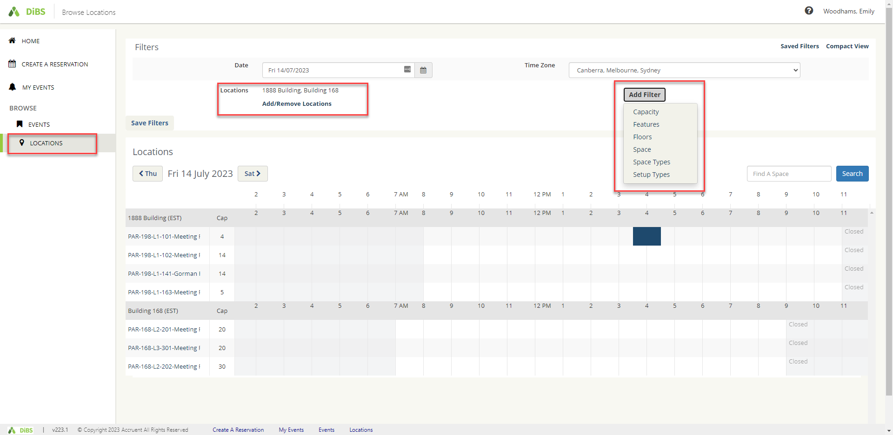
3.2 | Add filters and tick the options you require in your space.  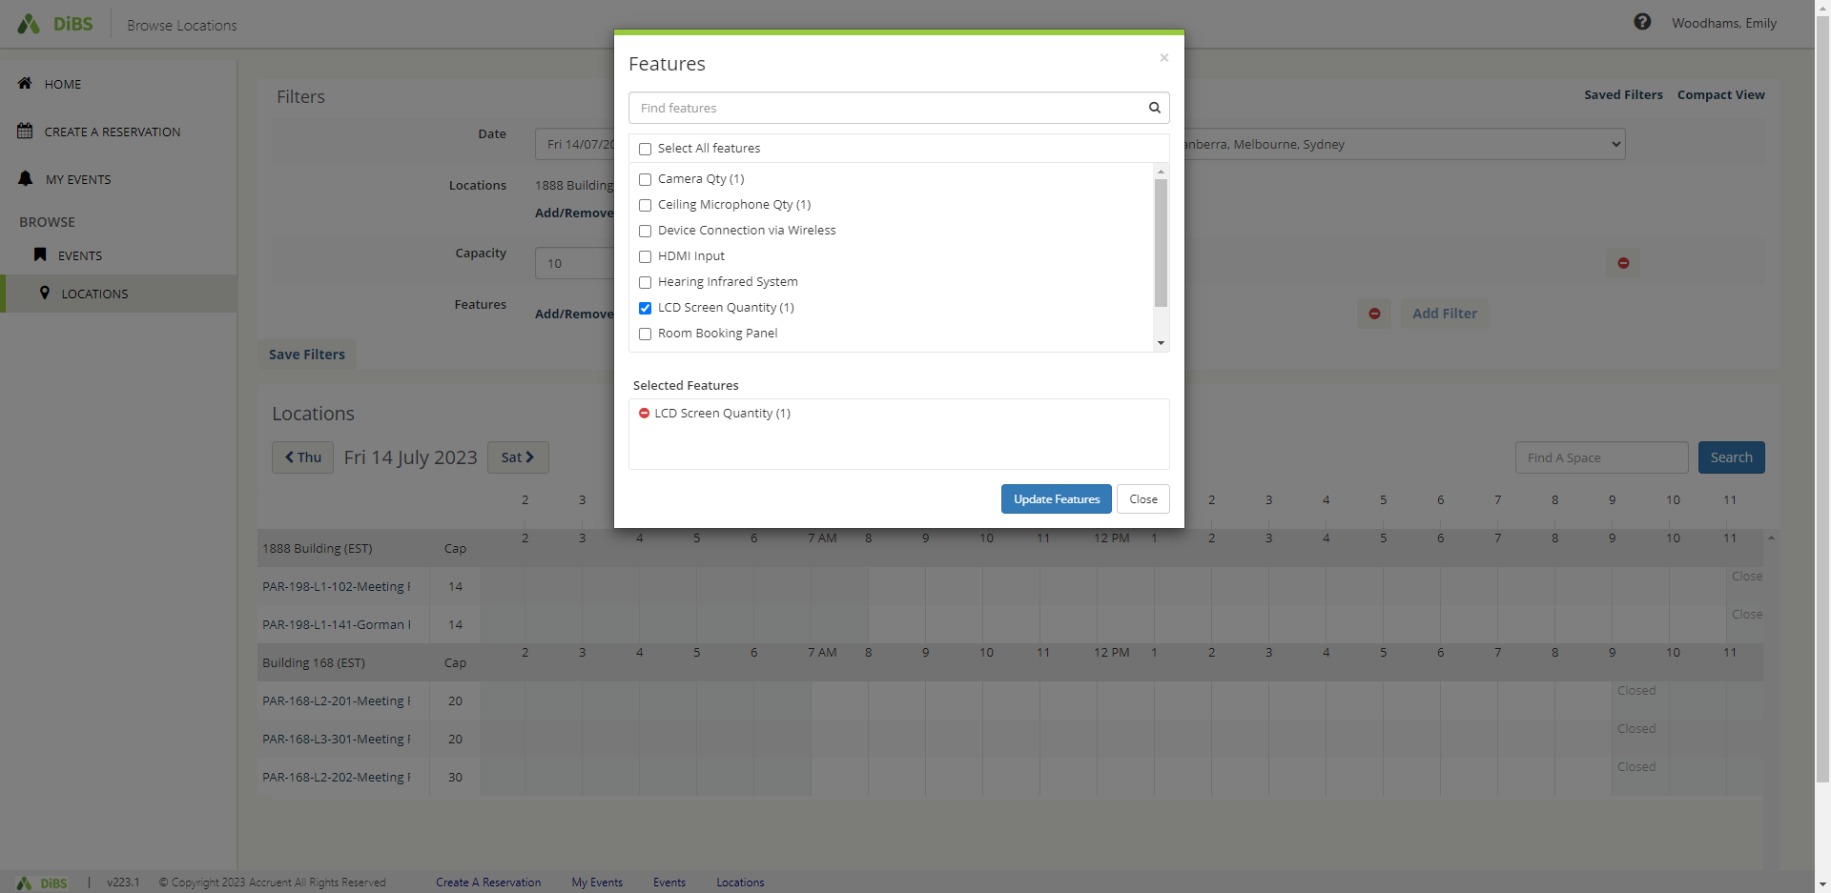
3.3 | See all available spaces that meet your requirements.  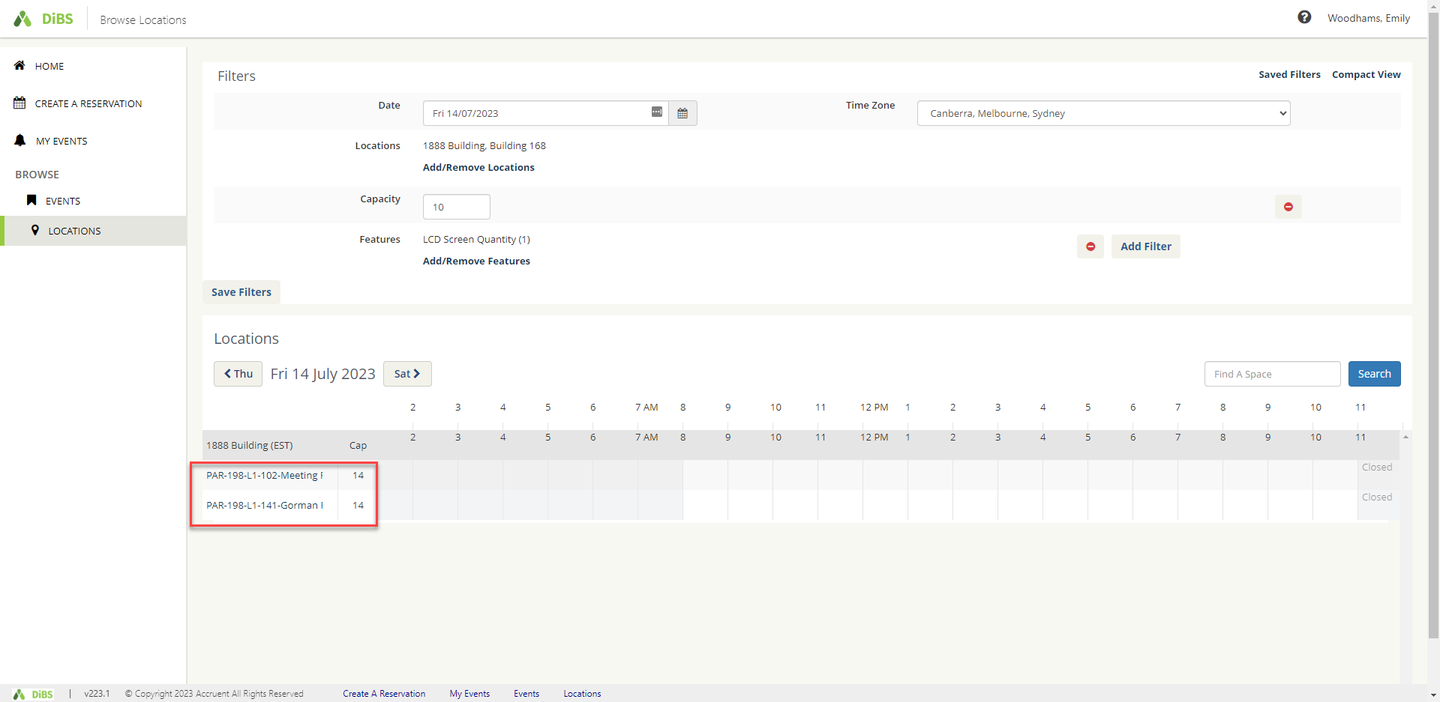
3.4 | Click on a room name to view information about the room.  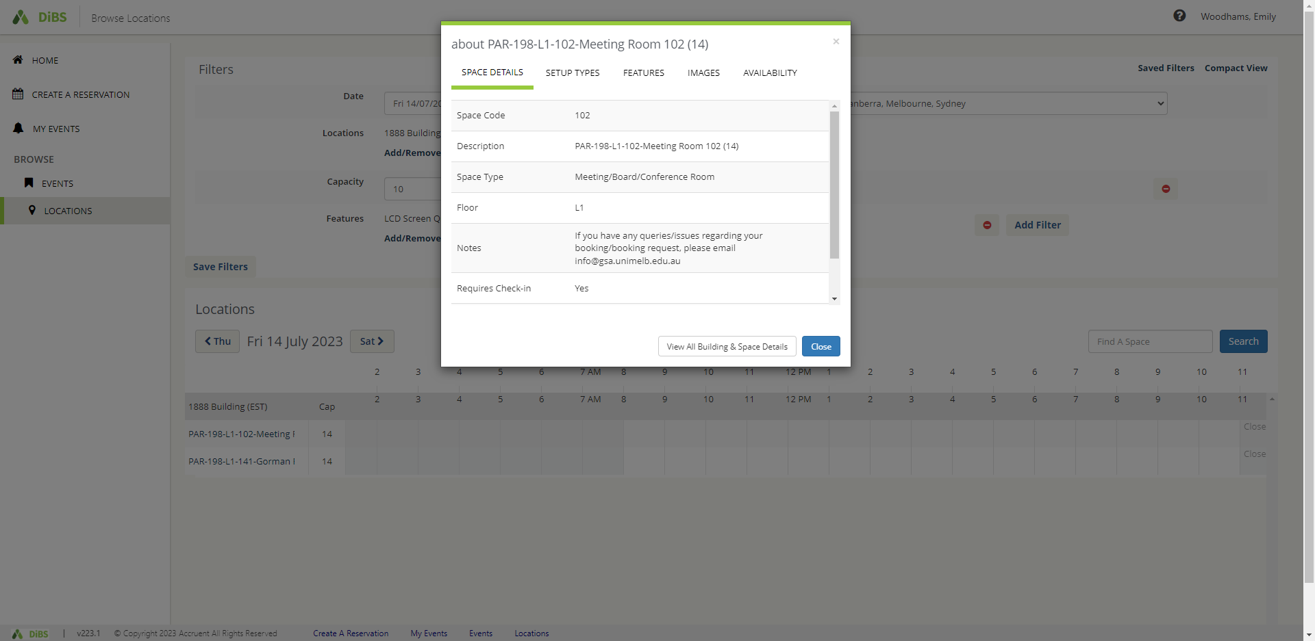

3.5 | Save the filters you have chosen for future booking searches if you wish.  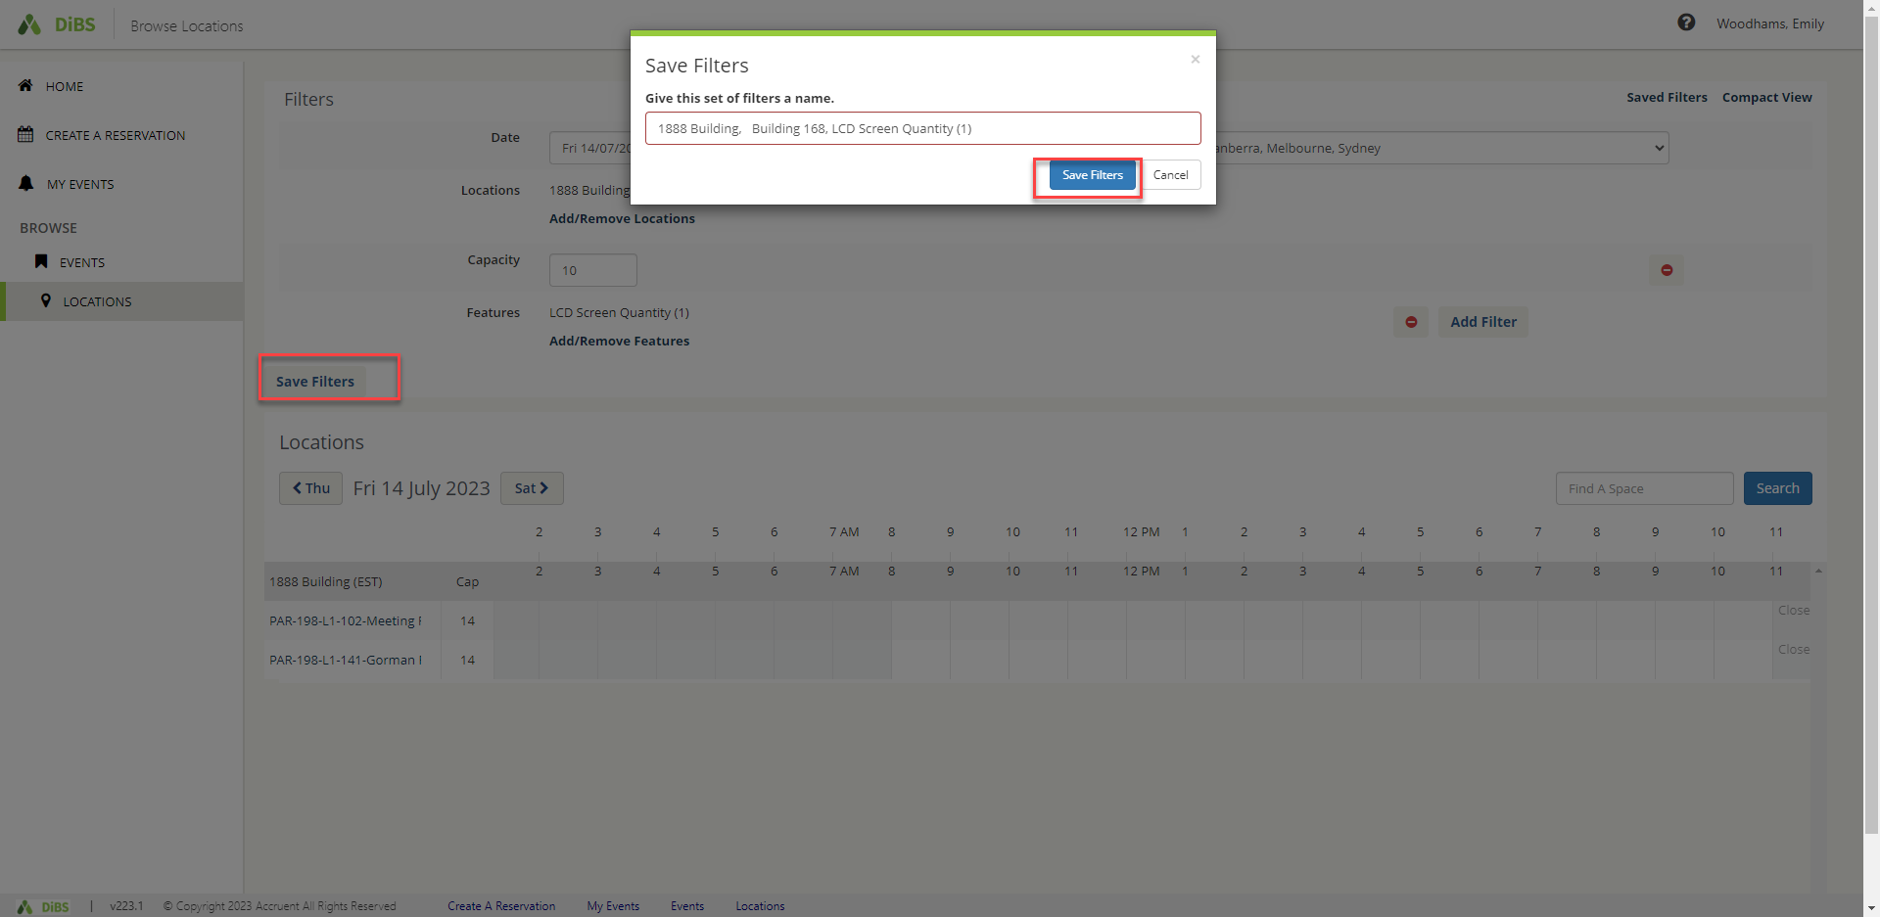
3.6 | To make the booking in your chosen space, click on the cell that corresponds to your preferred space and start time. A pop up will appear, asking you to nominate the start and stop times for your booking. Click continue.  #Note: You can only click on a cell with a future start time.  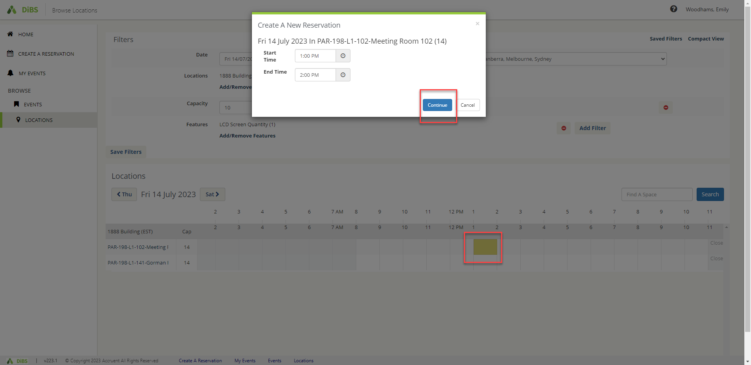
3.7 | You will be taken to the Reservation details page for that space. Click on the green and white plus to add the space to your booking.  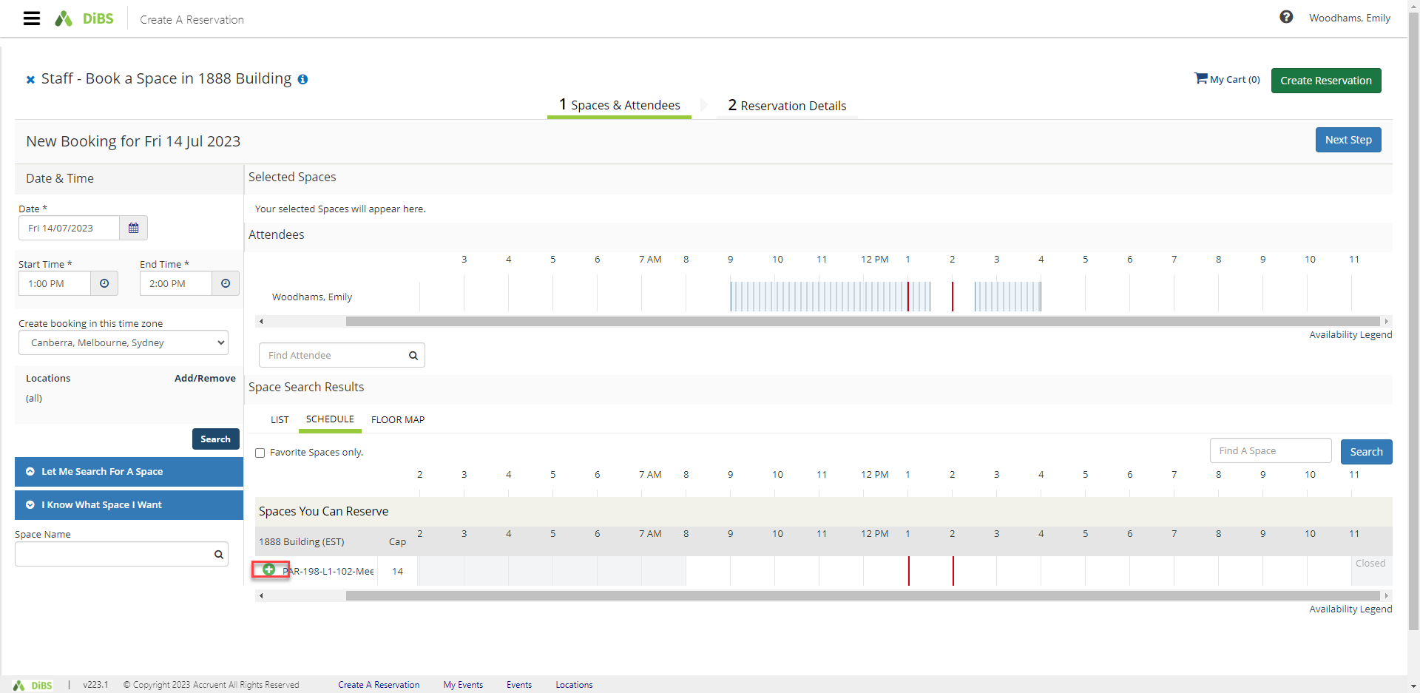
3.8 | Once the space has been added to your booking, continue to book as per standard booking process by clicking Next Step.  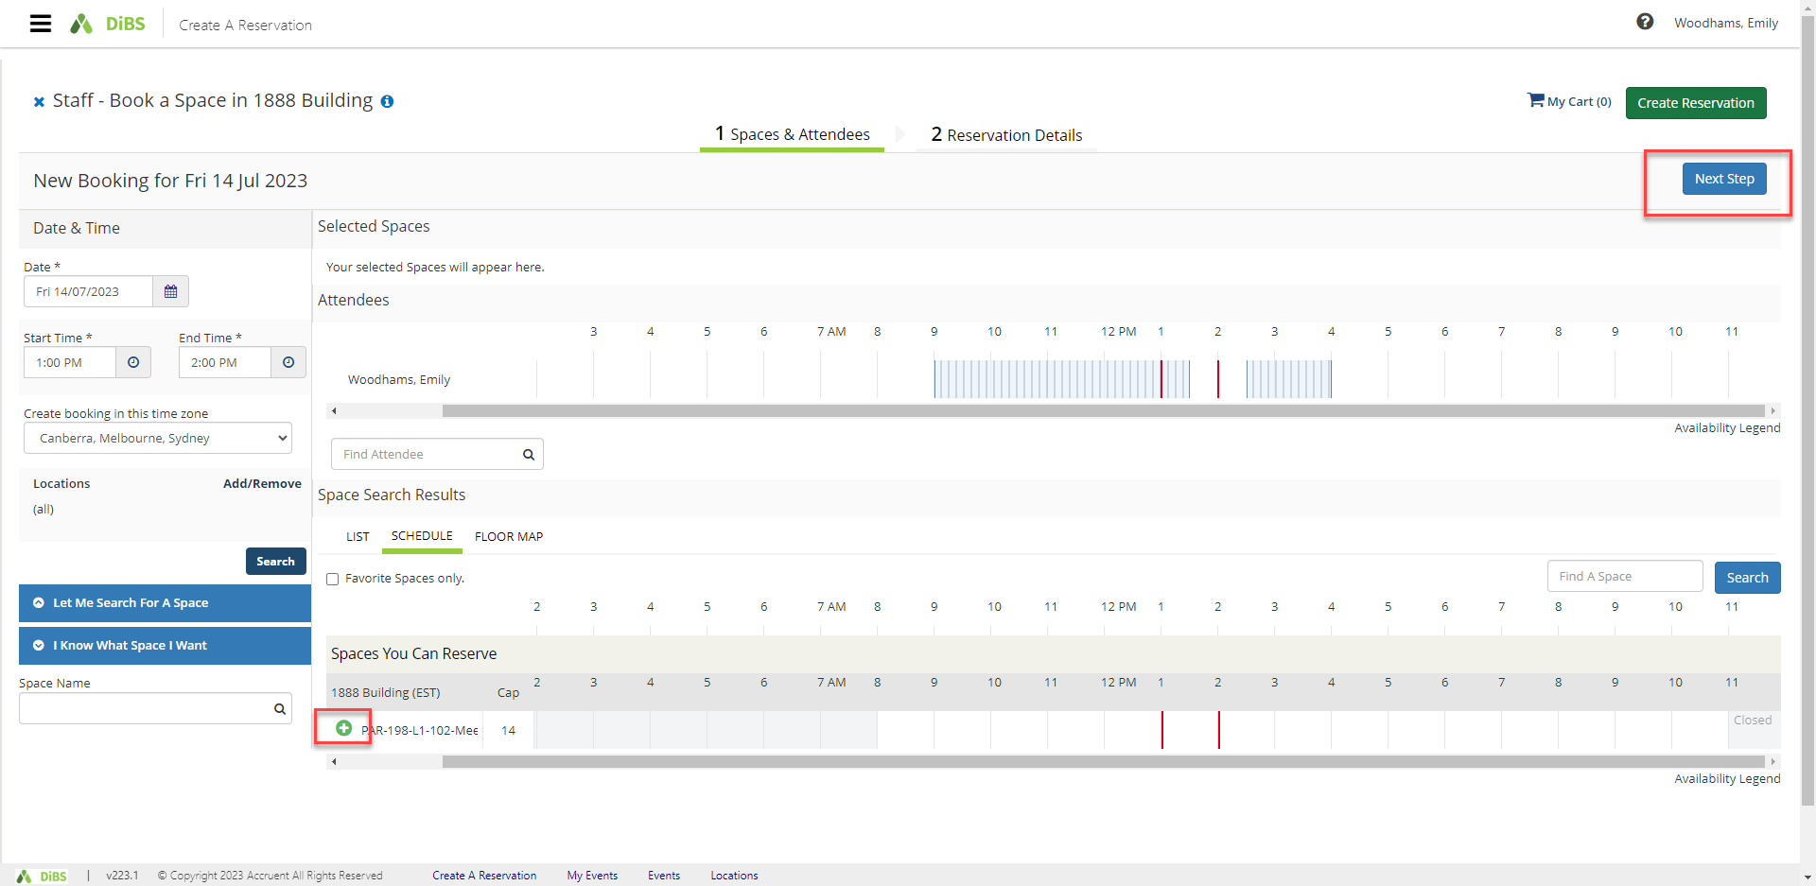

3.9 | Proceed with your reservation by completing the Event name, Event type, Message, Booker details, any additonal information and agreeing to the terms and conditions.  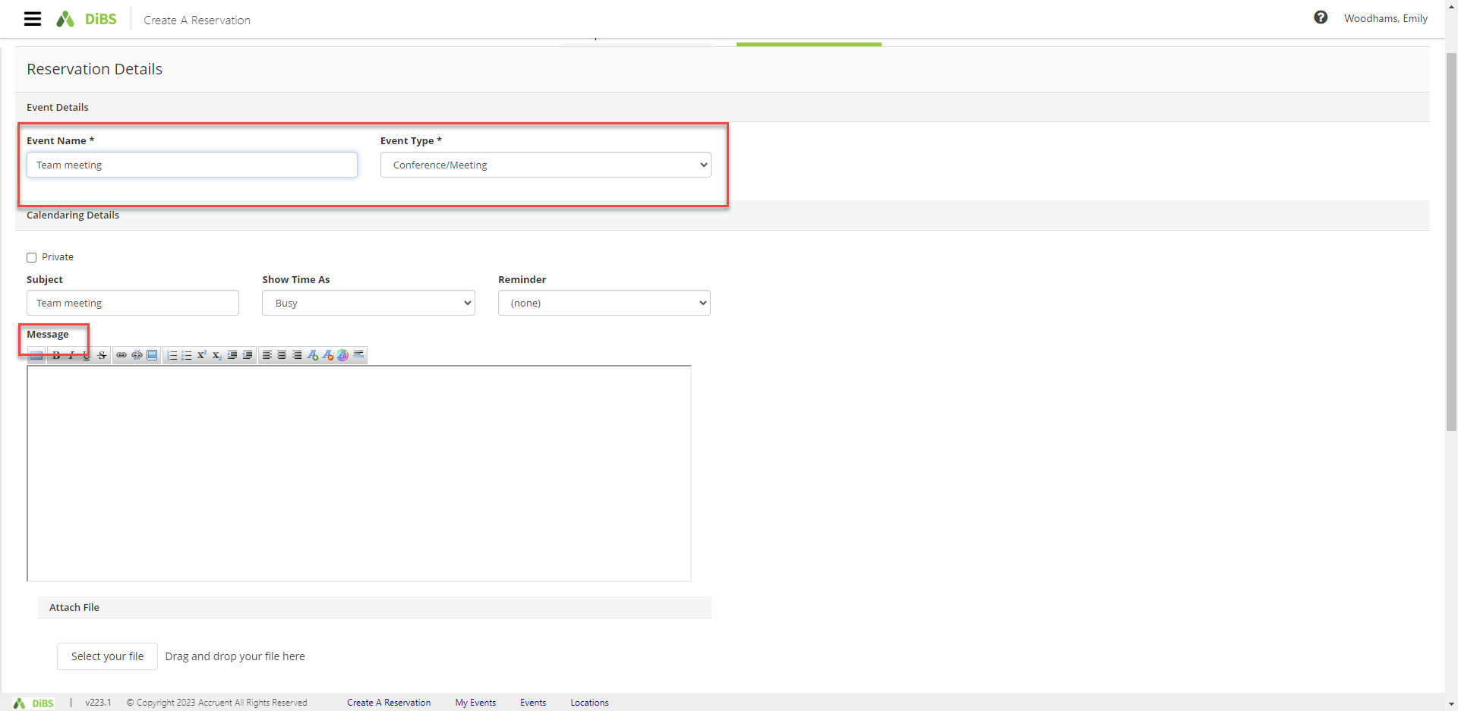  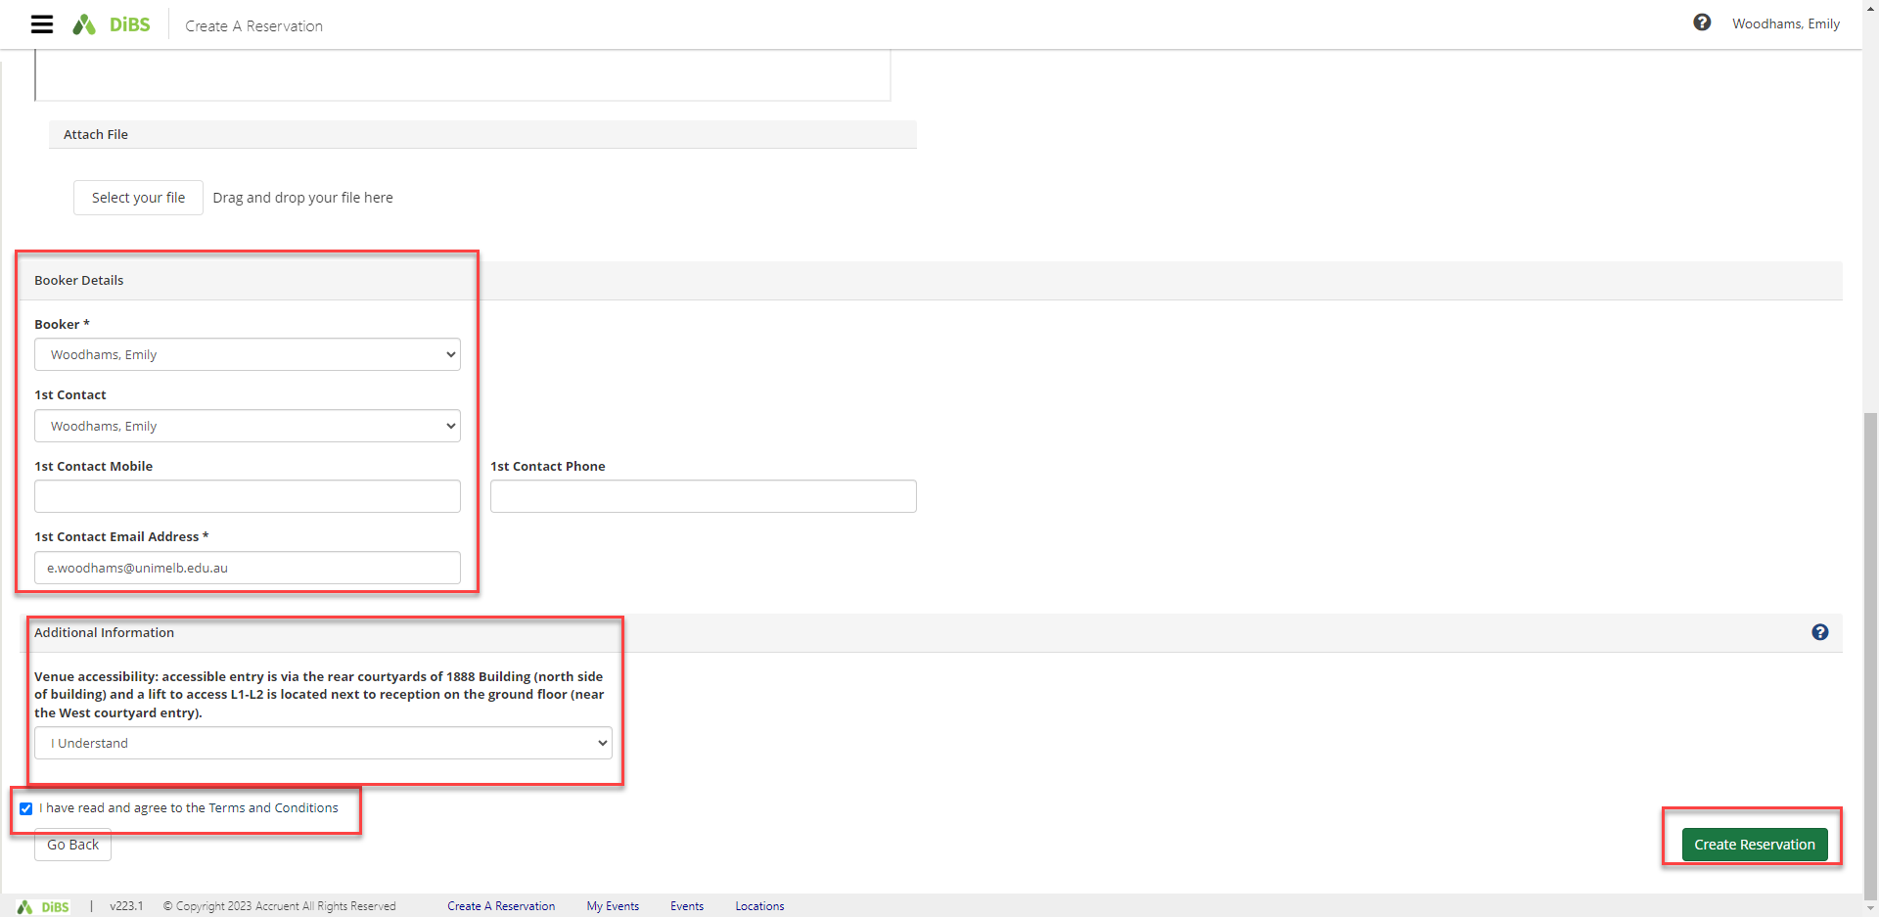

3.10 | The booking is complete and an email notification will be received.  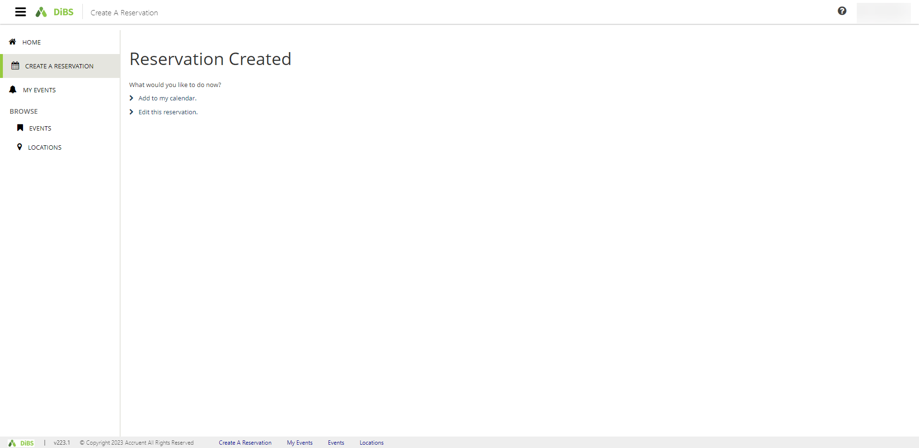

- Edit reservation details (eg Event name, Event type, Booker details only)
PLEASE NOTE: You are not able to change the date, time, or location of your reservation. If you need to adjust these details, please cancel your reservation (see 6. Cancelling a reservation) and make a new reservation.
4.1 | To edit your reservation details, navigate to My Events and select the booking you want to edit.  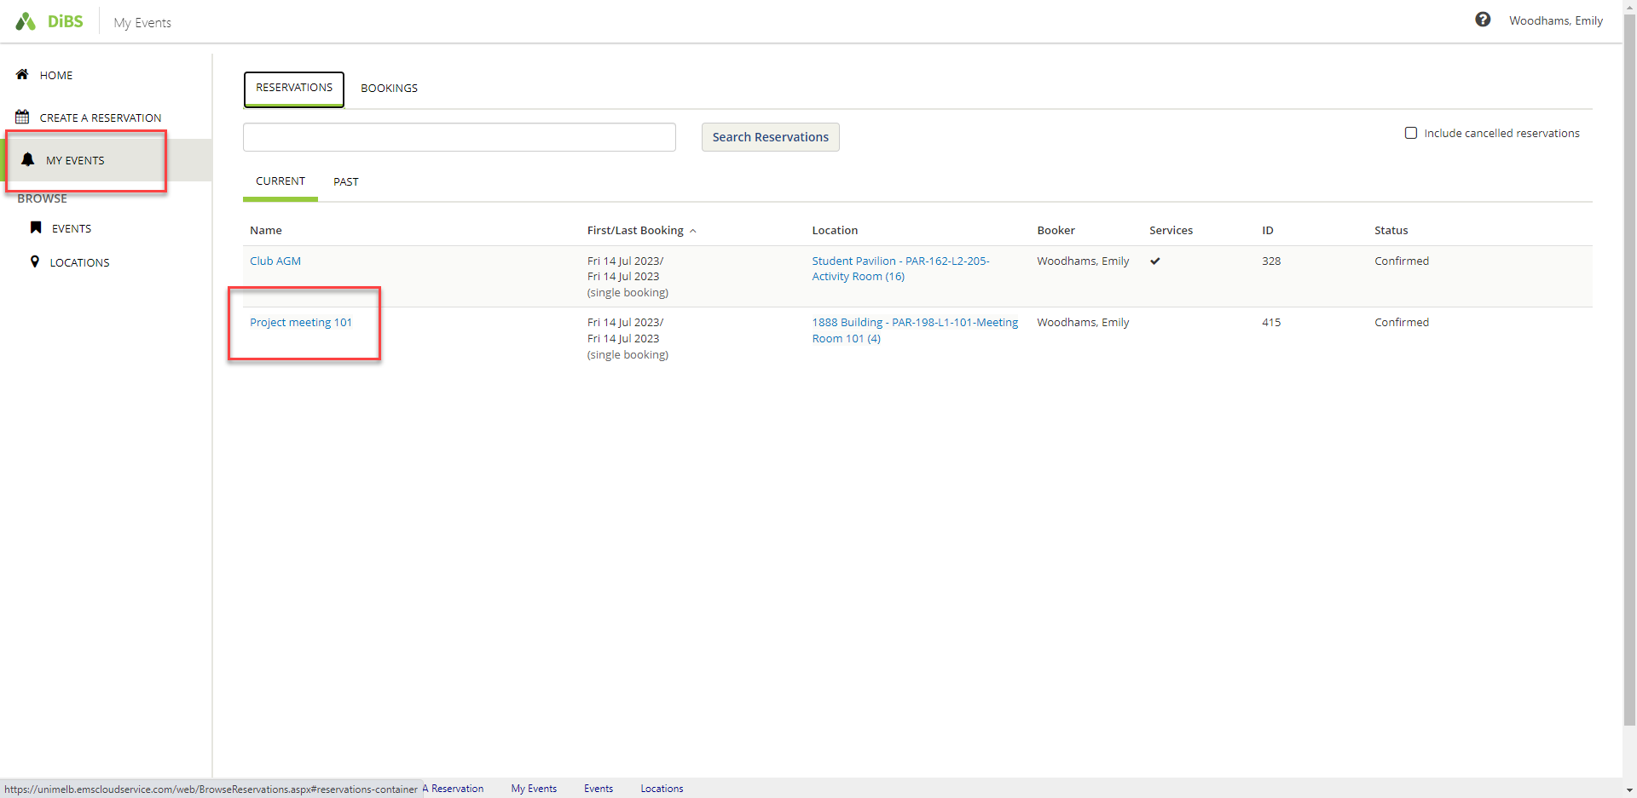
4.2 | Click on Edit Reservation Details.  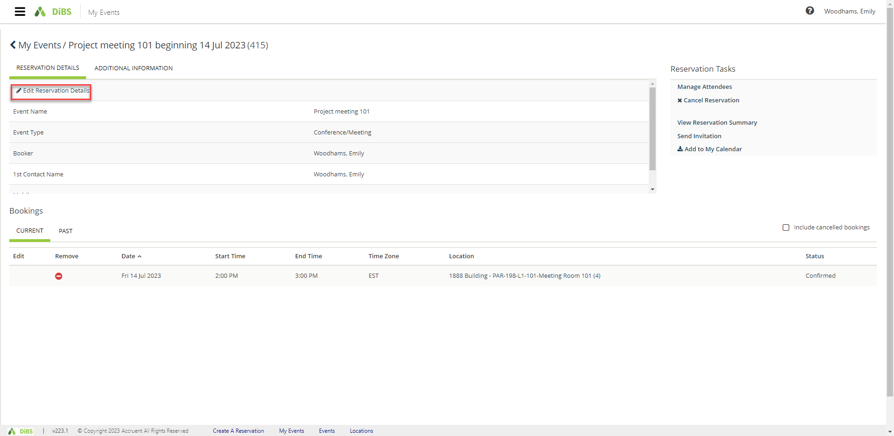

4.3 | Here, you can edit the name of the event, the contact person, or the event type.  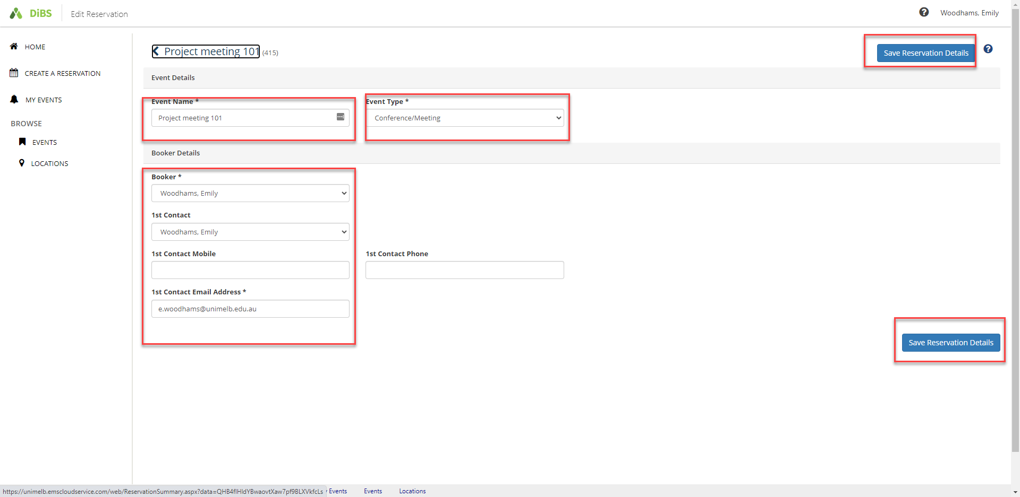
4.4 | Click ‘Save reservation details’ and new details will be displayed. The right-hand menu shows Reservation Tasks such as adding/cancelling services or sharing an invitation with another attendee.  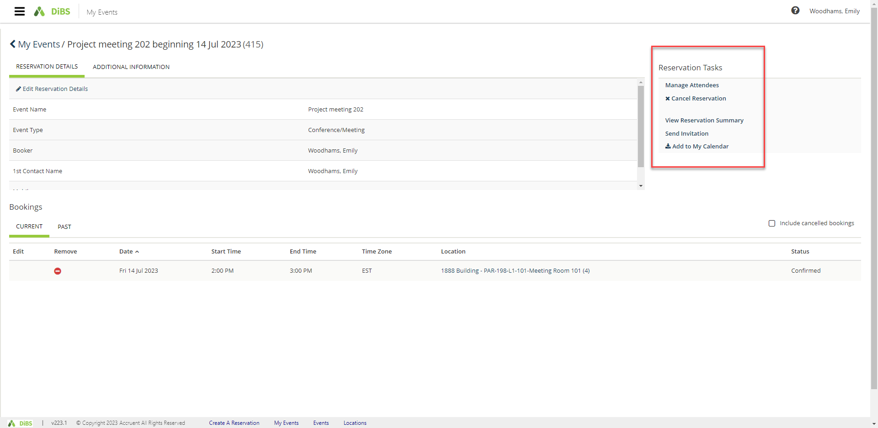

4.5 | To share your reservation details with another attendee, click on Send invitation. A pop up allows you to forward the booking details via email.  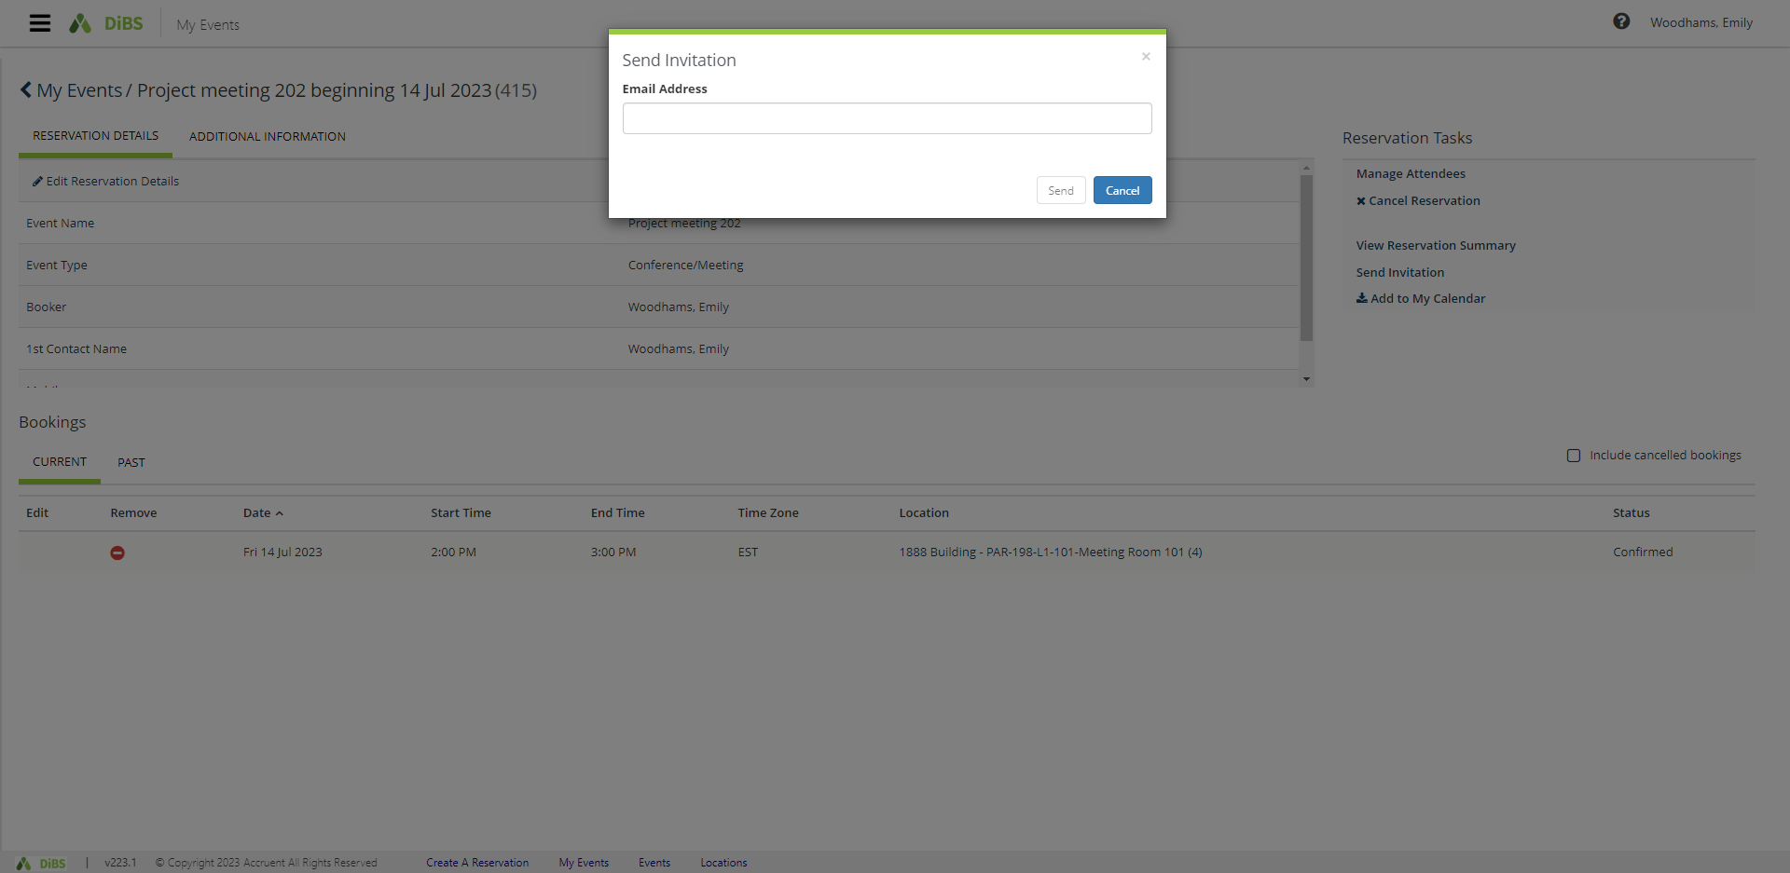

- Cancelling a reservation
5.1 | Navigate to My Events and click on the booking you wish to cancel.  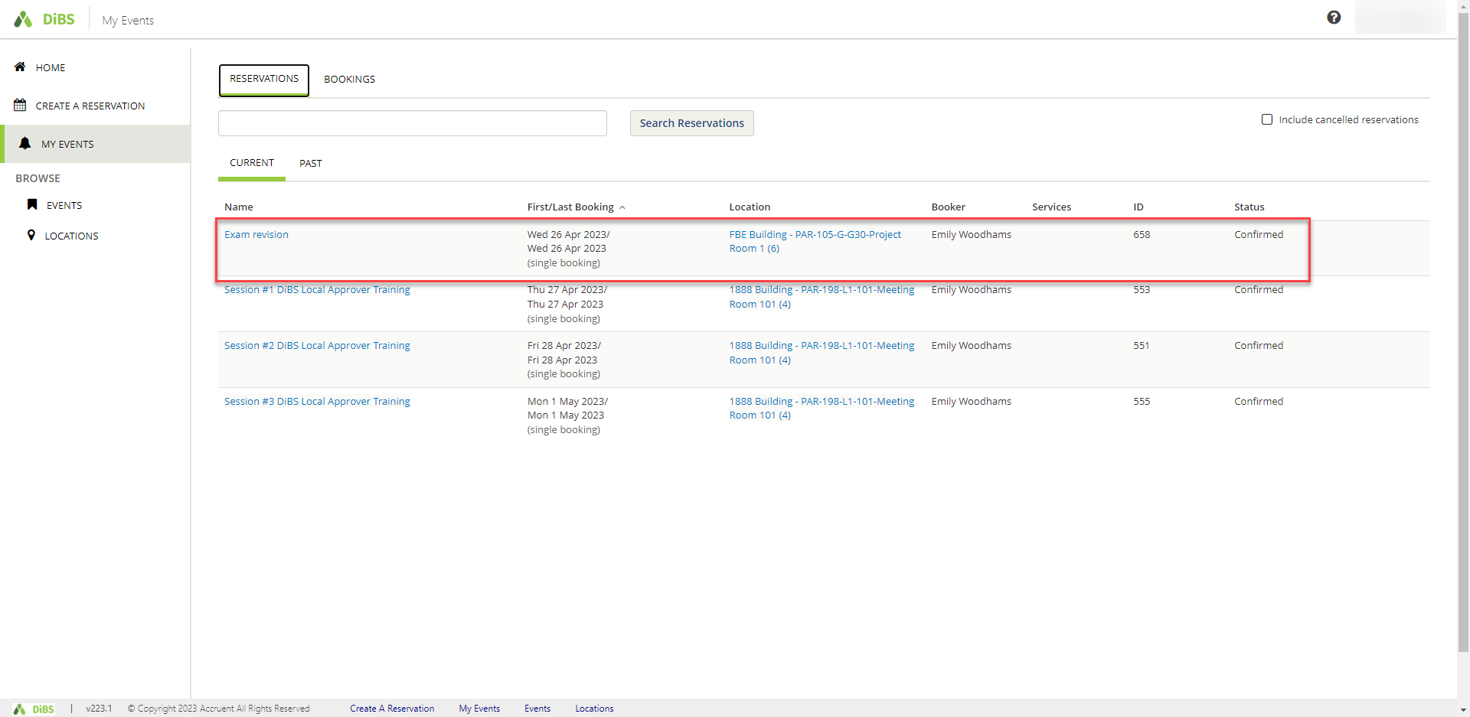
5.2 | You will be taken to the Reservation details screen.  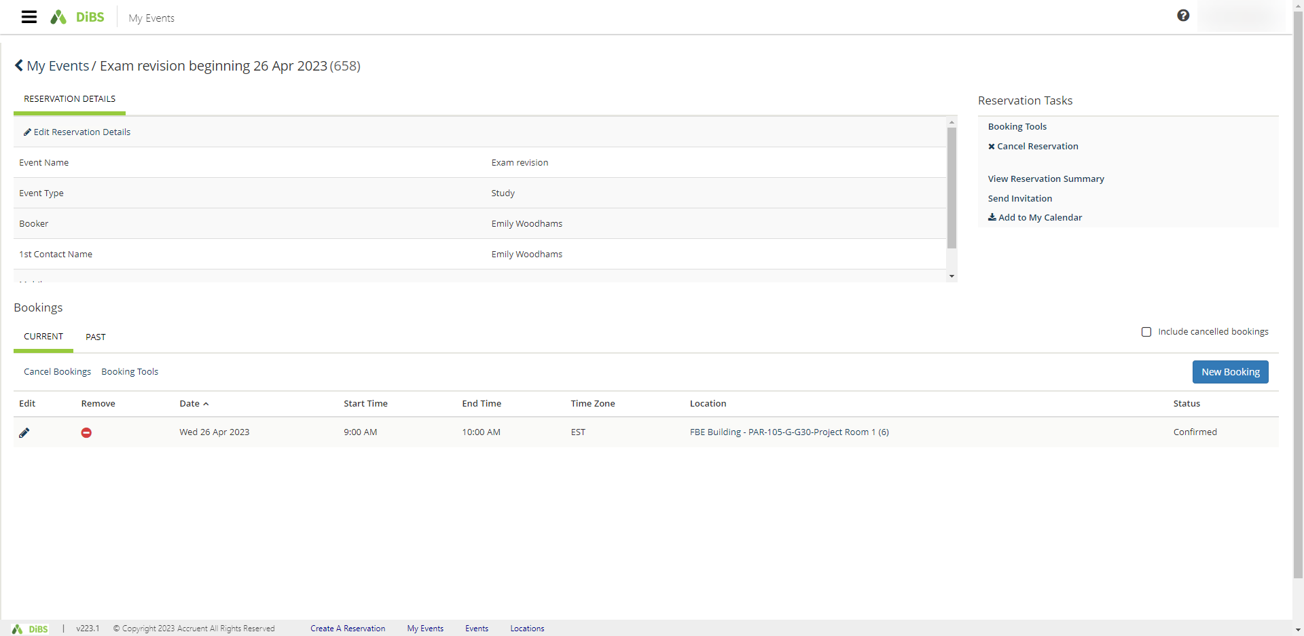

5.3 | To cancel a reservation, click Cancel Reservation under Booking Tools.  A pop-up will appear. Click Yes, Cancel Reservation.  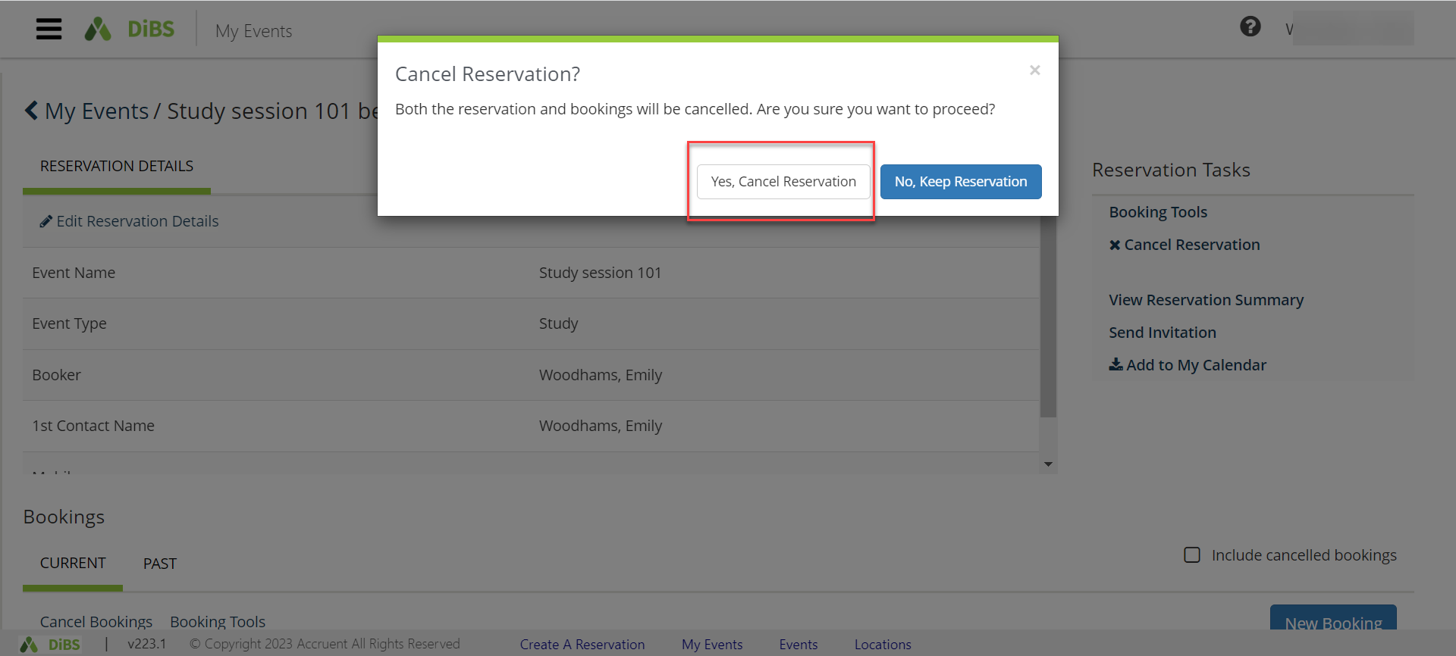
5.4 | Your reservation now appears with the status of Cancelled.  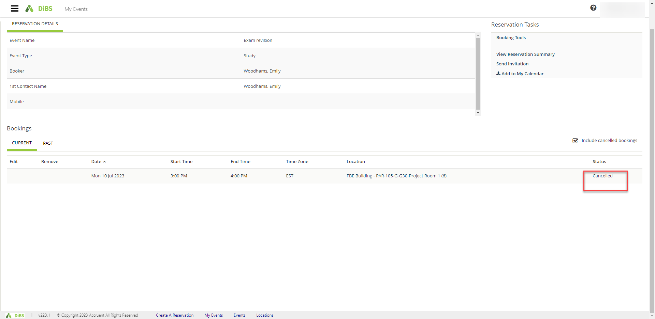
5.5 | You will receive an email notification within a few minutes to confirm the cancellation.

6. Checking in
6.1 | Some spaces require you to check in to confirm your attendance. You must check in no later than 15 minutes after your booking commences in order to retain your booking. You can do this by logging in to DiBS and going to My Events. 30 minutes prior to your booking commencing, the Check in button will appear. Click the Check in button to confirm that you are still intending to use the space.  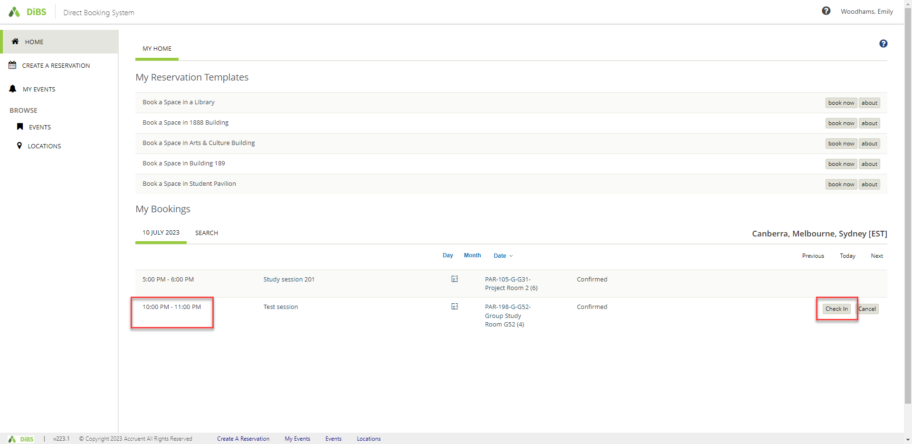
6.2 | Once you click on the Check In button, you will receive a pop up confirmation. The bottom right hand buttons indicate that you are checked in (this button is greyed out). If you choose to end the booking early, you can click the End now button to end your booking immediately.  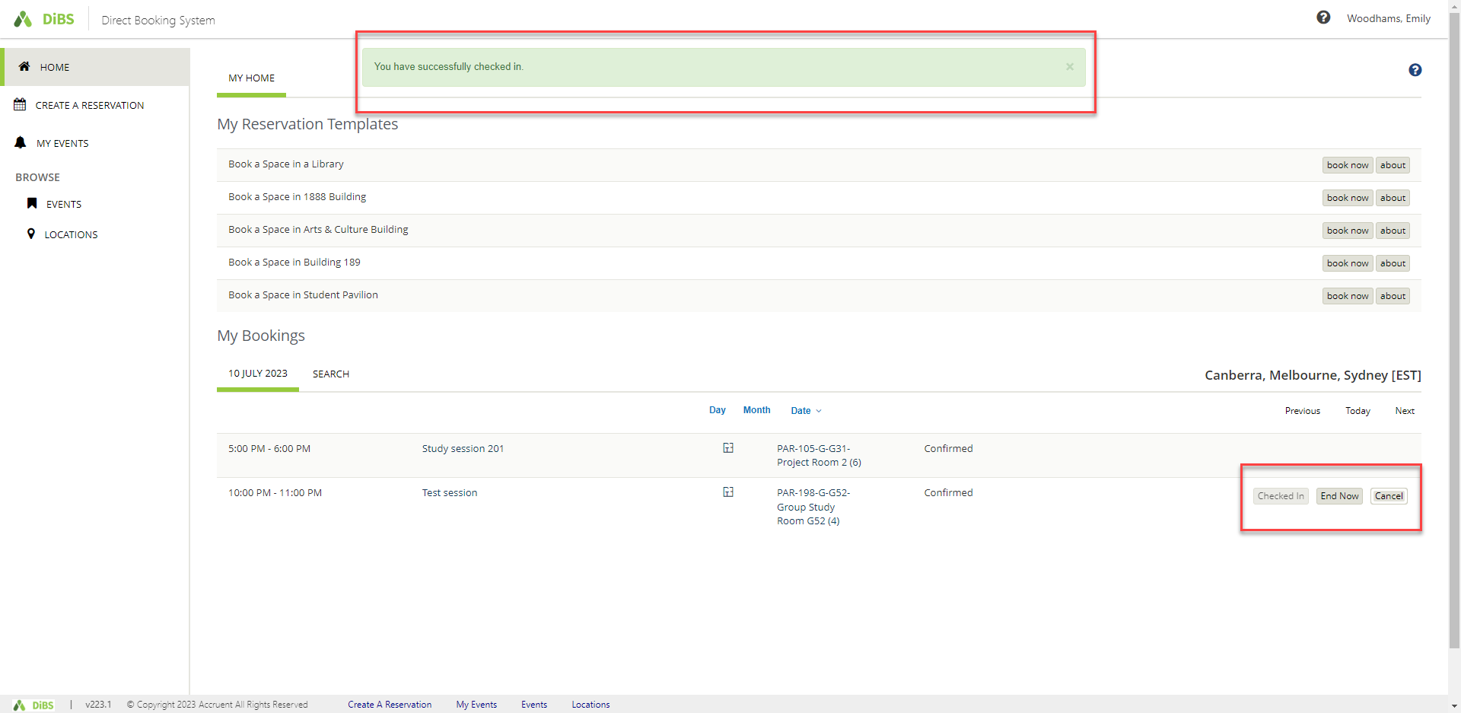
6.3 | An alternative way to check in is via the email notification. You will receive a Check In email notification prior to your booking commencing. You can click on the links in the email to confirm whether you want to Check In or Cancel the booking.  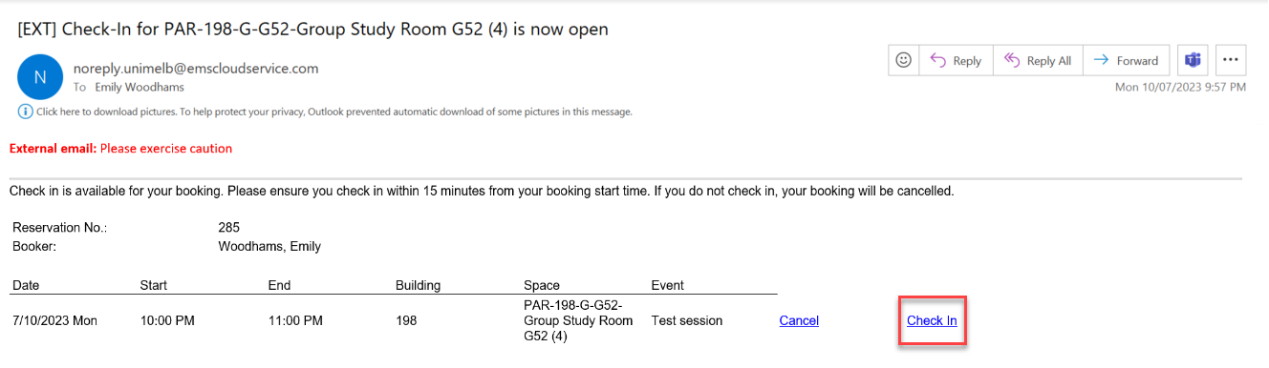

6.4 | Once you click on the Check In link in the email, you will be taken to DiBS and a pop-up notification will confirm that you have been checked in.  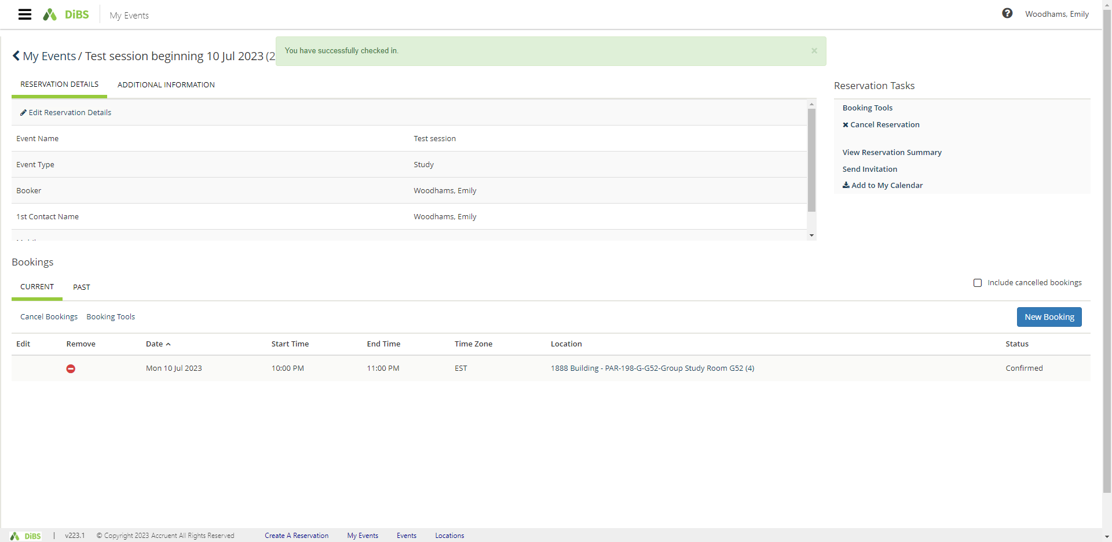
6.5 | You can also see that you have been checked in via the My Events section in DiBS.  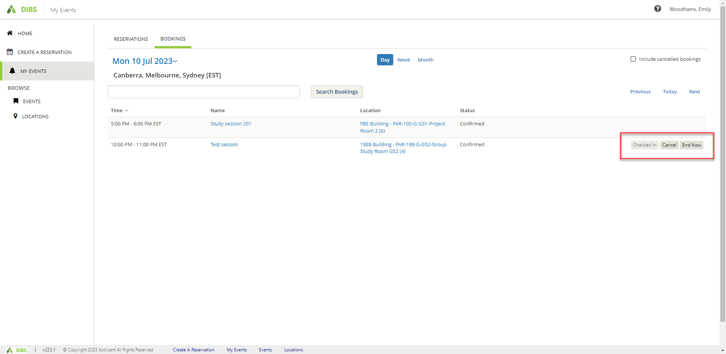

- Recurring bookings (Outdoor spaces and Law spaces only)
7.1 | Log in to DiBS and select the Law Building Template or Outdoor Space Template. Click Book now.  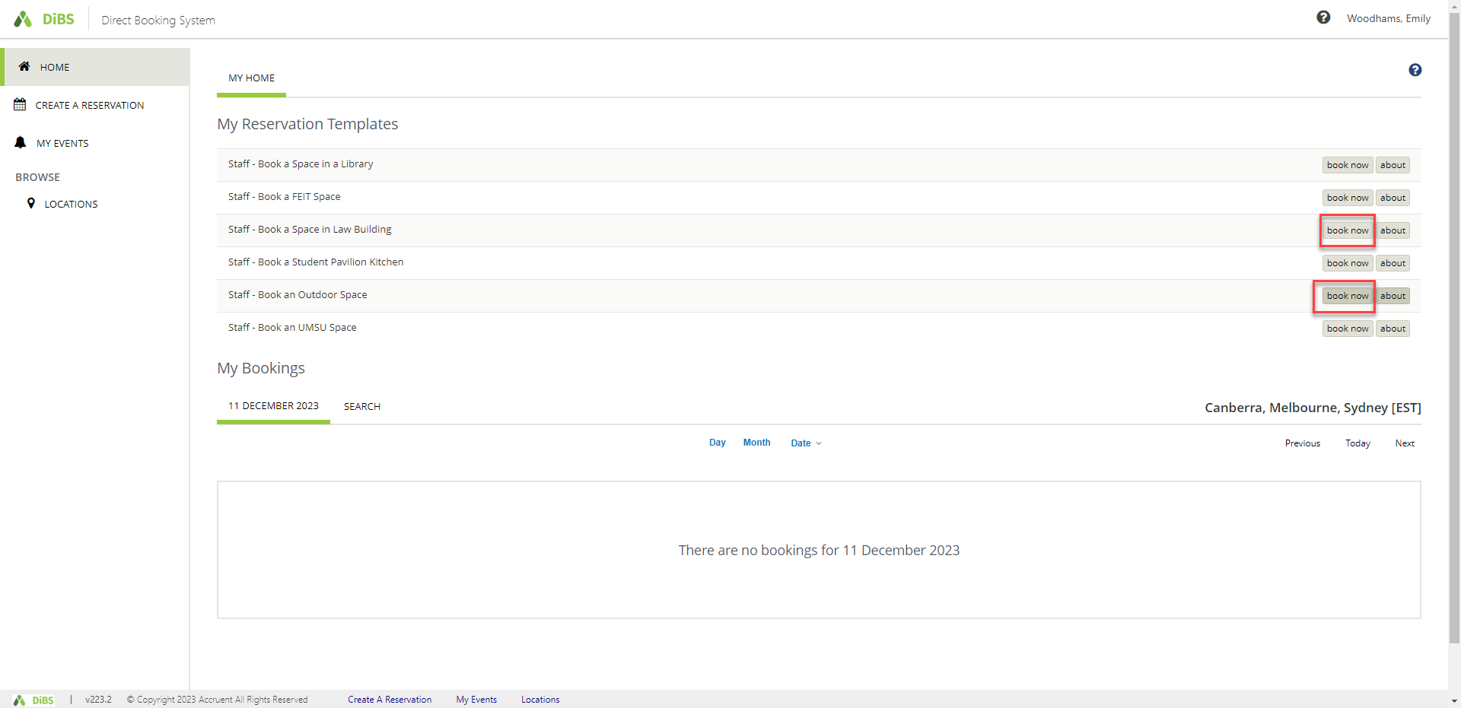
7.2 | Click the Recurrence button  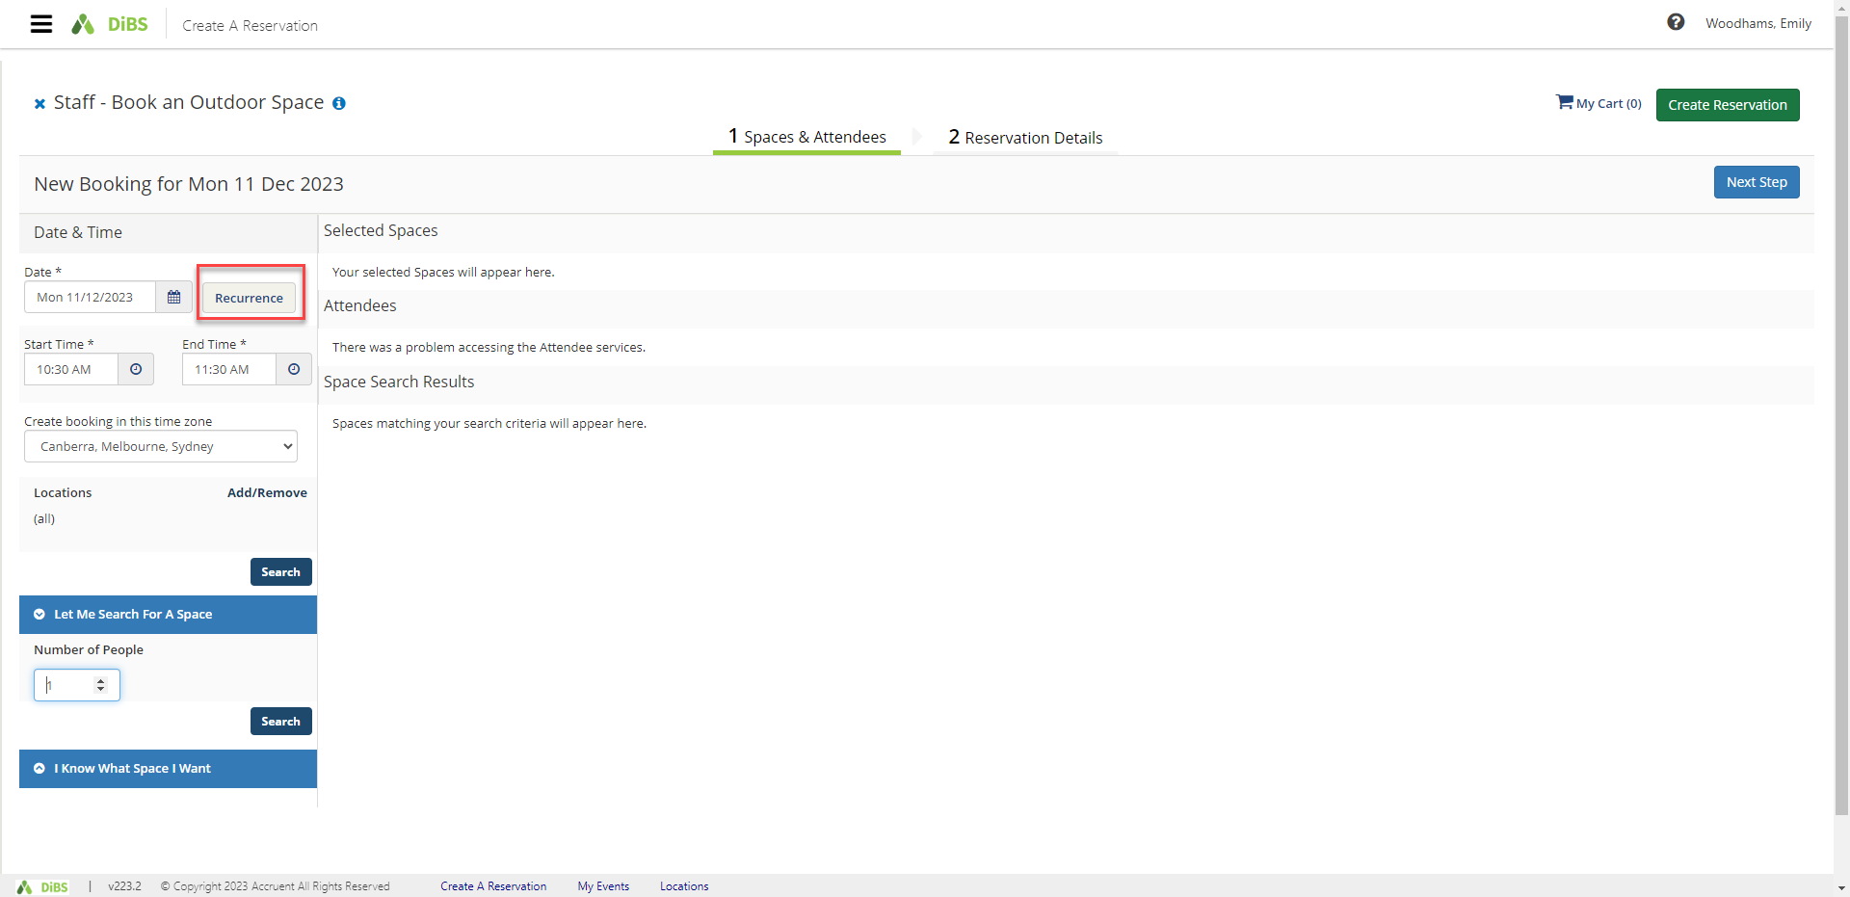
7.3 | Select the frequency of the booking (daily, weekly or monthly). You can choose a start and end date OR a number of occurrences. Click Apply Recurrence to find the available spaces.  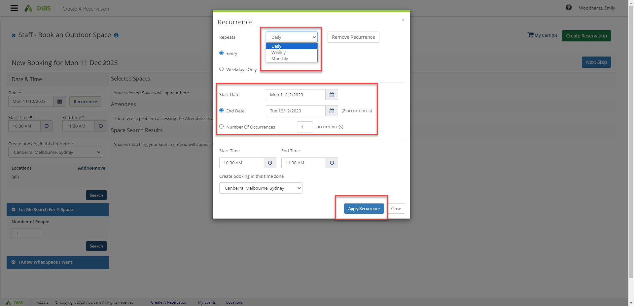
7.4 | Click on Location on the left-hand menu to find available spaces. A list of available spaces will appear, with the centre column of information showing how many times this space is available for your booking. (eg for a 5 x booking, the spaces that are available 5/5 are available for all the recurring bookings. Spaces that are available for only some of your bookings will appear as 4/5, 3/5 etc)  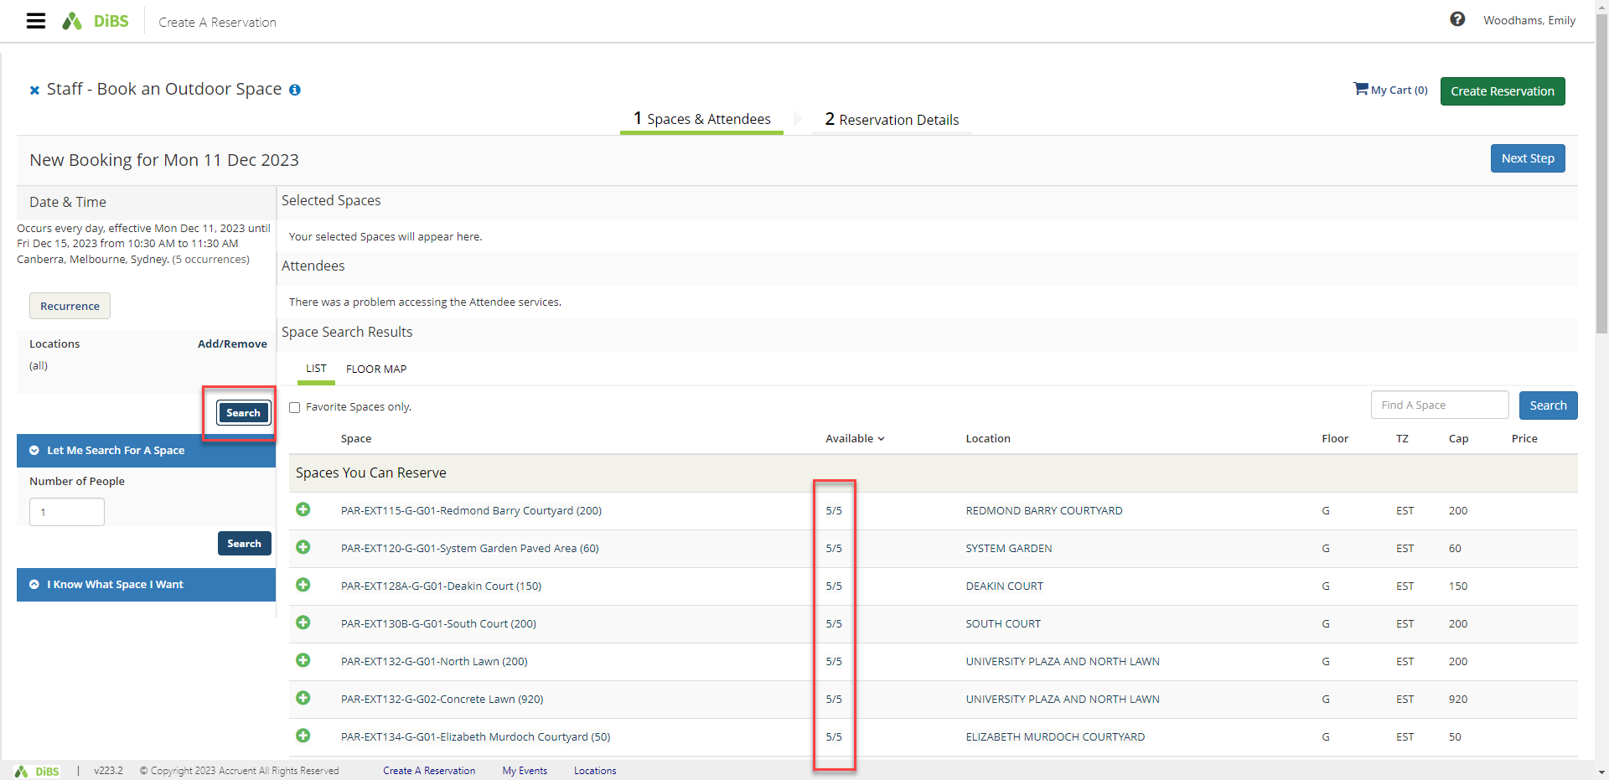
7.5 | Select the space you would like to book by clicking the green plus symbol and proceed with your booking as usual (see 2. Reserve a Space using ‘My Reservation Templates’).

