User Guide for Students
Direct Booking System (DiBS)

About DiBS
Direct Booking System (DiBS) is a cloud-based platform that allows staff and students to reserve a space on campus to meet, work and study.

What is changing?
Previously there were multiple different platforms used to book a space on campus, including Resource Booker and BookIT (for library spaces). We are gradually migrating the majority of campus spaces to DiBS, to give a consistent experience for staff and students.

When is it changing?
DiBS is expected to launch on 17 July, with bookings available from 24 July onwards.

What do I have to do?
Install the DiBS desktop client on your device and familiarise yourself with this User Guide, which covers the main functions of DiBS.

Where do I go for help?
If you need support using DiBS, please contact the following:
Visit https://studentit.unimelb.edu.au/ and chat with an IT support officer or log a request through https://unimelb.service-now.com/student
For support with library spaces, you can also speak to the Library Service Desk staff or Student IT staff.

Contents
1. Logging in 3
2. Reserve a space using ‘My Reservation Templates’ 4
3. Request a space using ‘My Reservation Templates’ 9
4. Browse for a space: to find a space that meets your requirements 11
5. Edit reservation details (eg Event name, Event type, Booker details) 17
6. Edit booking details (Location, Date and Time) 19
7. Cancelling a booking 23
8. Checking in 25

1. Logging in
1.1 | LOGGING IN:  You can access DiBS by opening a web browser and entering the following URL: https://go.unimelb.edu.au/dibs  You will see the Single sign on page below.
1.2 | Once you have logged in with your username and password, you will be taken to the homepage.  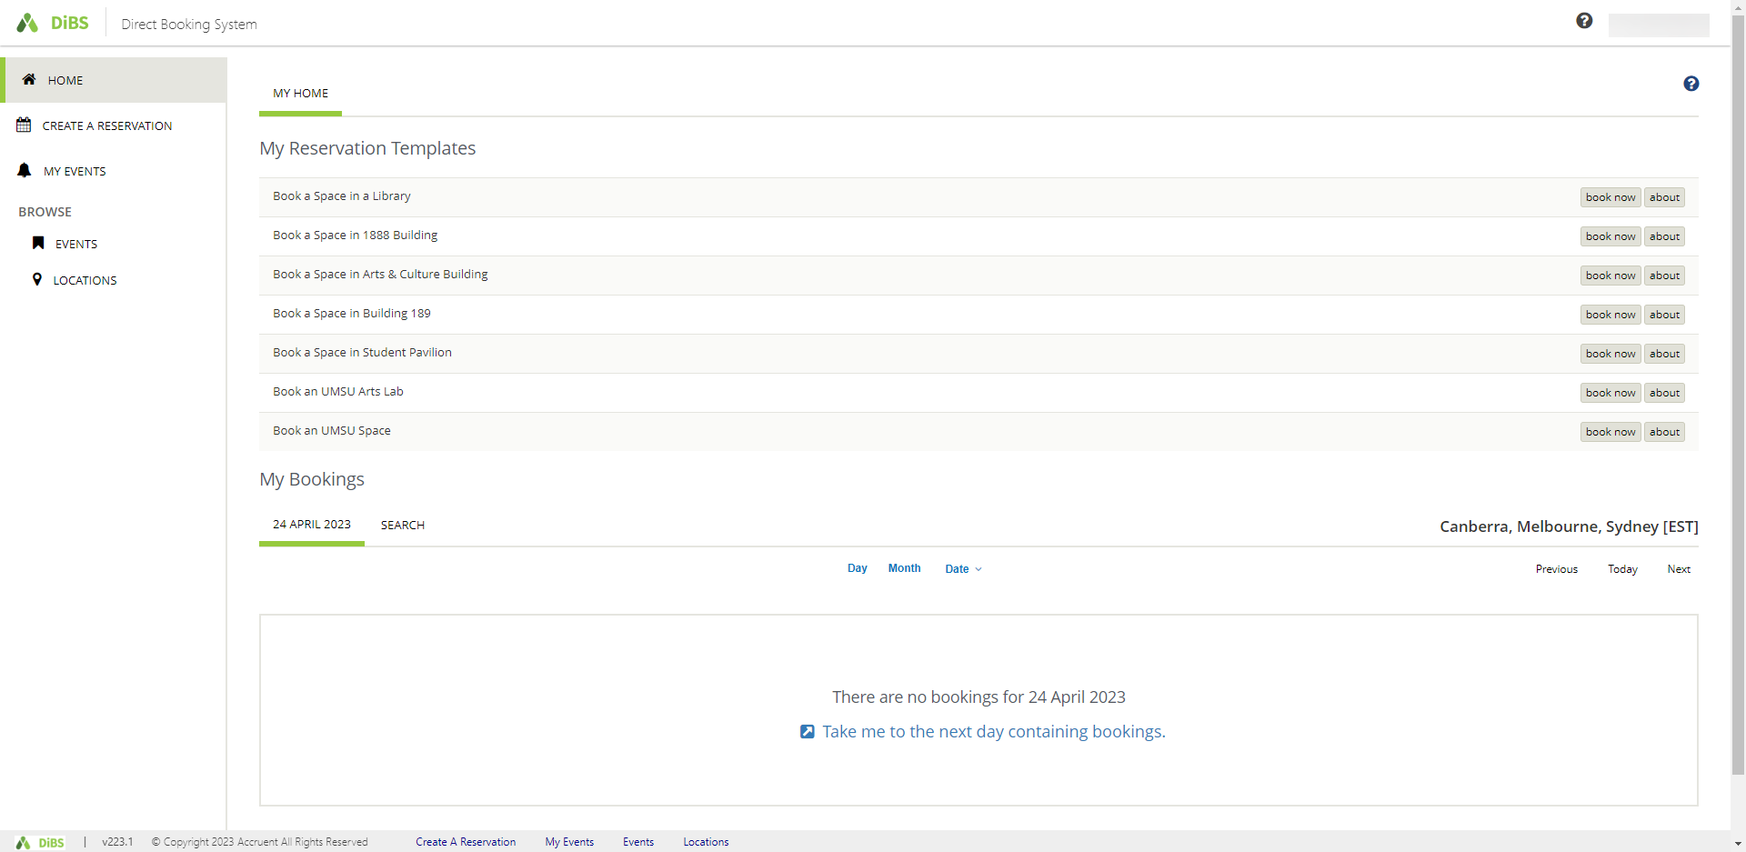

2. Reserve a space using ‘My Reservation Templates’
2.1 | To reserve a space using My Reservation Templates, click on the Book Now button for the  building in which you wish to book.  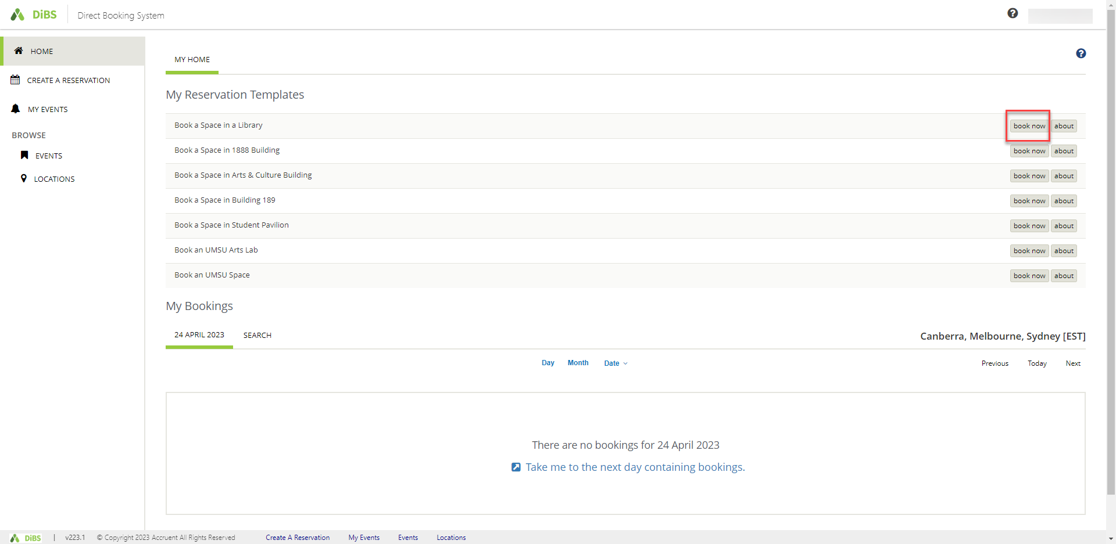
2.2 | Alternatively, you can click on the About button to find out the rules for booking a space with this template.  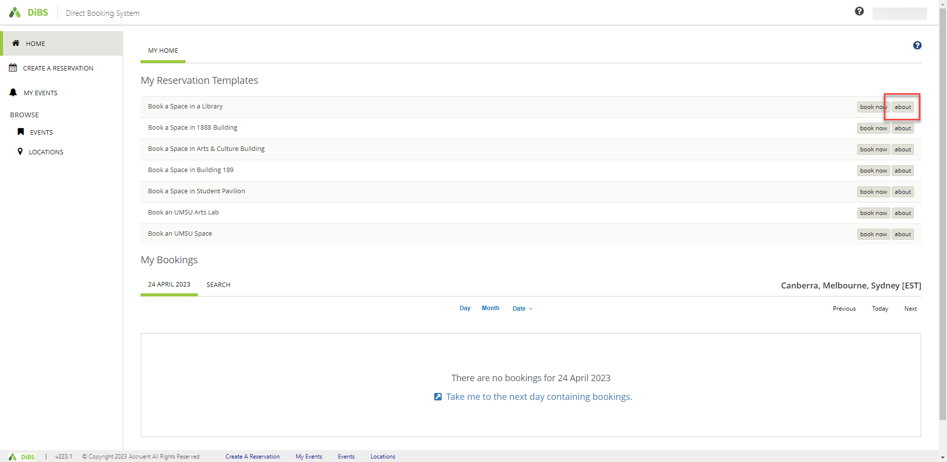

2.3 | When you click on About, the rules for the template are displayed. Select Book Now With This Template to proceed with your booking.  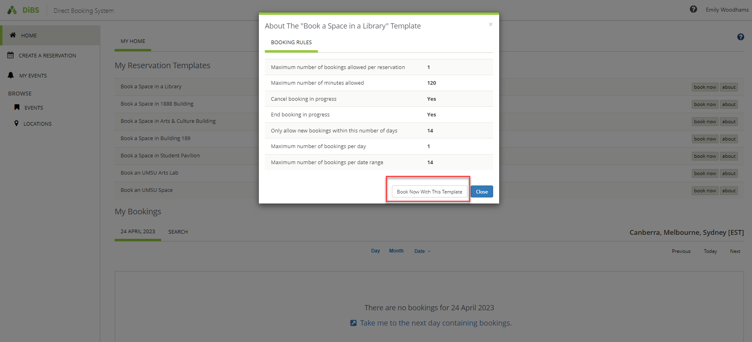
2.4 | When you click either of the Book Now buttons, you are taken to the New Booking page. Select the date, start time and end time for your booking. You can also narrow the search to a particular building if you wish.  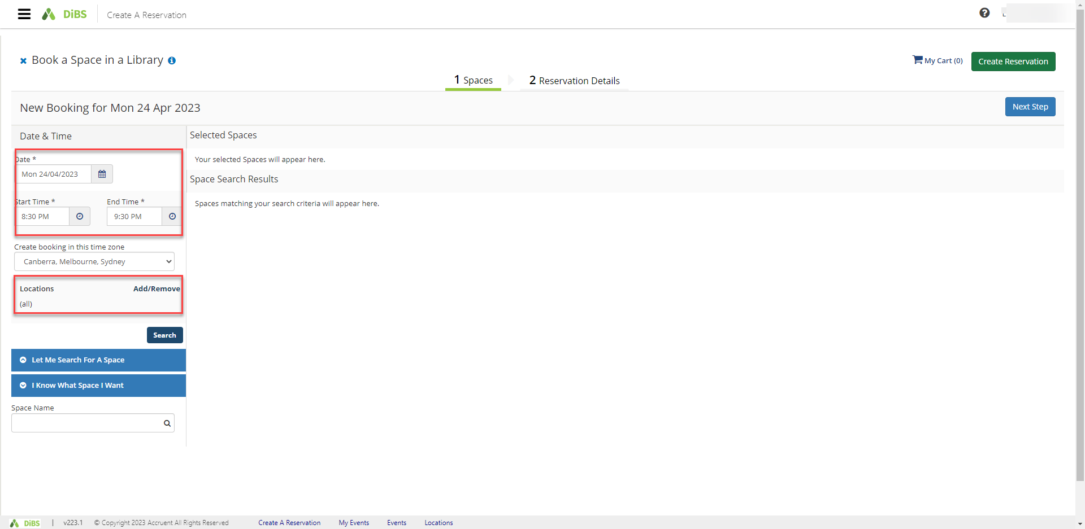

2.5 | Once you hit Search, available spaces for your chosen date and time appear in a list view automatically.  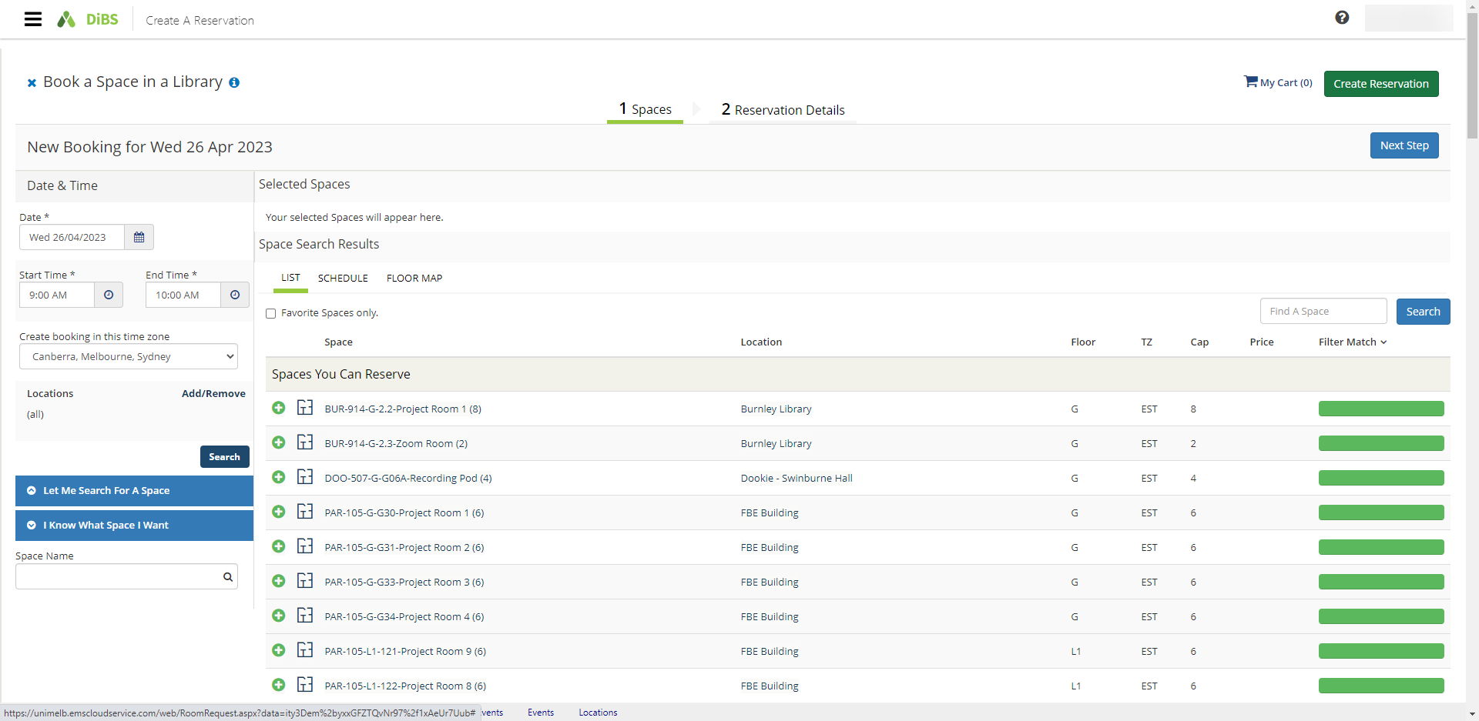
2.6 | You can also choose to view the available rooms by Schedule view or Floor Map view.  Schedule view:  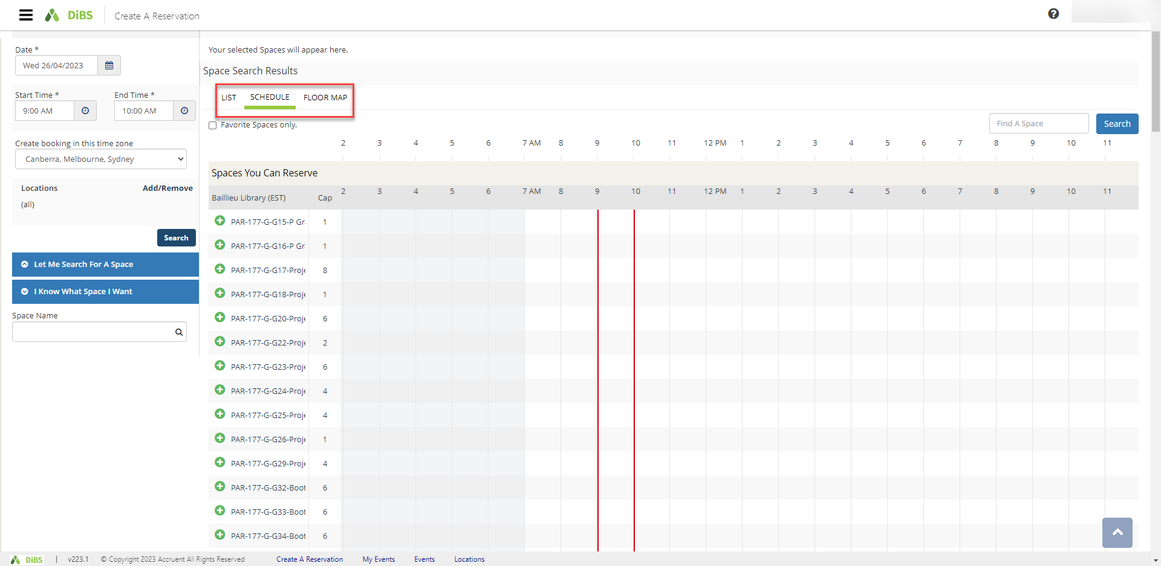  Floor Map view: (you must select a floor and building for this view)  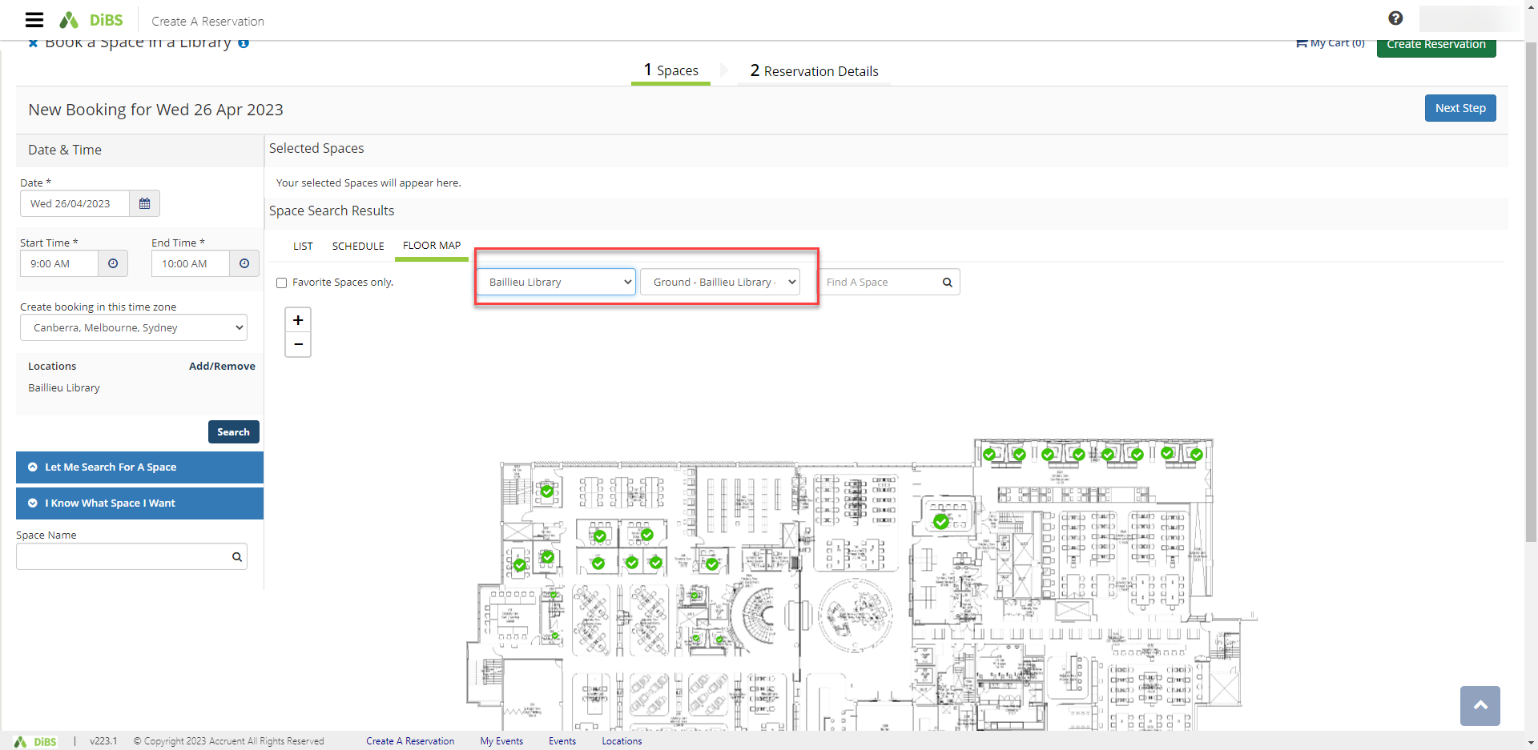
2.7 | Select the room you would like to book. Click the plus button (green and white).  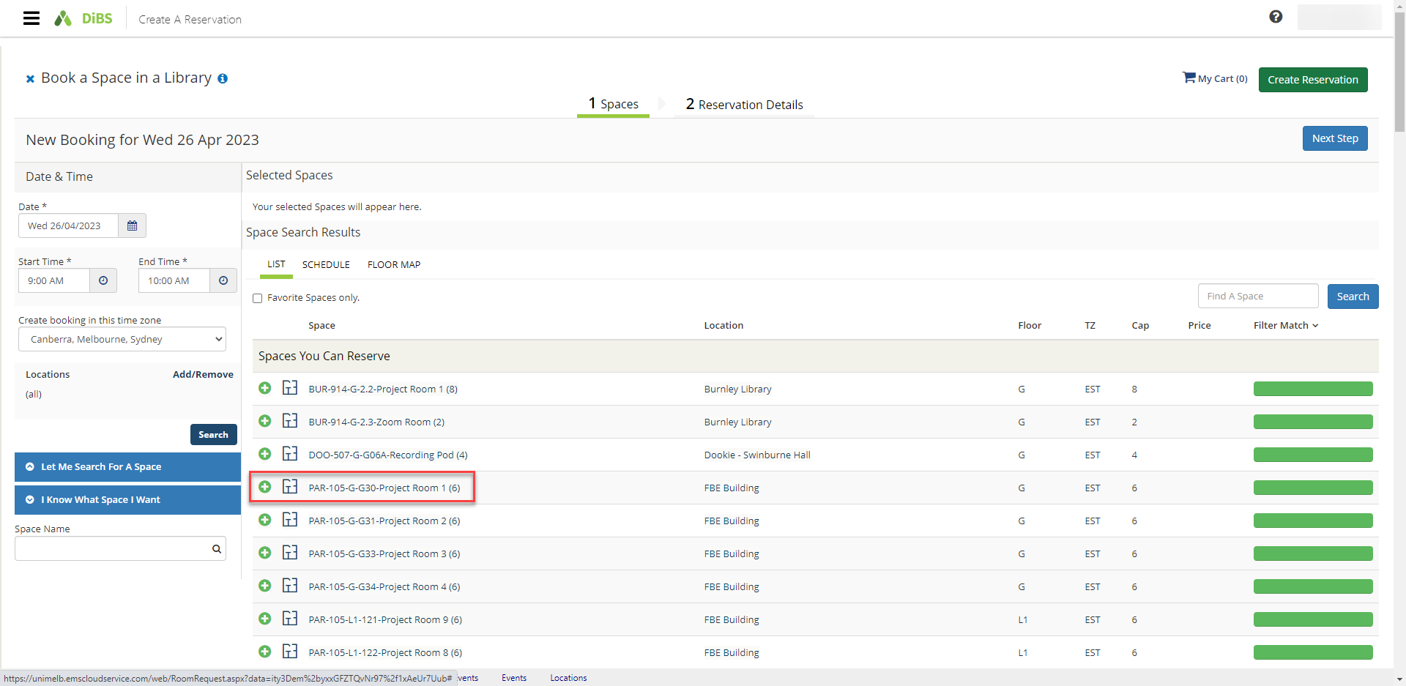
2.8 | Enter the number of attendees and click Add Space  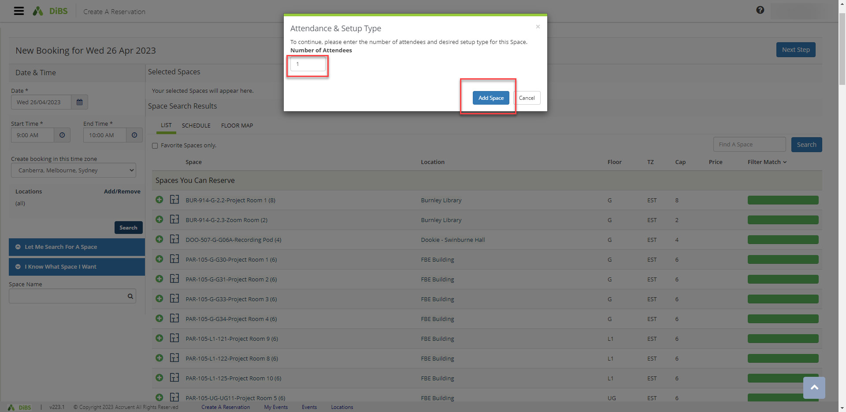
2.9 | Selected room has now turned red (unavailable). Proceed to click Next Step.  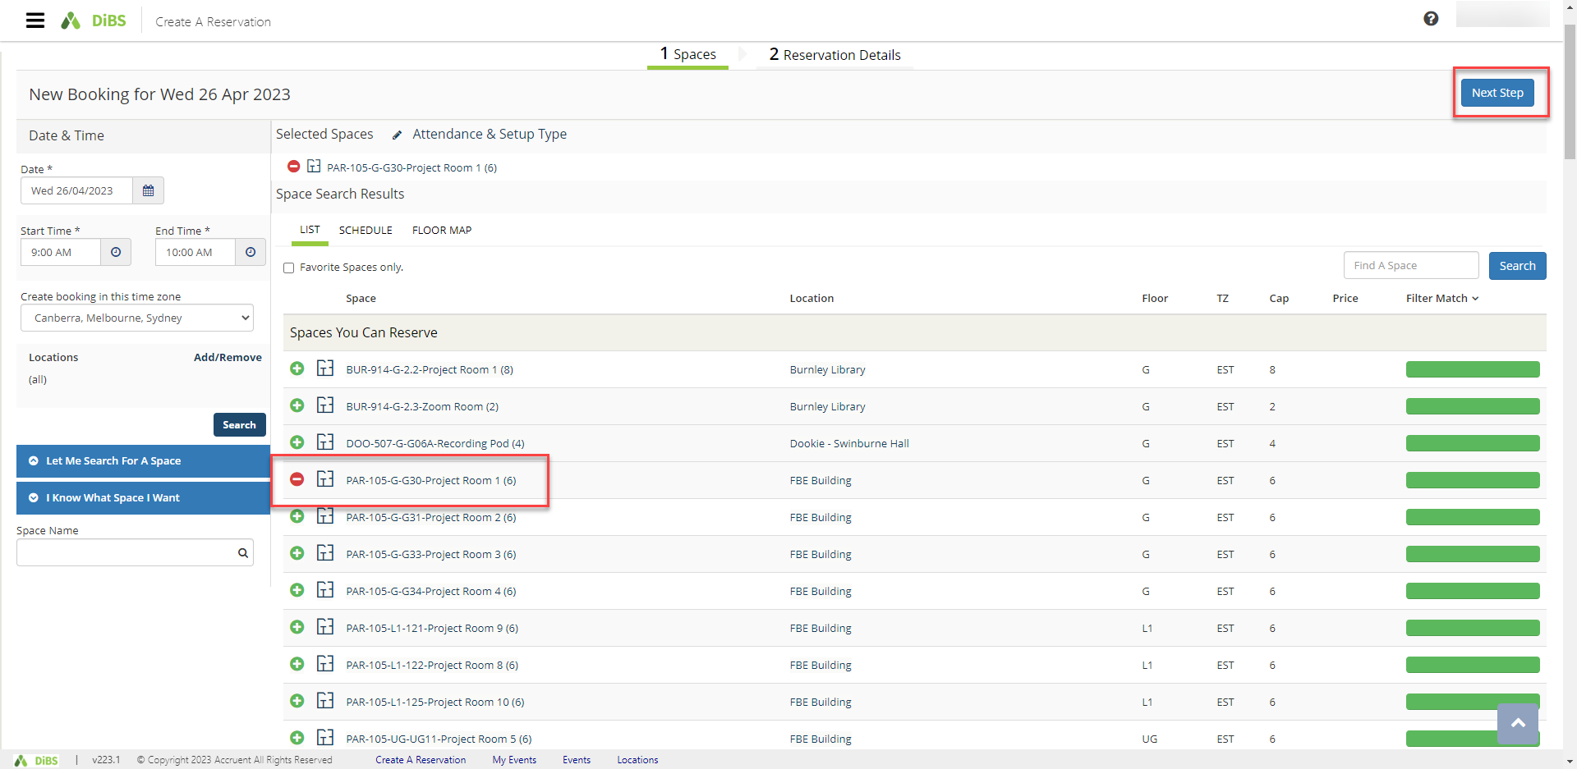
2.10 | On the Reservation details screen, enter Event Name, select Event Type from the drop down menu, confirm your contact details and confirm that you agree to the Terms and Conditions. The click Create Reservation.  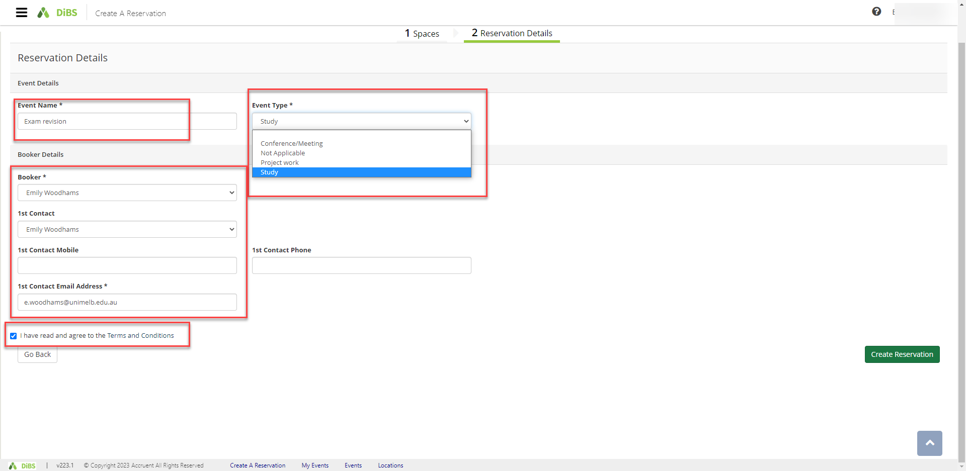
2.11 | Your booking is confirmed. An email notification will be sent to your nominated email address within a few minutes.  Email notification:

2.12 | Your booking will appear under My Events  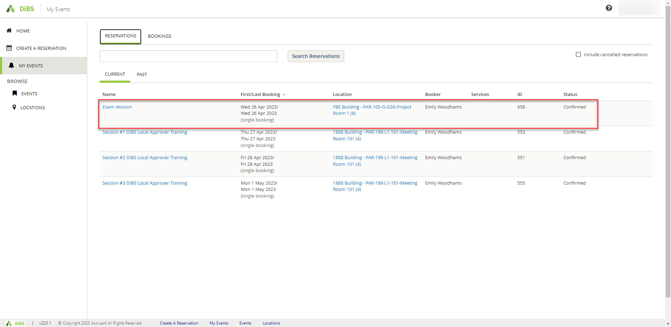

3. Request a space using ‘My Reservation Templates’

3.1 | Some booking requests must be approved my local administrators before your booking is confirmed. If the space you would like to book requires approval, it will be indicated as a Space You Can Request.  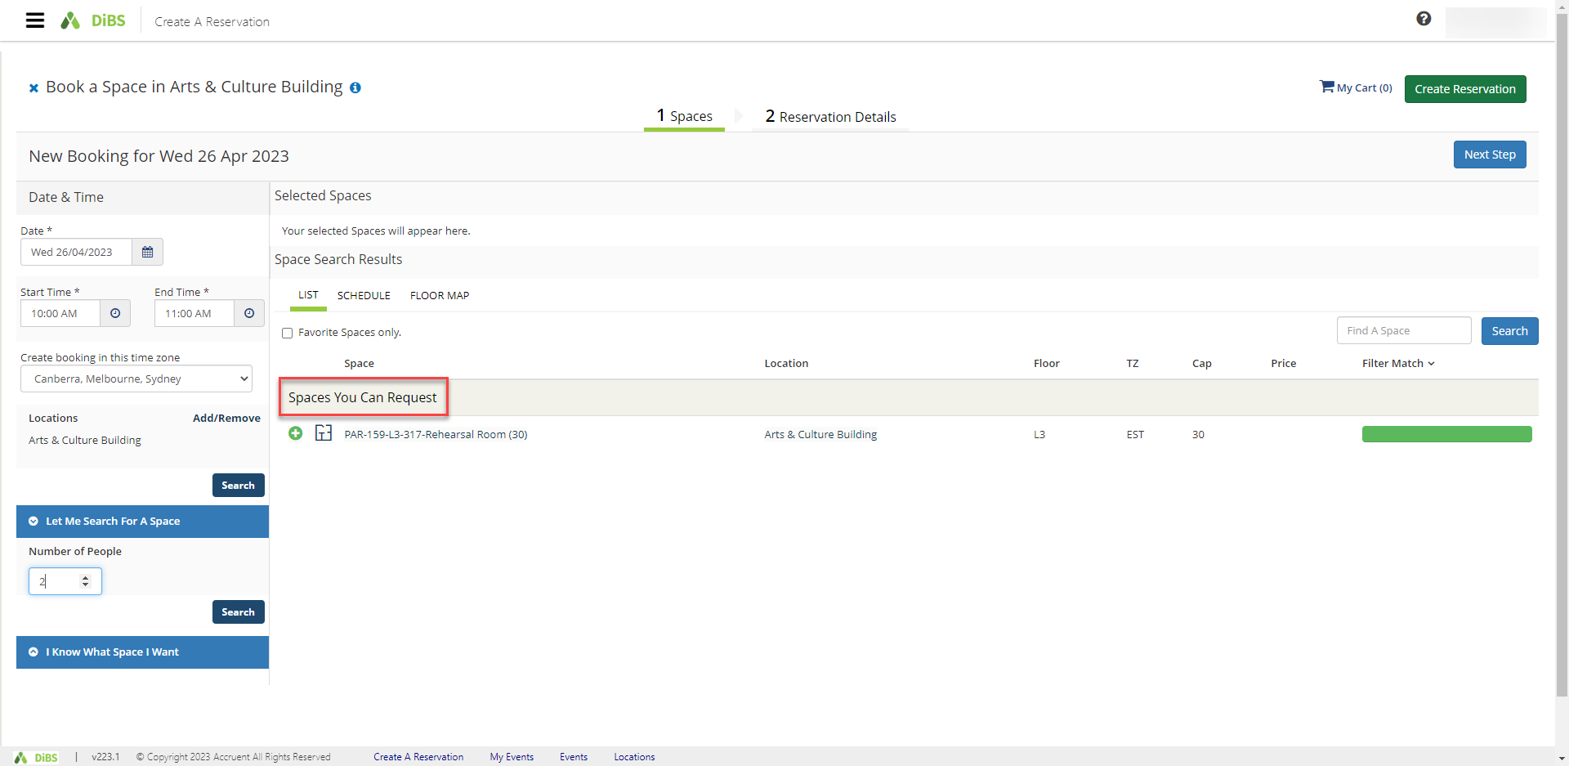

3.2 | To book a space that requires approval, proceed as per 2. Reserve a space using ‘My Reservation Templates’. On the booking details page, you may be required to provide extra information for the approver.  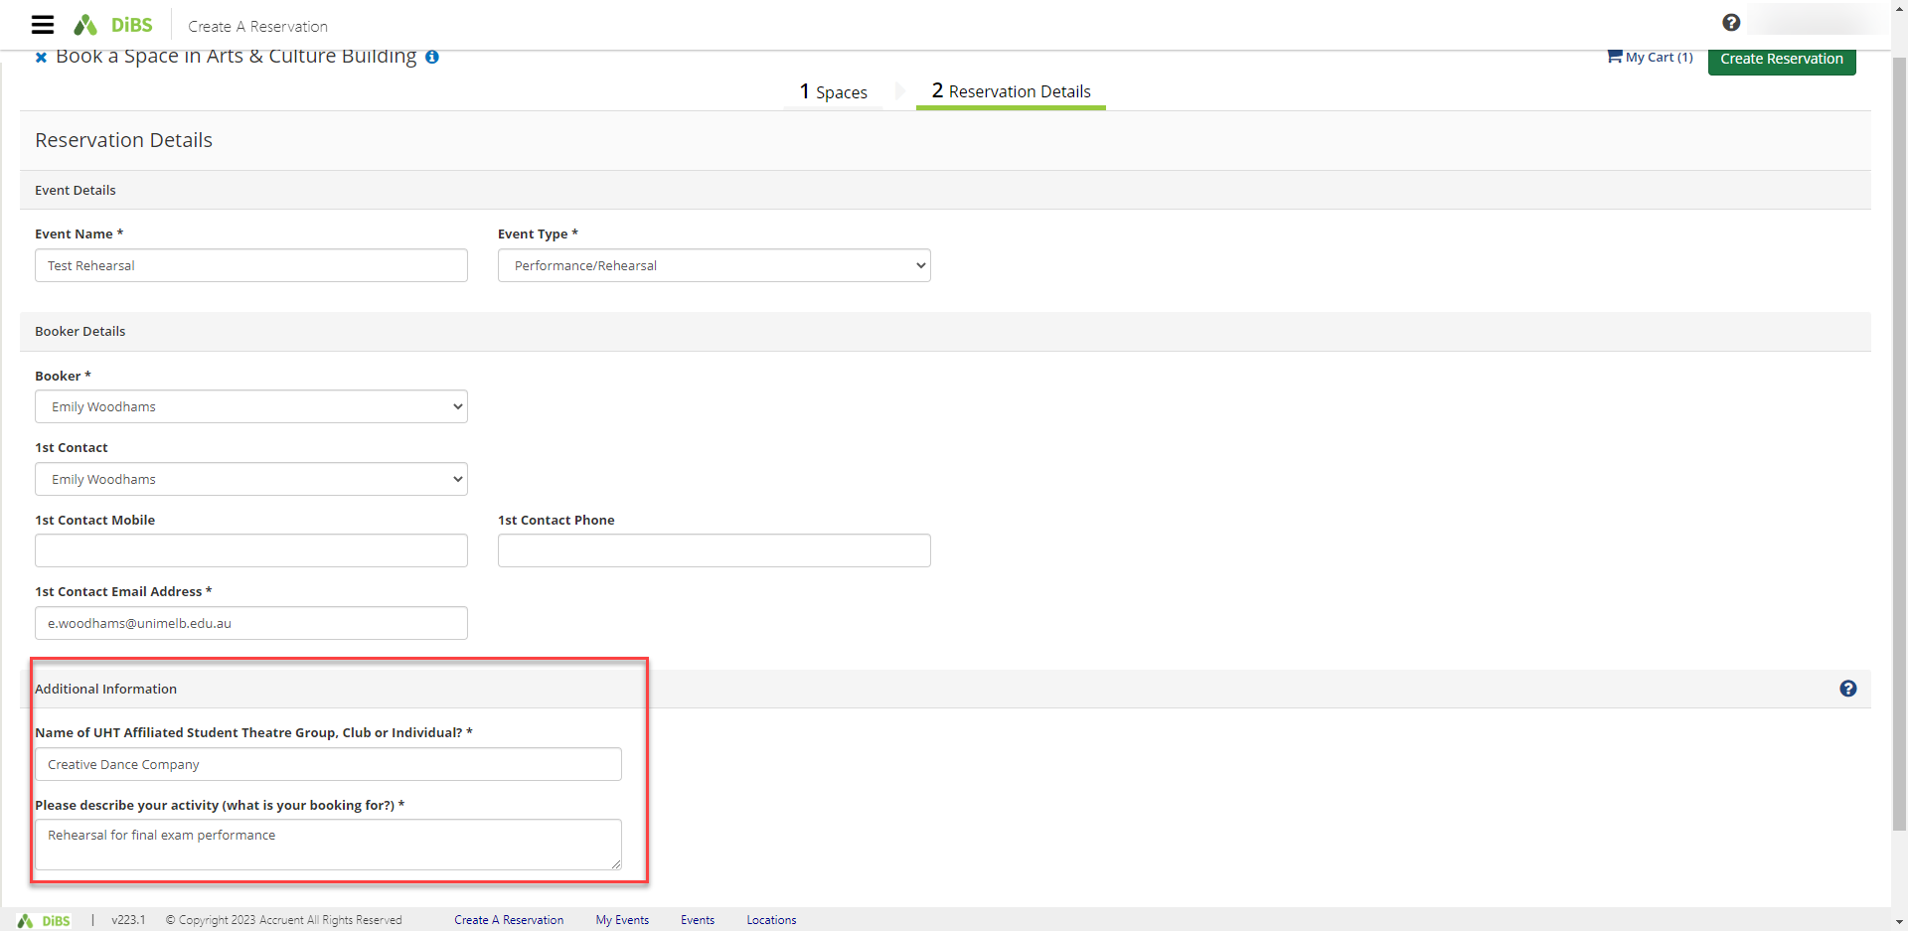
3.3 | Click Create Reservation and the request will be sent through to the appropriate local administrator.  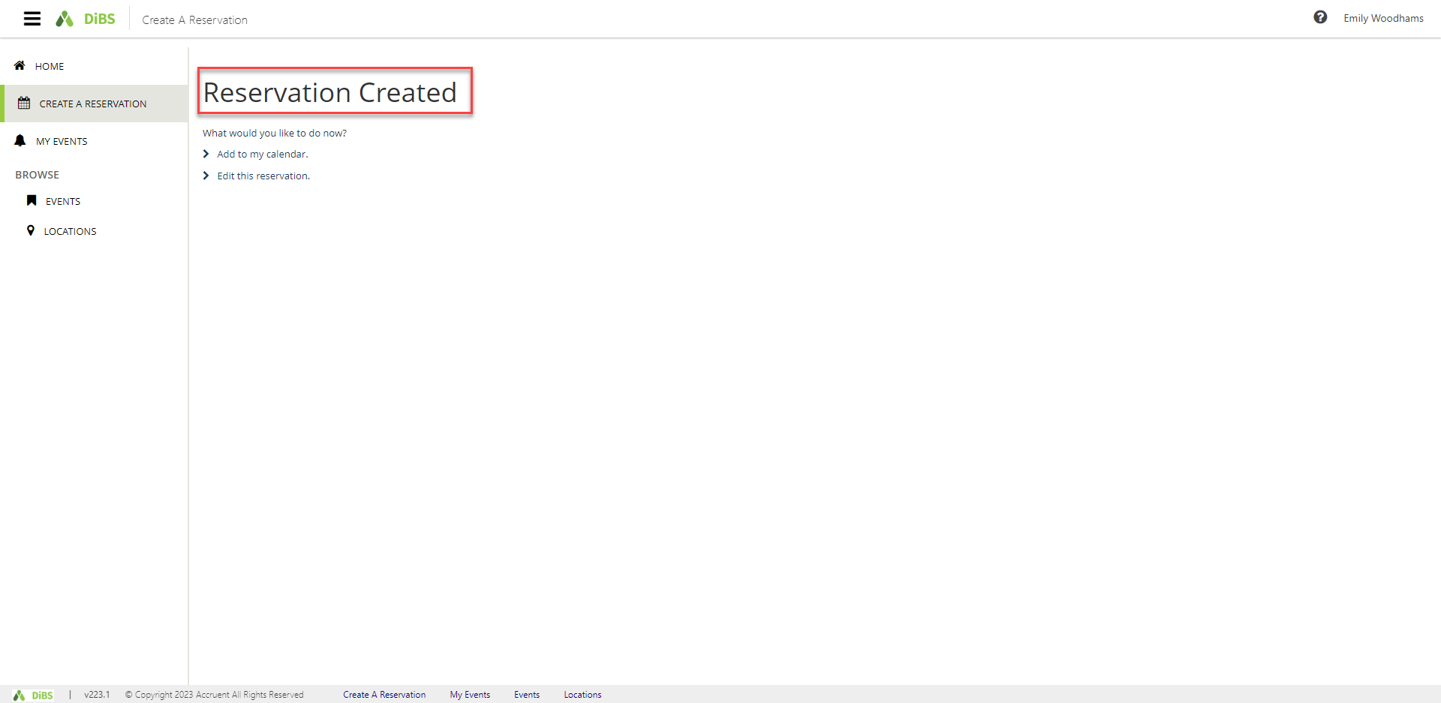  Under My Events, your booking will appear as ‘Requested’ until approved or rejected by the administrator.  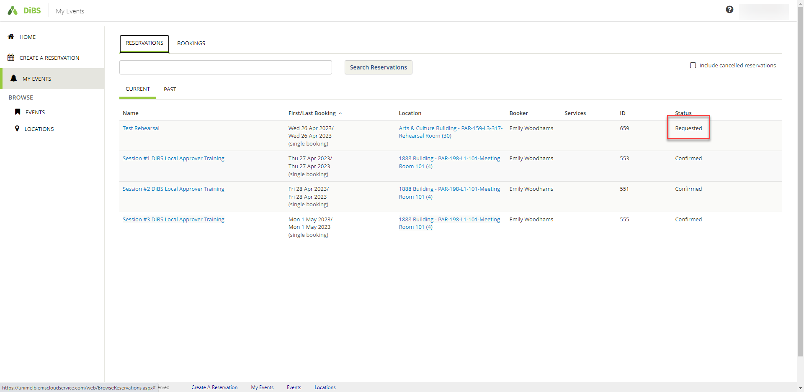
3.4 | Once your request has been approved or rejected by the local administrator you will receive an automated email notification.

- Browse for a space: to find a space that meets your requirements
4.1 | To search for a space by location, date or feature, navigate to the Browse function on the left-hand menu. Select Locations and filter your results by specific building, or characteristics such as capacity, features, space types etc.  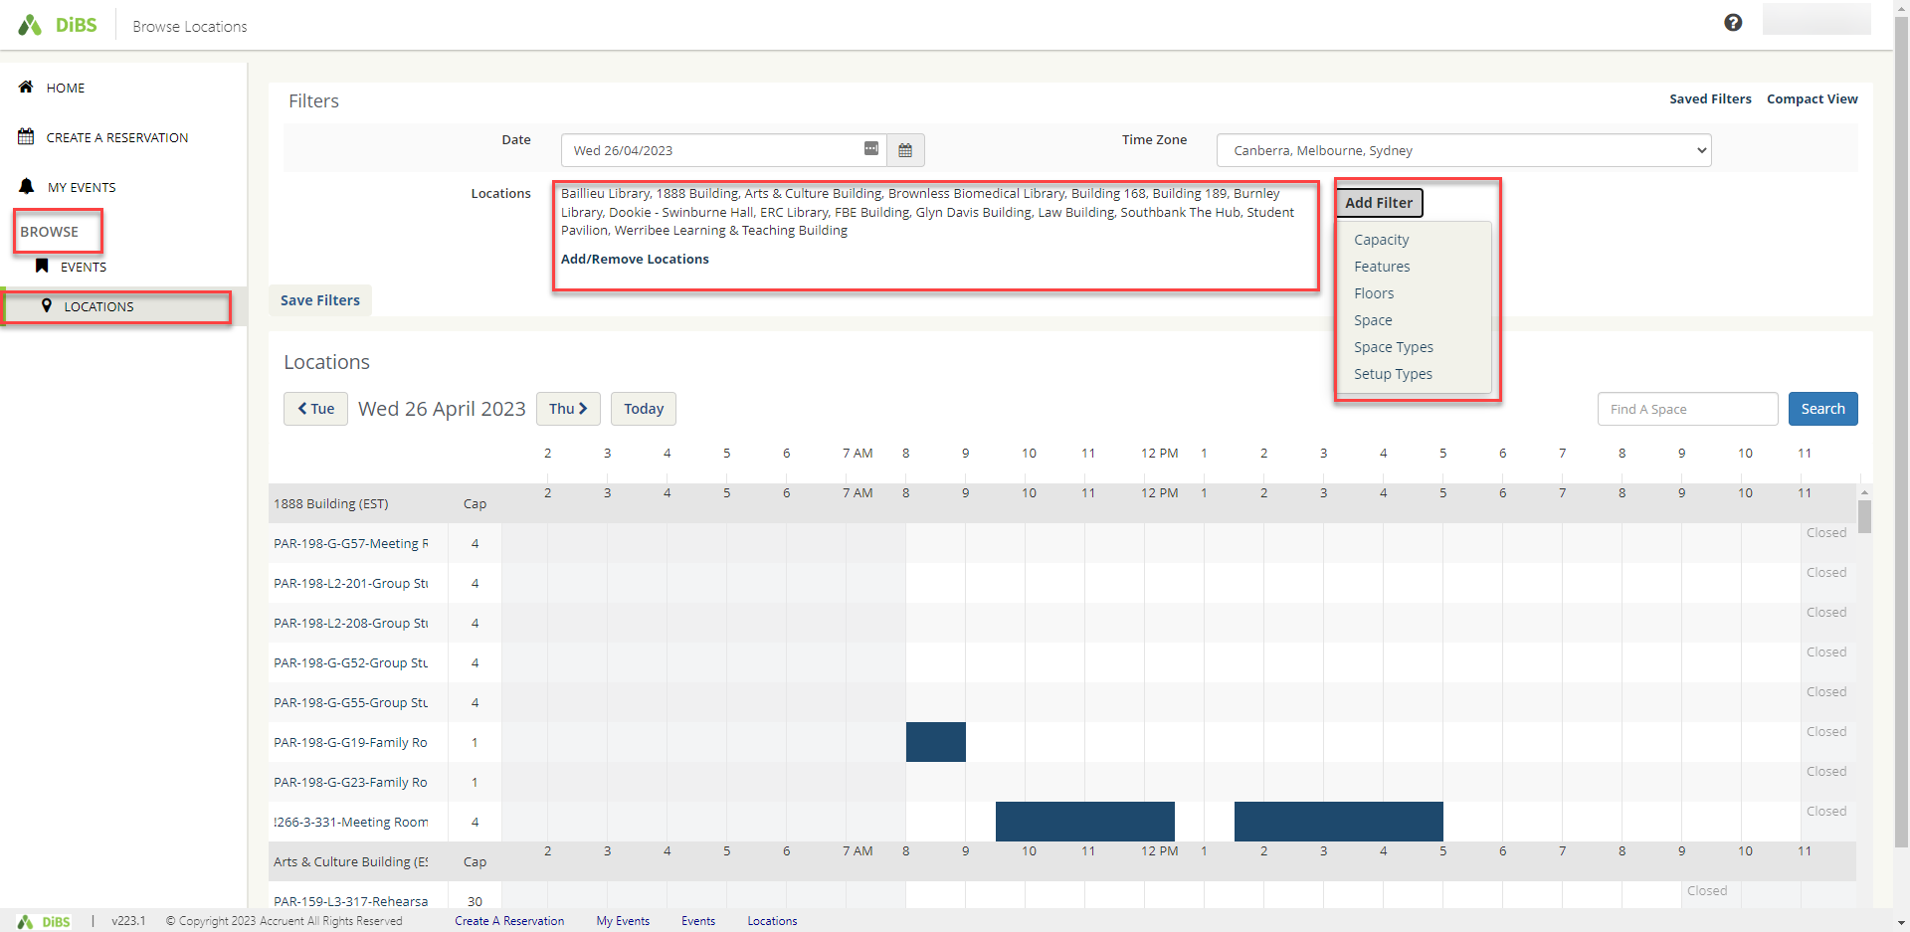
4.2 | Add filters and tick the options you require in your space.  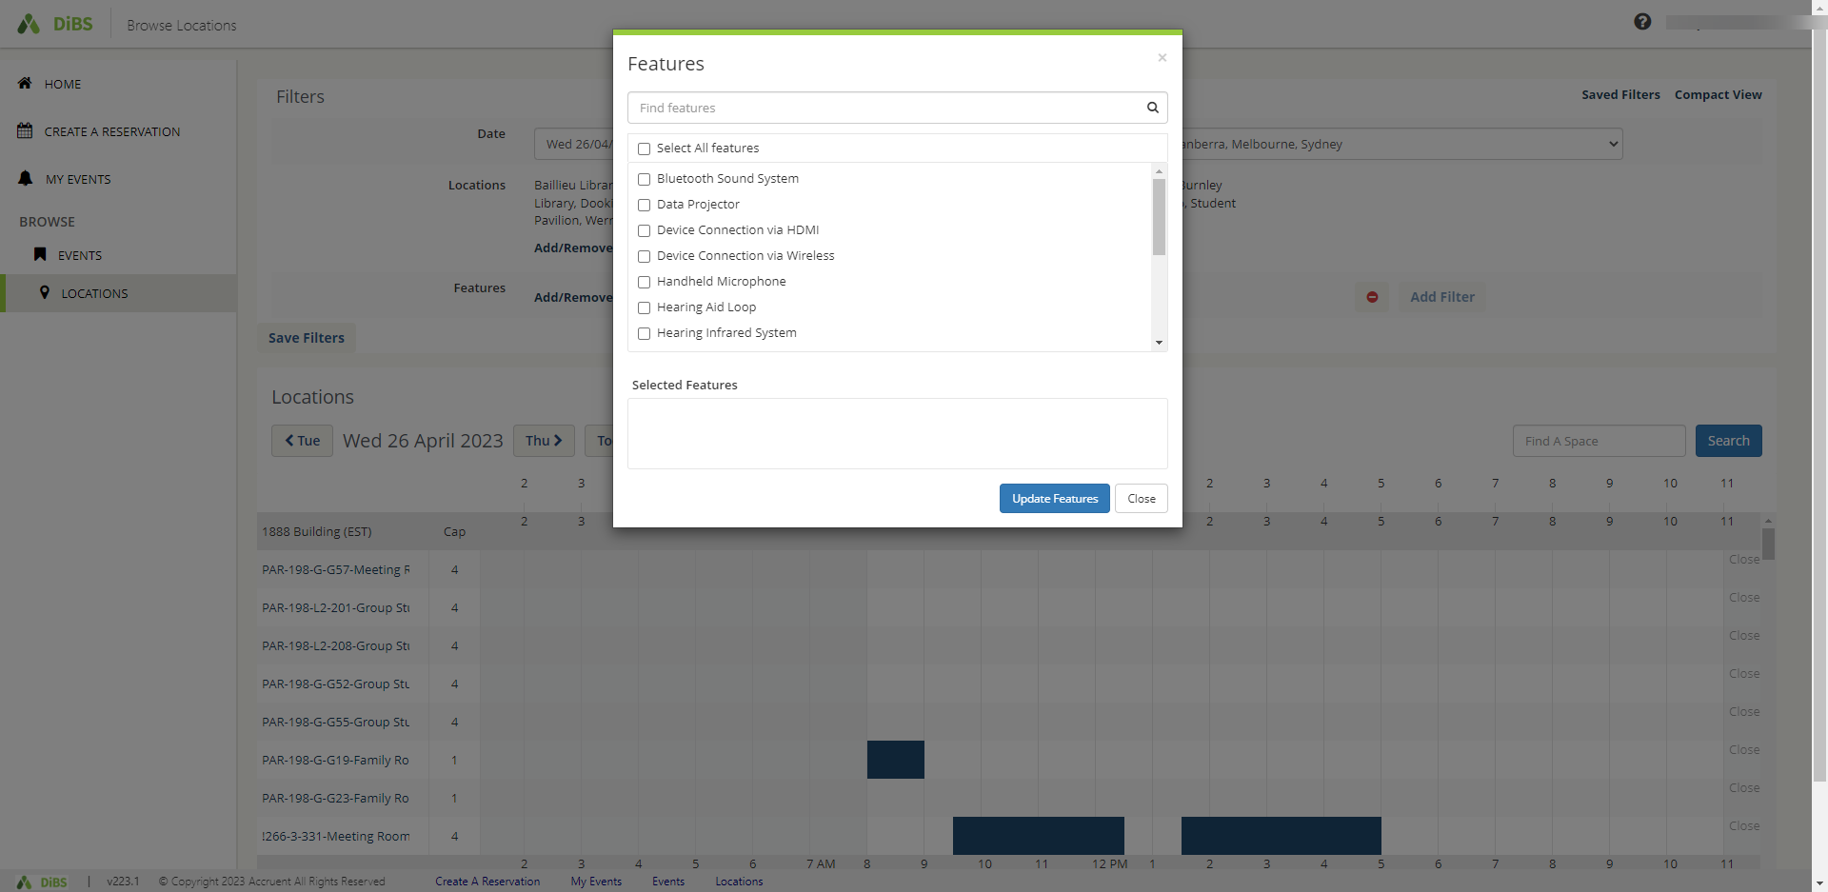
4.3 | Scroll down to see all available spaces that meet your requirements.  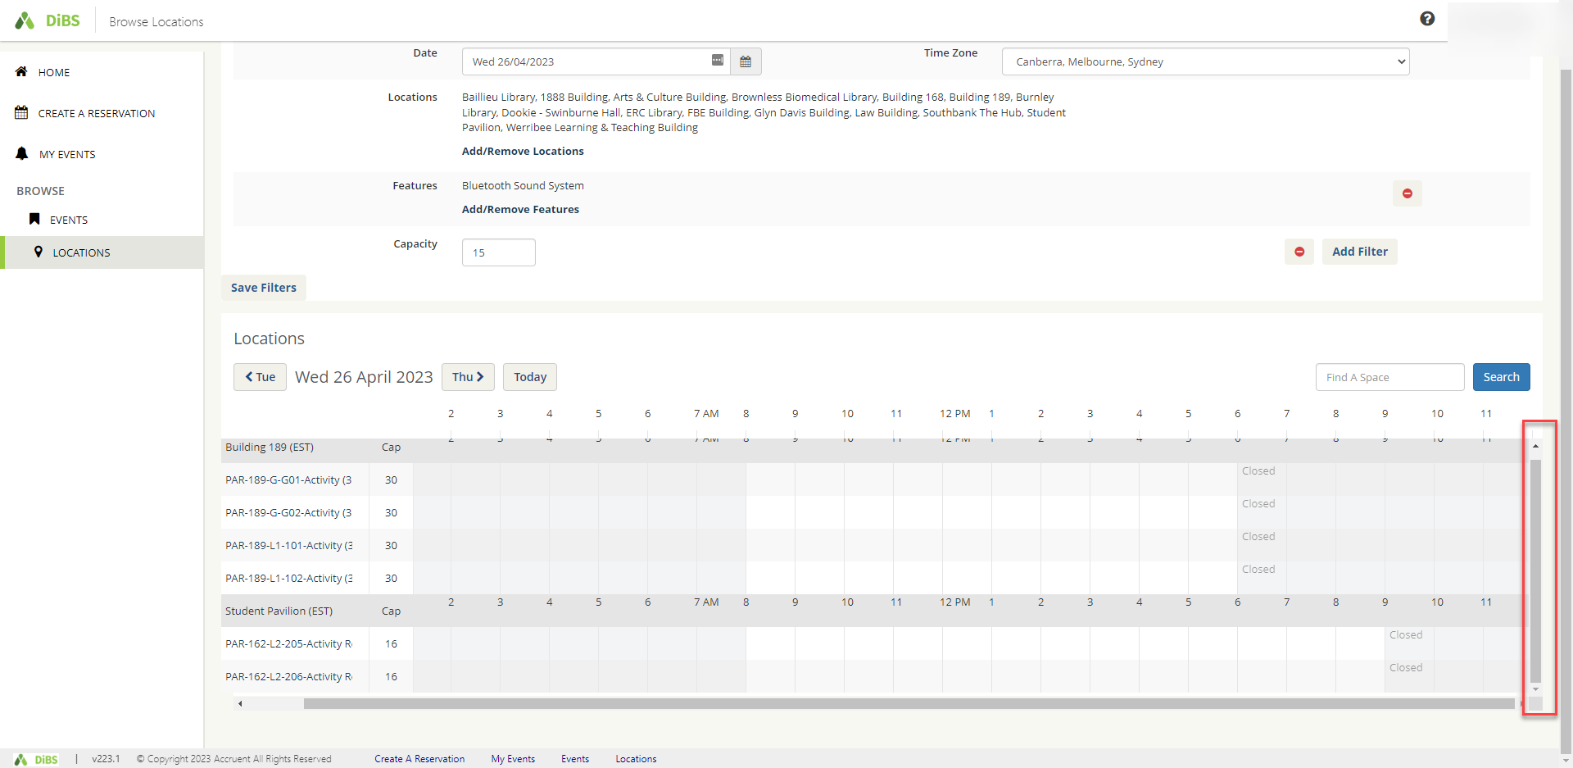
4.4 | Click on a room name to view information about the room.  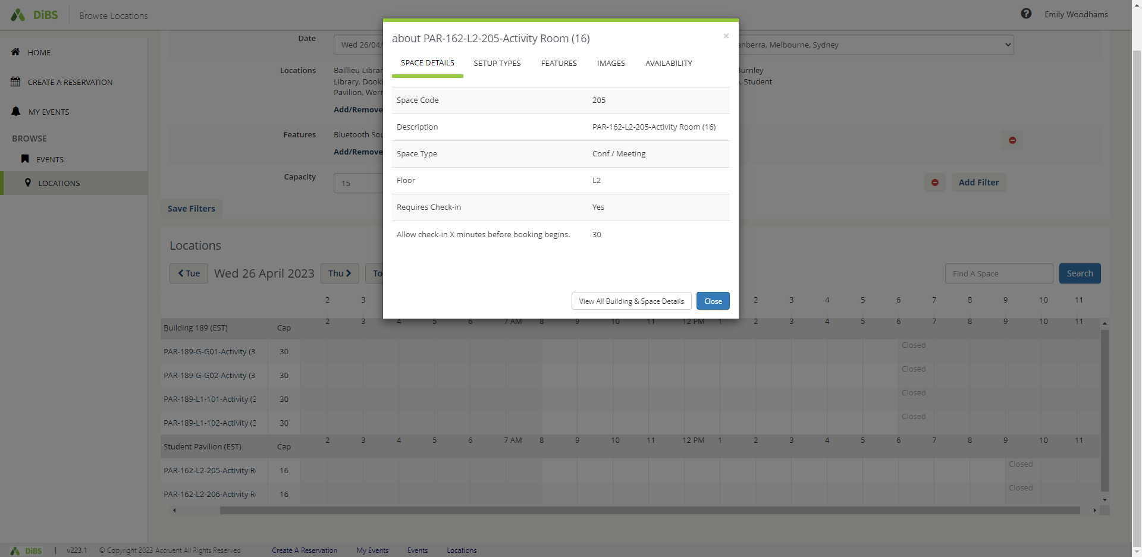

4.5 | Save the filters you have chosen for future booking searches if you wish.  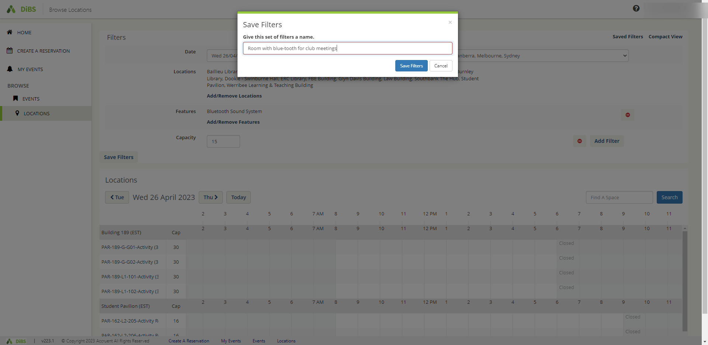
4.6 | To make the booking in your chosen space, click on the cell that corresponds to your preferred space and start time. A pop up will appear, asking you to nominate the start and stop times for your booking. Click continue.  #Note: You can only click on a cell with a future start time.  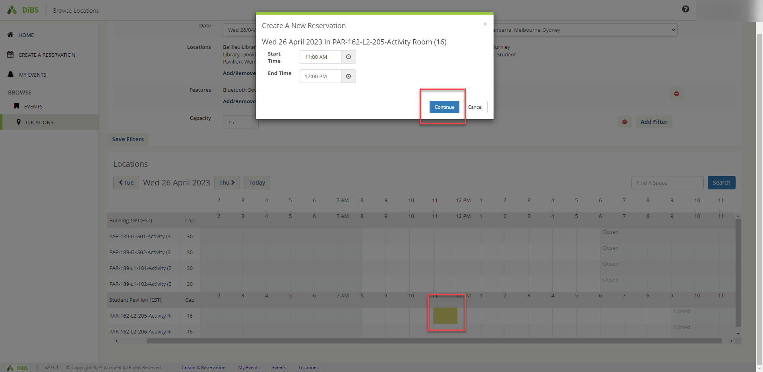
4.7 | You will be taken to the Reservation details page for that space. Click on the green and white plus to add the space to your booking.  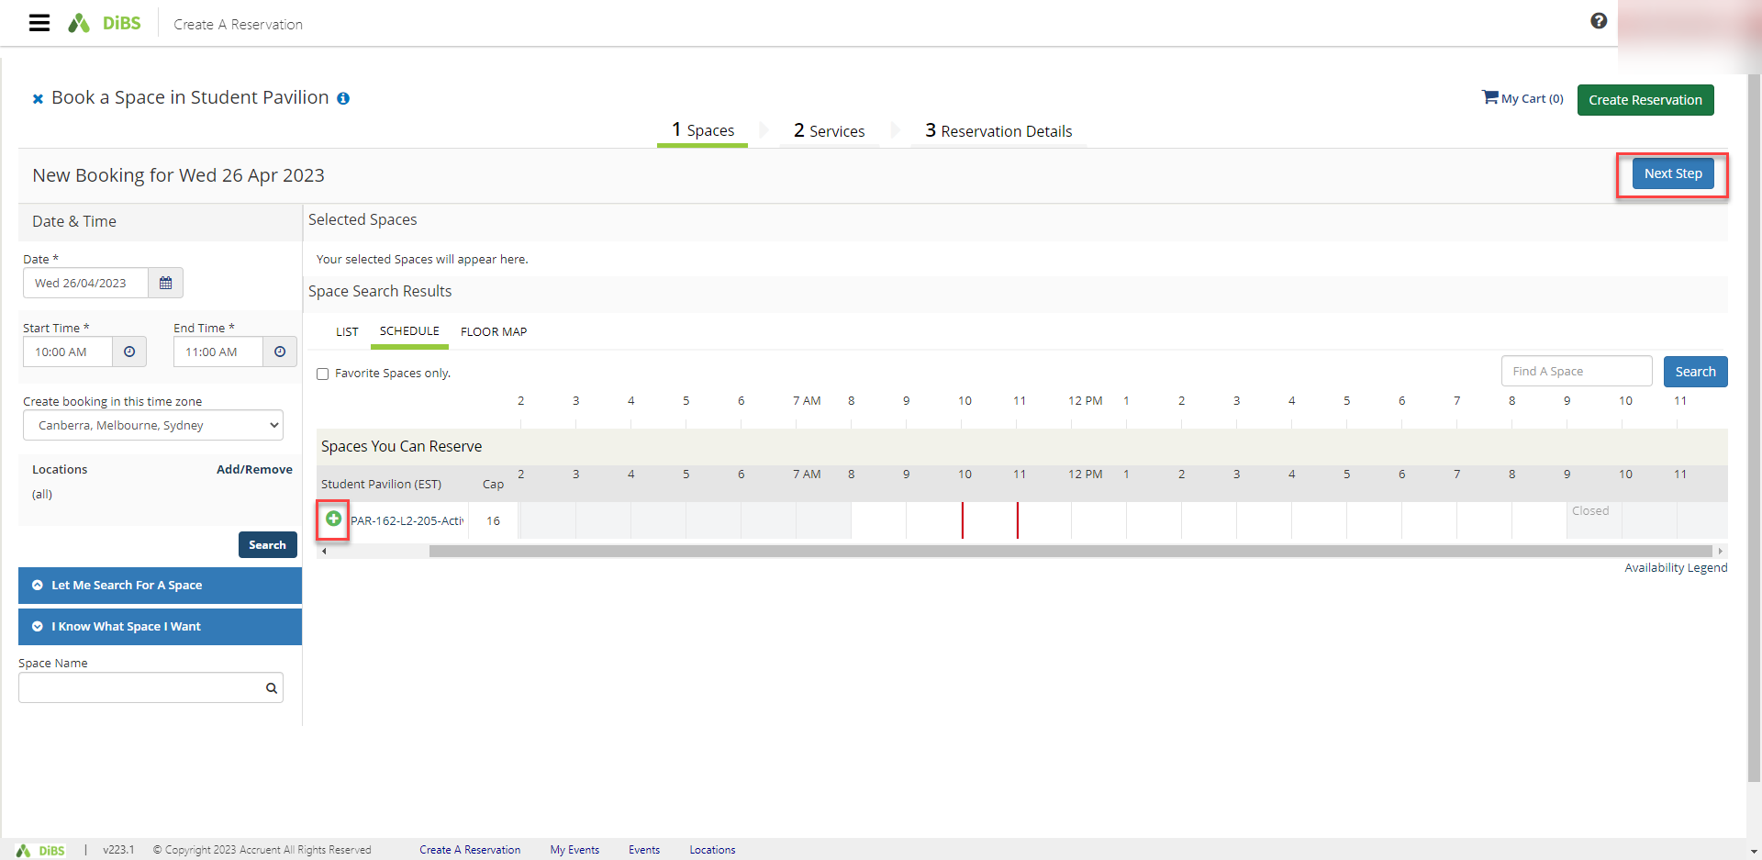
4.8 | Once the space has been added to your booking, continue to book as per standard booking process by clicking Next Step.  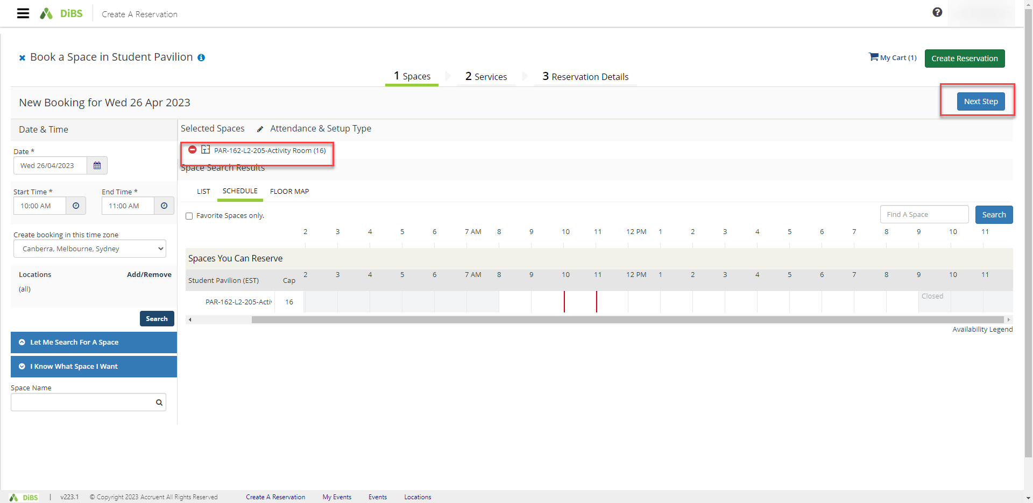

4.9 | If the space you are booking has additional services available such as booking a Mobile TV screen, these will be included in the booking process.  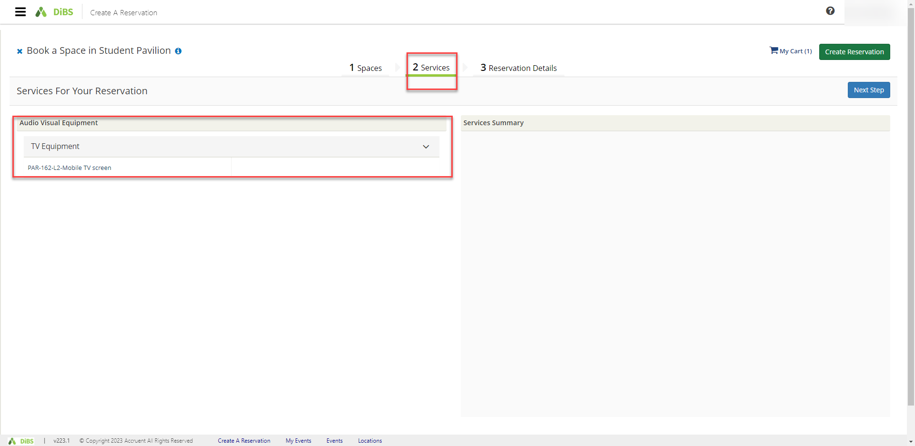  Click on the Service to include it in your booking. Click OK.  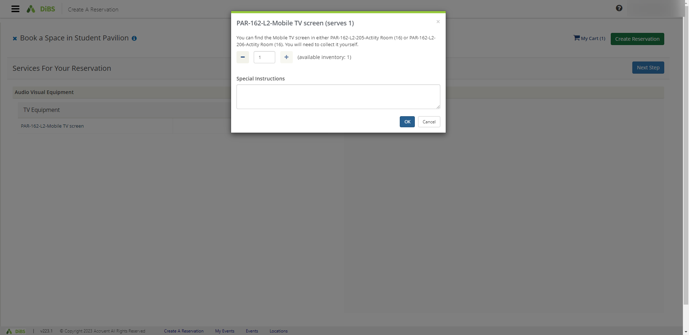  The service will be added to your booking under Services Summary. Click Next Step to proceed with your booking by completing the Reservation details (see 2. Reserve a Space using My Reservation Templates).  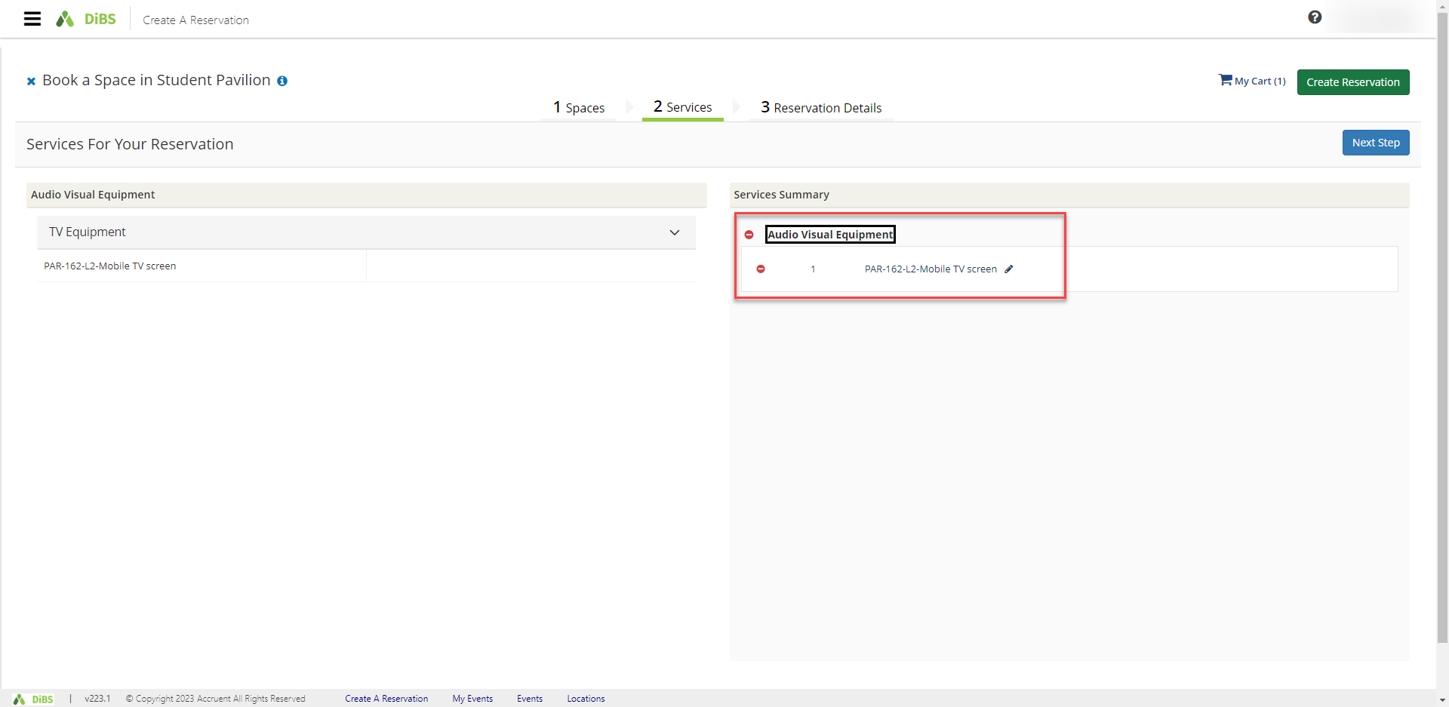
4.10 | The booking is complete and an email notification will be received.  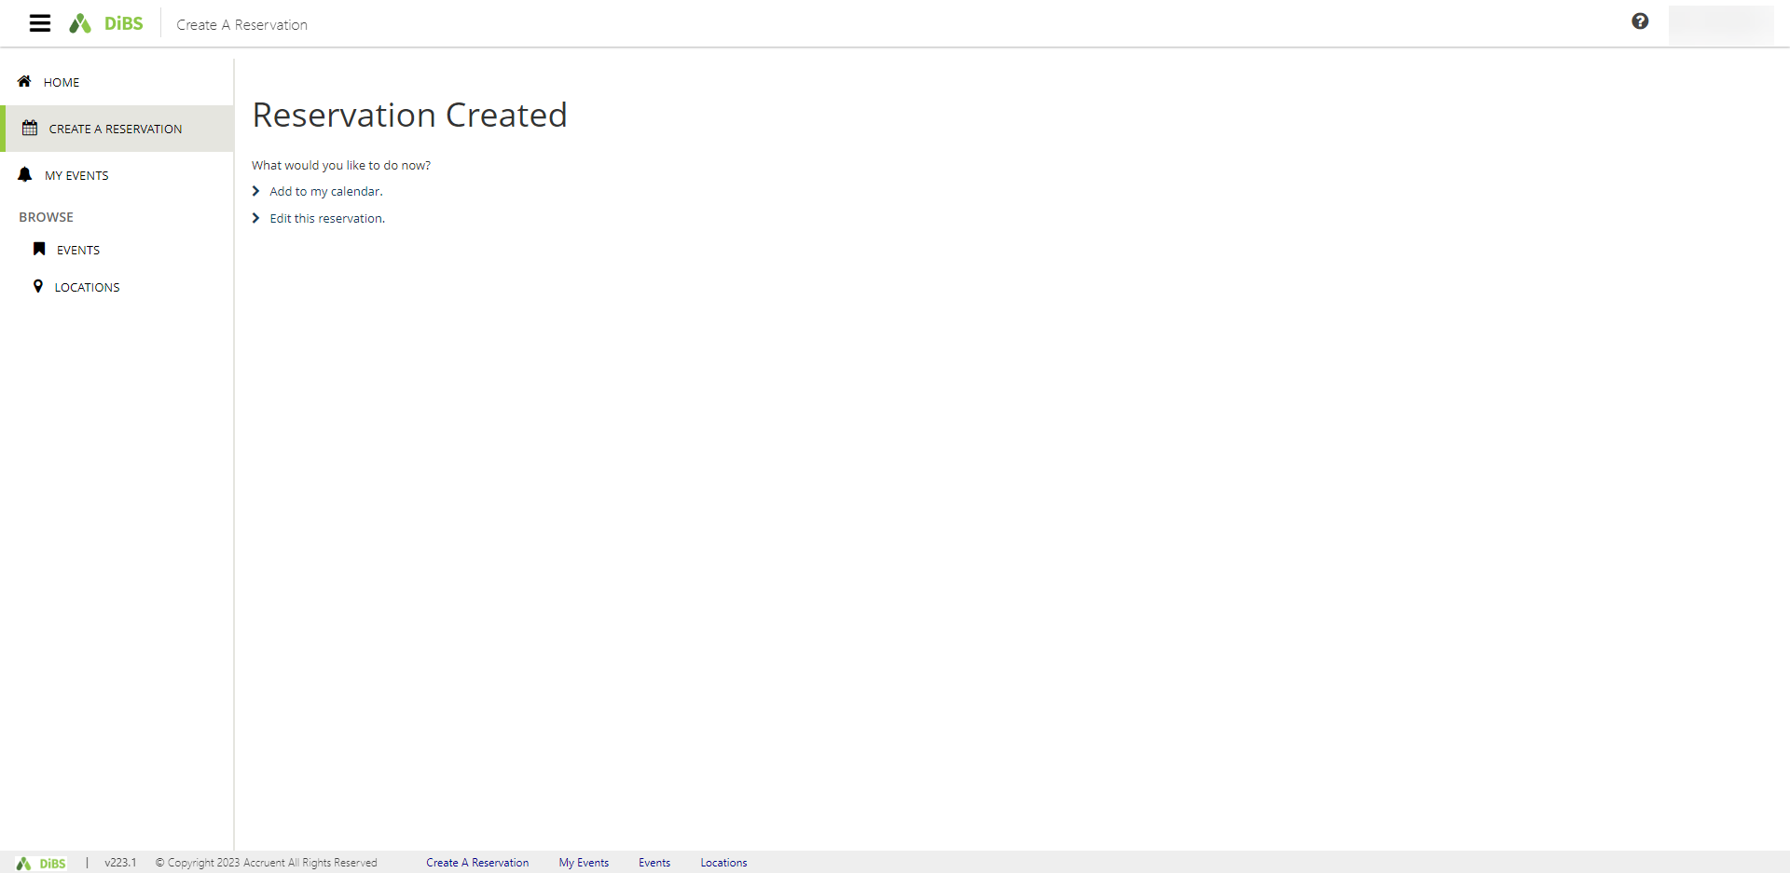

5. Edit reservation details (eg Event name, Event type, Booker details)
5.1 | To edit your reservation, navigate to My Events and select the booking you want to edit.  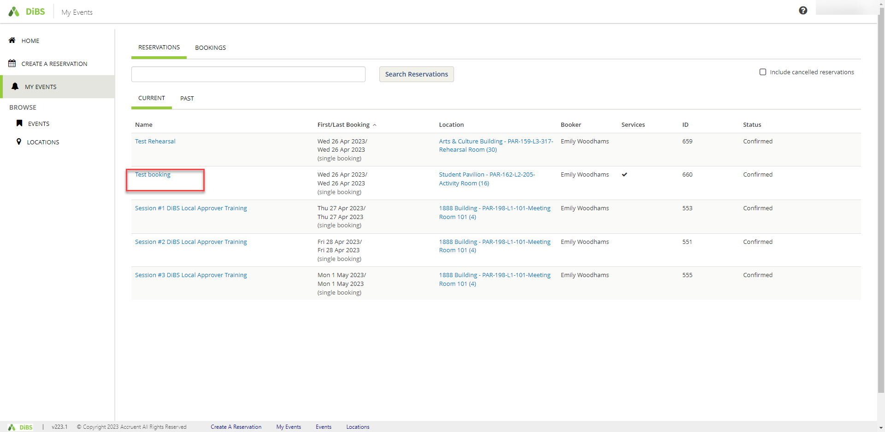
5.2 | Click on Edit Reservation Details.  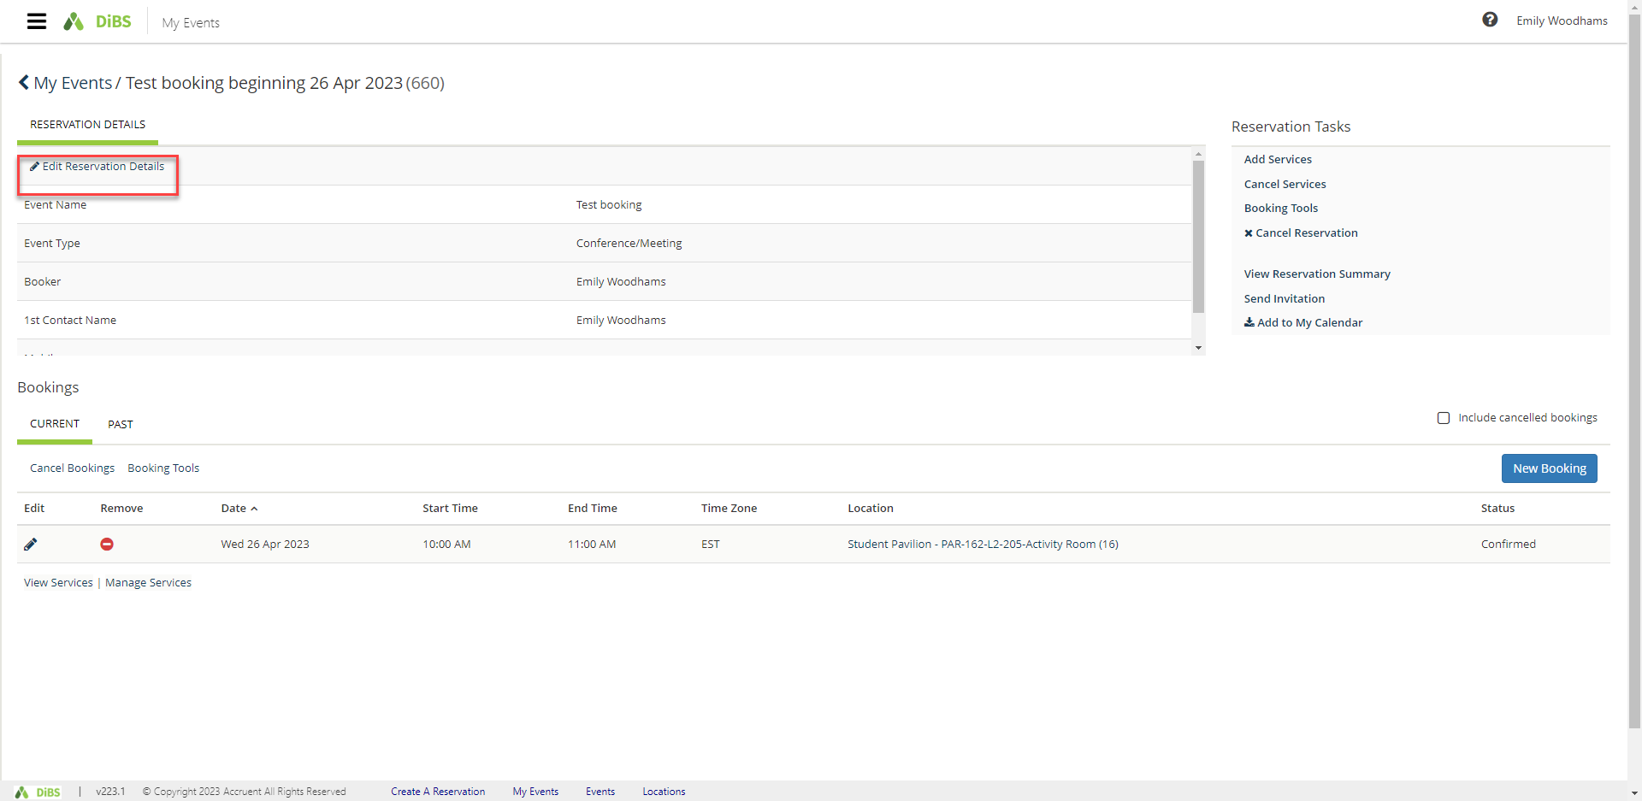

5.3 | Here, you can edit the name of the event, the contact person, or the event type.  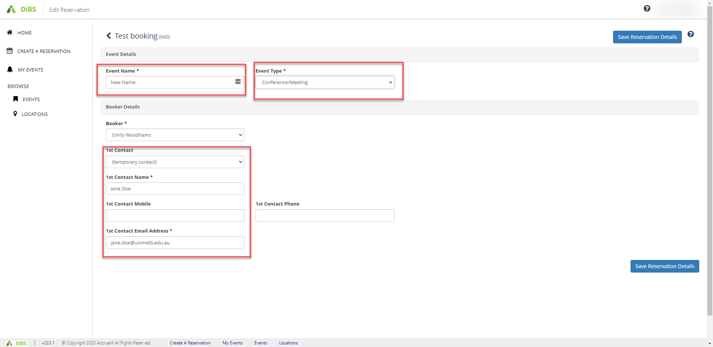
5.4 | Click ‘Save reservation details’ and new details will be displayed. The right-hand menu shows Reservation Tasks such as adding/cancelling services or sharing an invitation with another attendee.  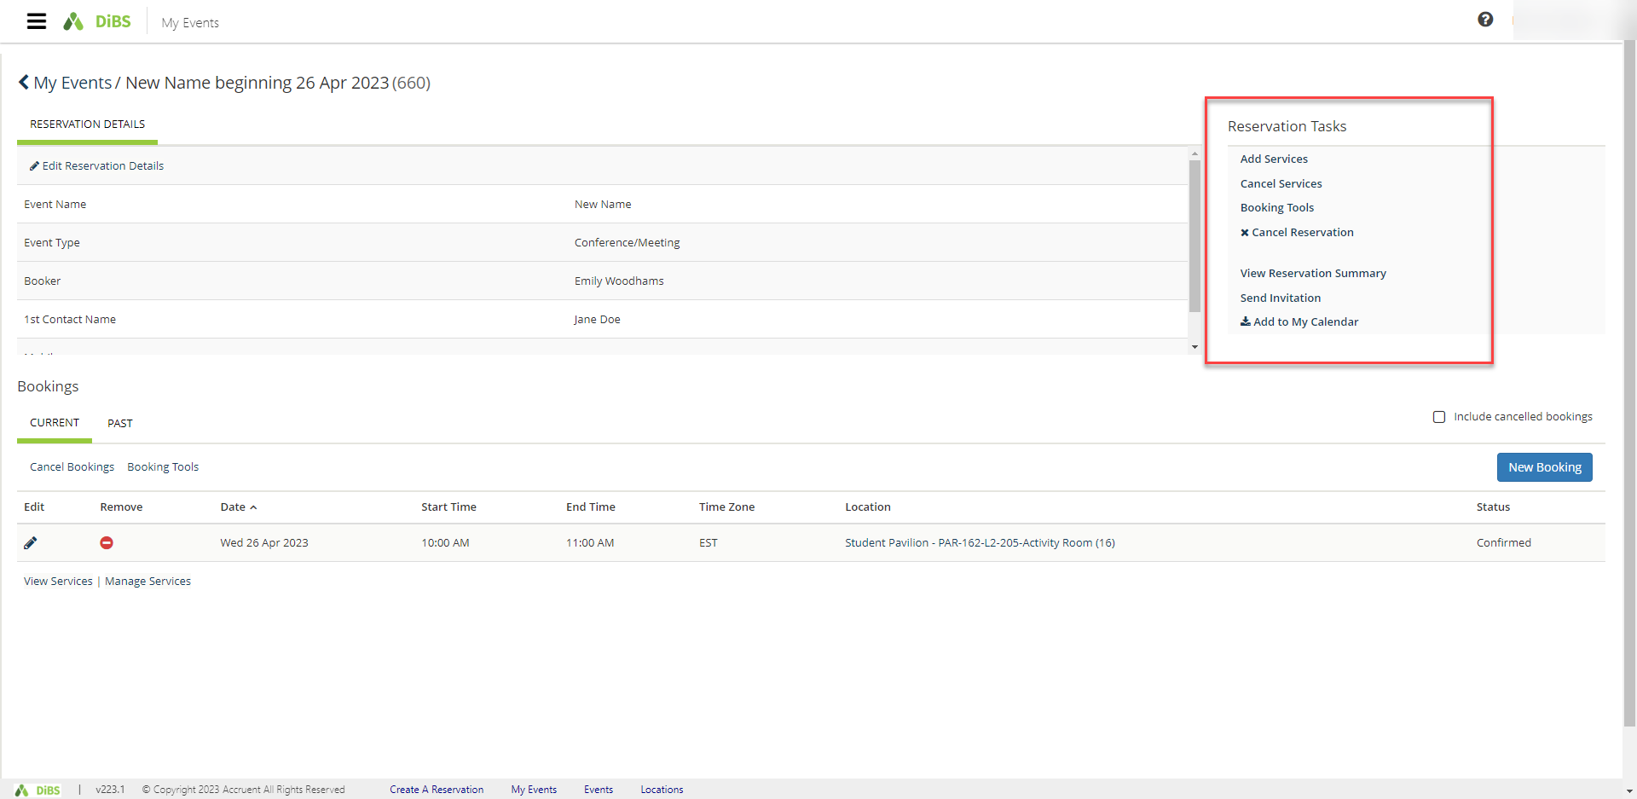
5.5 | To share your reservation details with another attendee, click on Send invitation. A pop up allows you to forward the booking details via email.  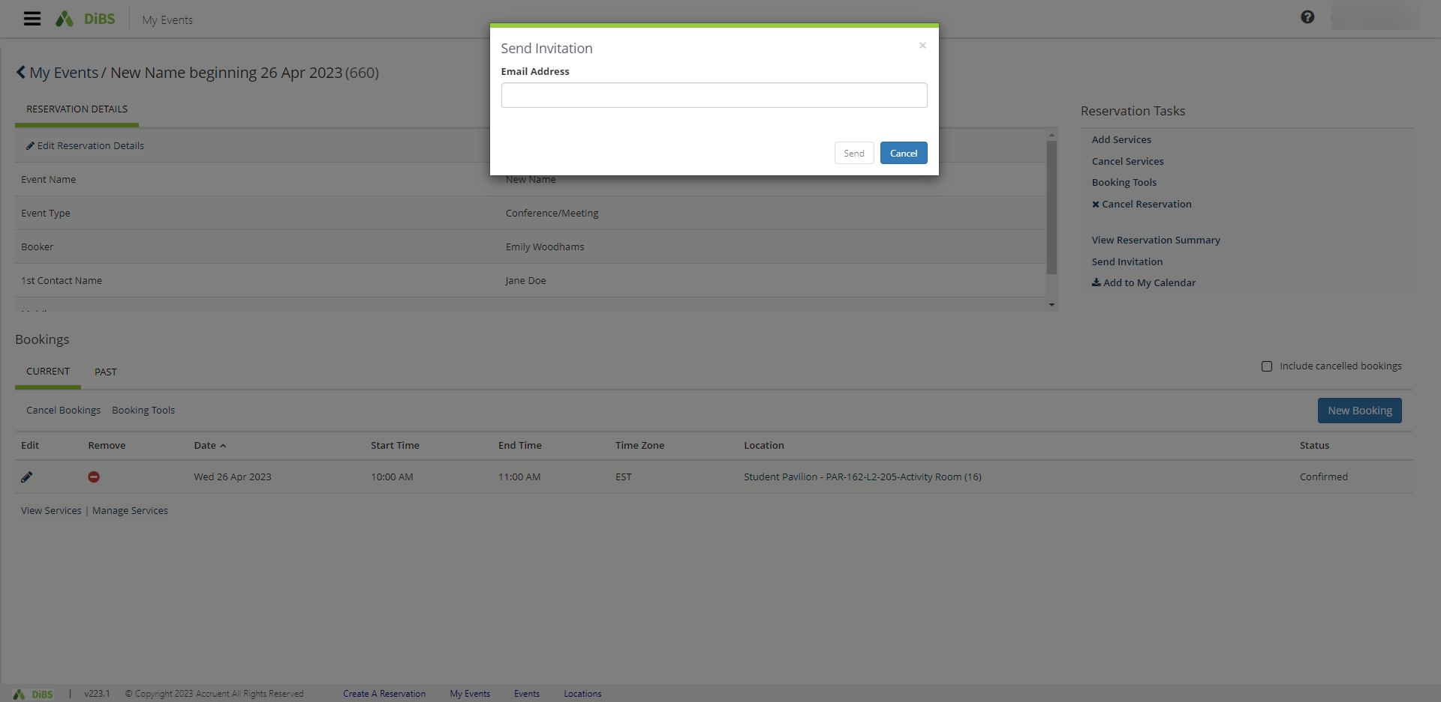

- Edit booking details (Location, Date and Time)
6.1 | Go to My Events and click on the event you would like to modify.  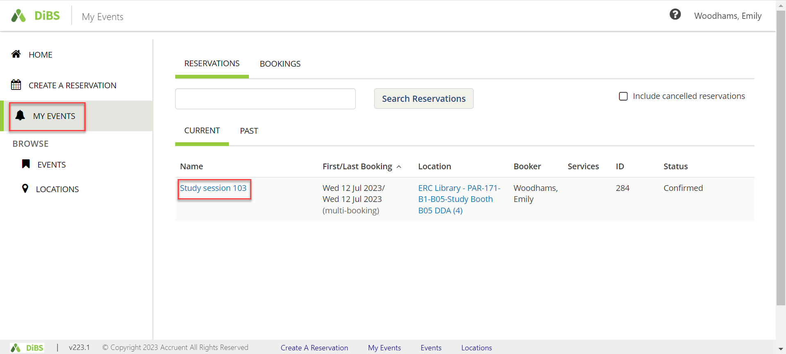
6.2 | Scroll down to the bookings section and click on the red and white minus symbol to remove the booking.  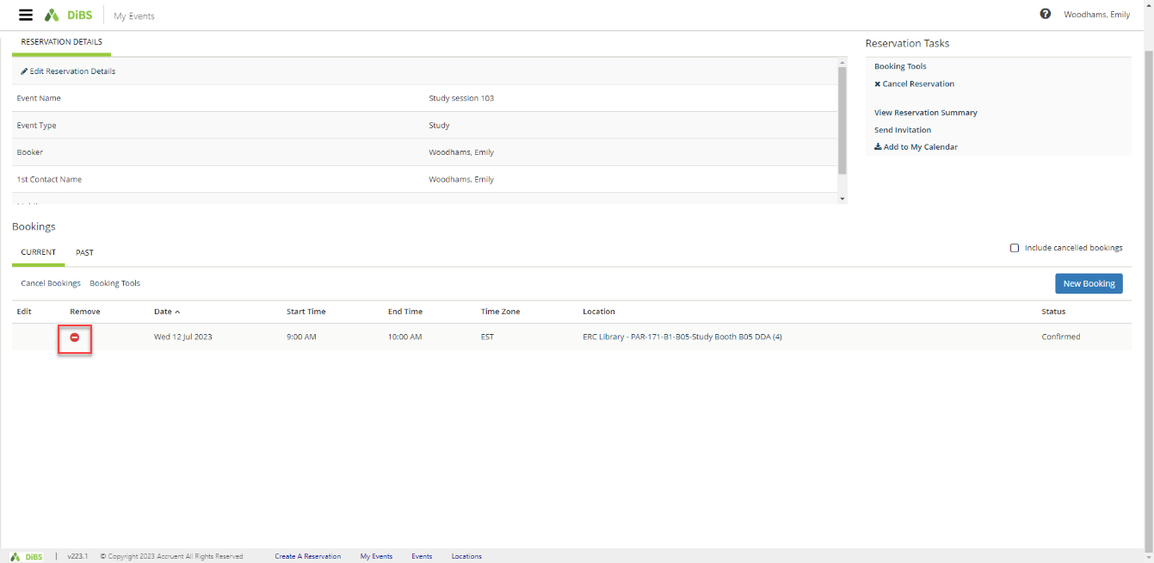

6.3 | Select ‘Yes, Cancel booking’  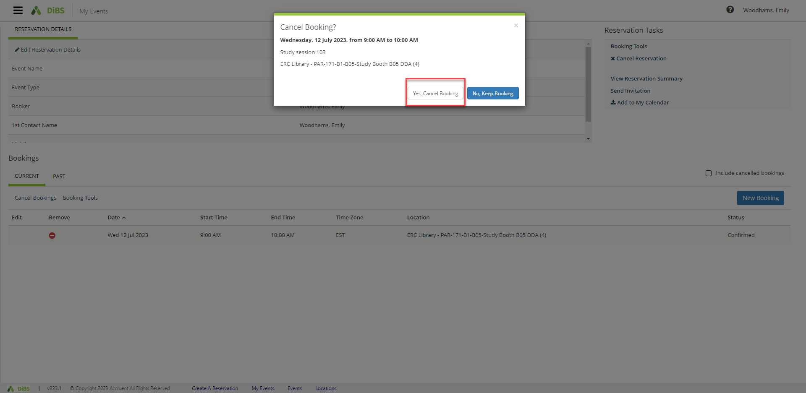
6.4 | Click on the New booking button.  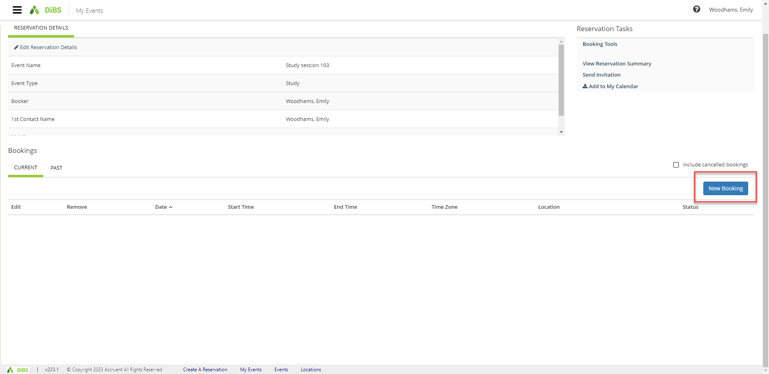
6.5 | Update the required details (date, time or location) here.  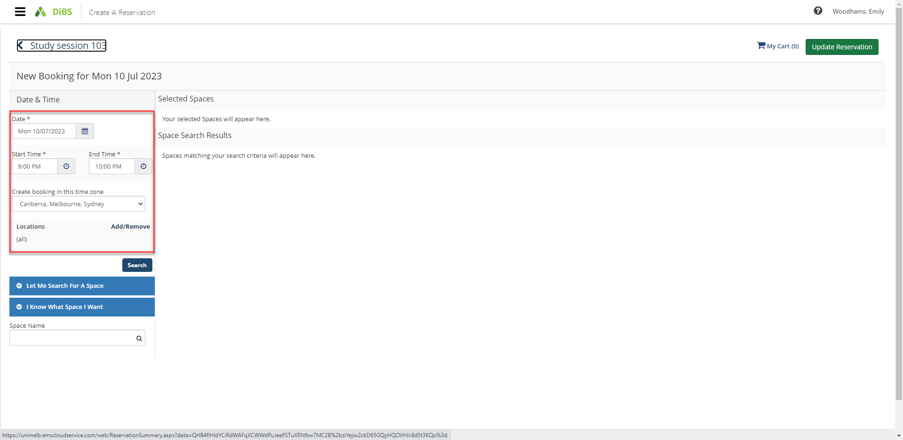
6.6 | Select a space that is available at your new time, date or location. Confirm the attendees and click the green Update Reservation button.  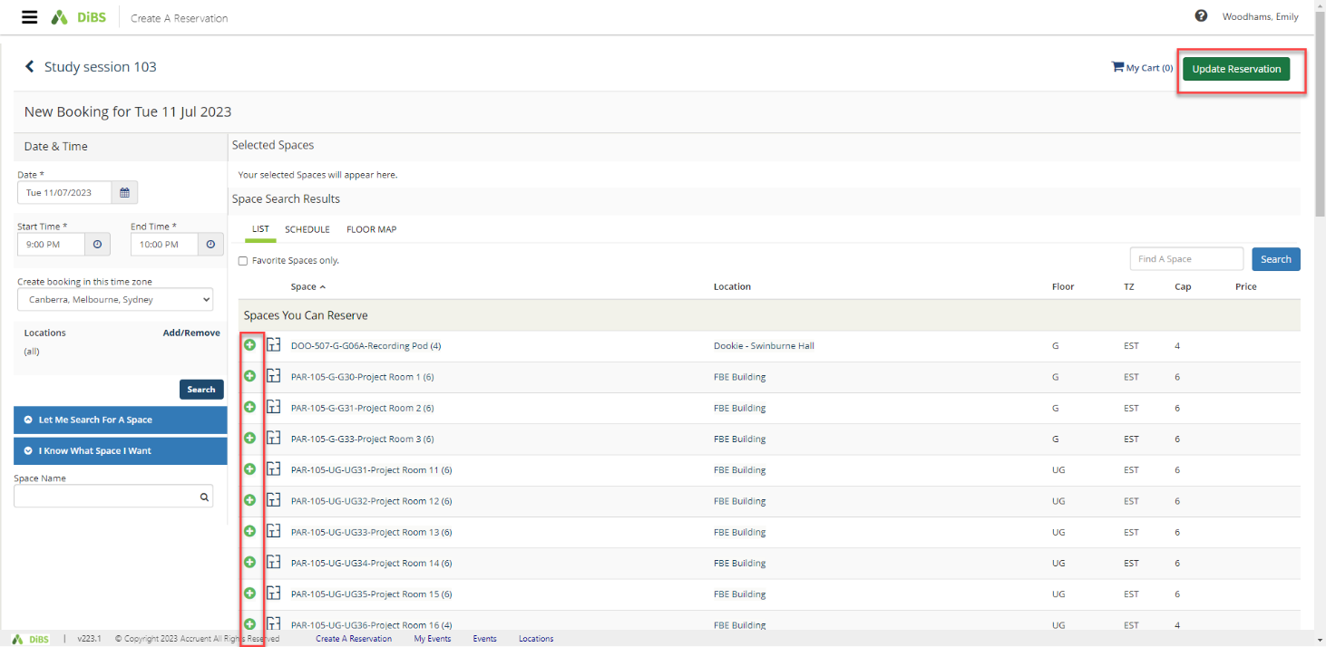

6.7 | The booking has now been updated with your new time, date or location.  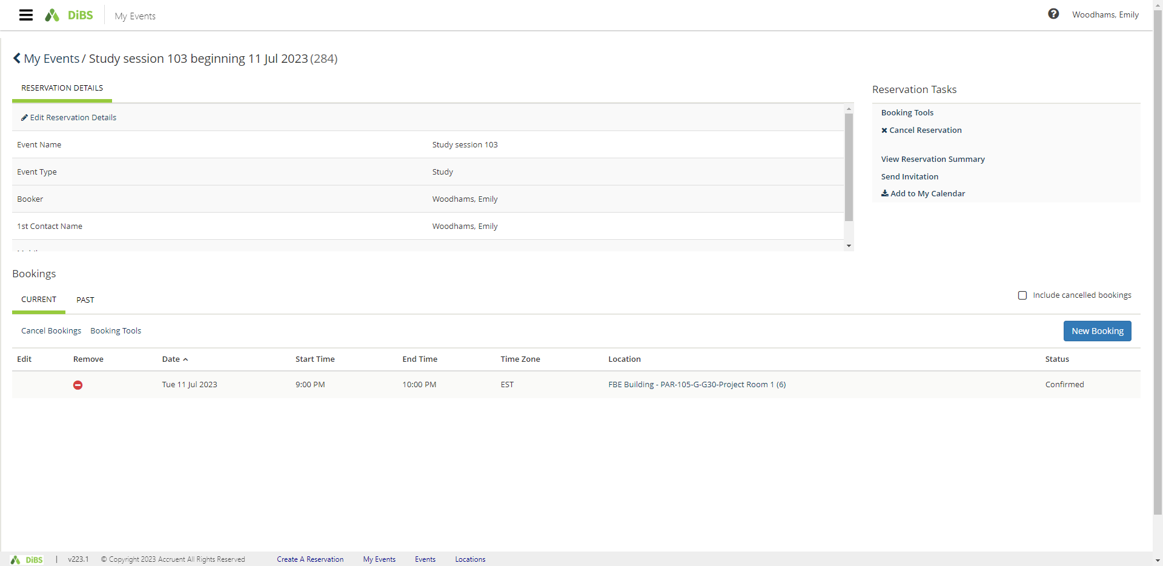
6.8 | You will receive an email notification within a few minutes to confirm your updated booking details.  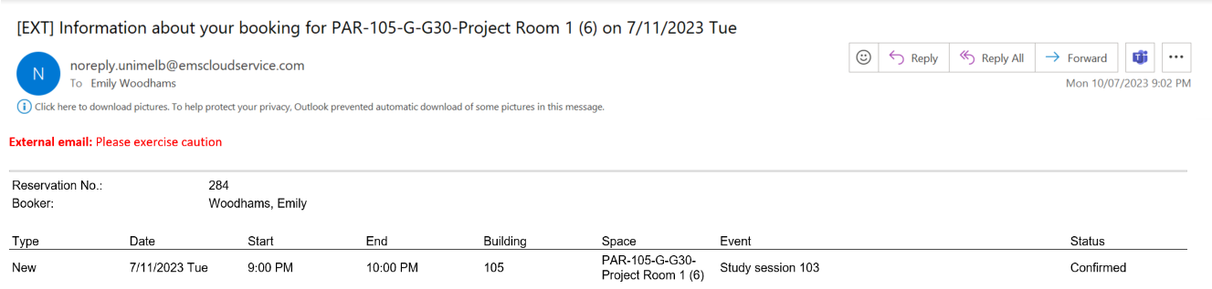

- Cancelling a booking
7.1 | Navigate to My Events and click on the booking you wish to cancel.
7.2 | You will be taken to the Reservation details screen.  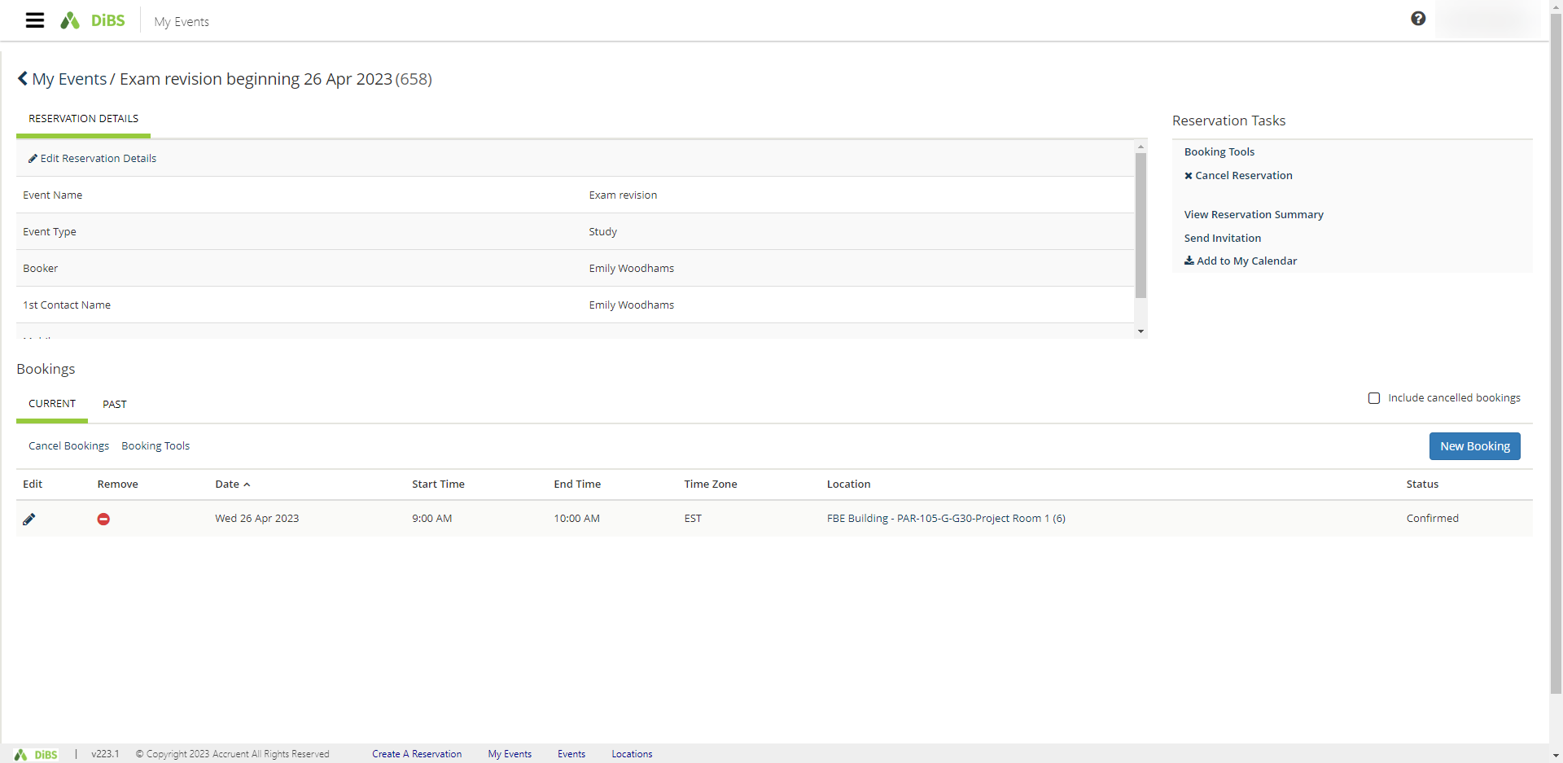
7.3 | To cancel a reservation, click Cancel Reservation under Booking Tools.  A pop-up will appear. Click Yes, Cancel Reservation.  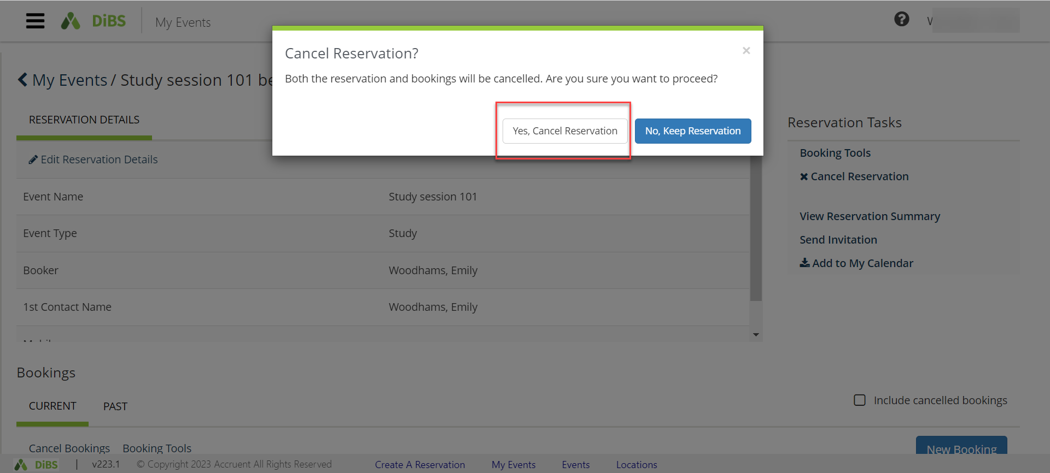
7.5 | Your reservation now appears with the status of Cancelled.  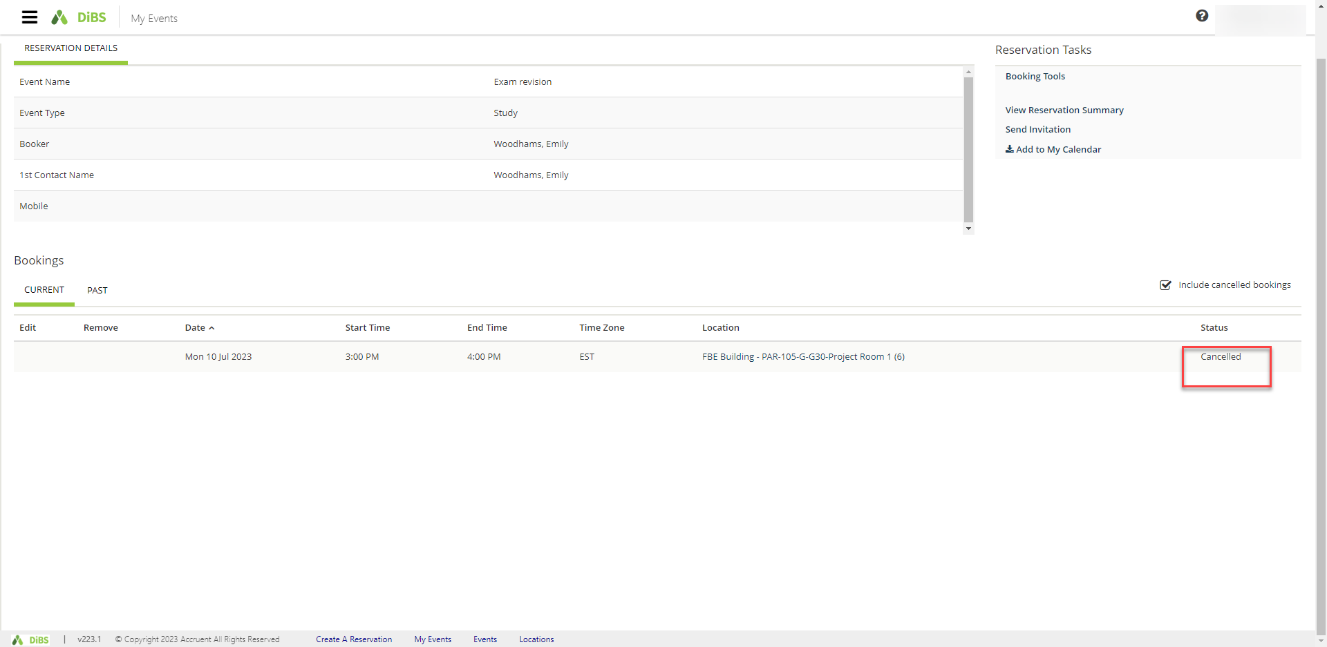
7.6 | You will receive an email notification within a few minutes to confirm the cancellation.

8. Checking in
8.1 | Some spaces require you to check in to confirm your attendance. You must check in no later than 15 minutes after your booking commences in order to retain your booking. You can do this by logging in to DiBS and going to My Events. 30 minutes prior to your booking commencing, the Check in button will appear. Click the Check in button to confirm that you are still intending to use the space.  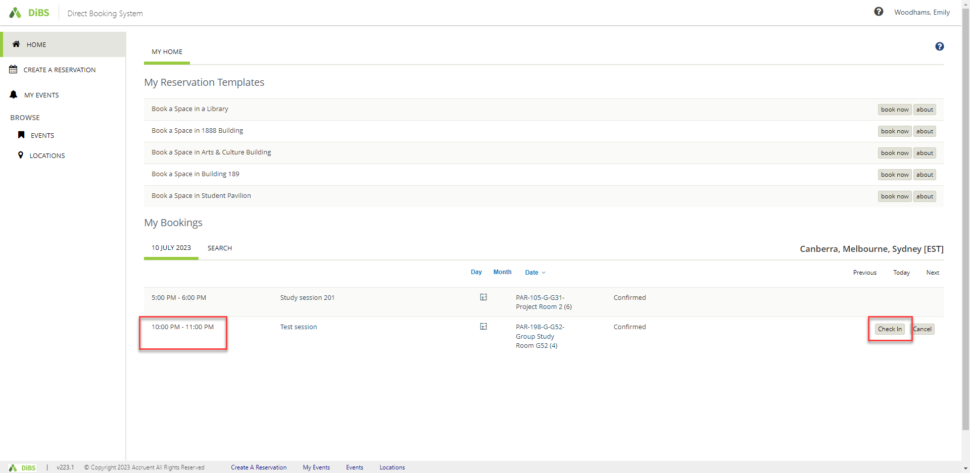
8.2 | Once you click on the Check In button, you will receive a pop up confirmation. The bottom right hand buttons indicate that you are checked in (this button is greyed out). If you choose to end the booking early, you can click the End now button to end your booking immediately.  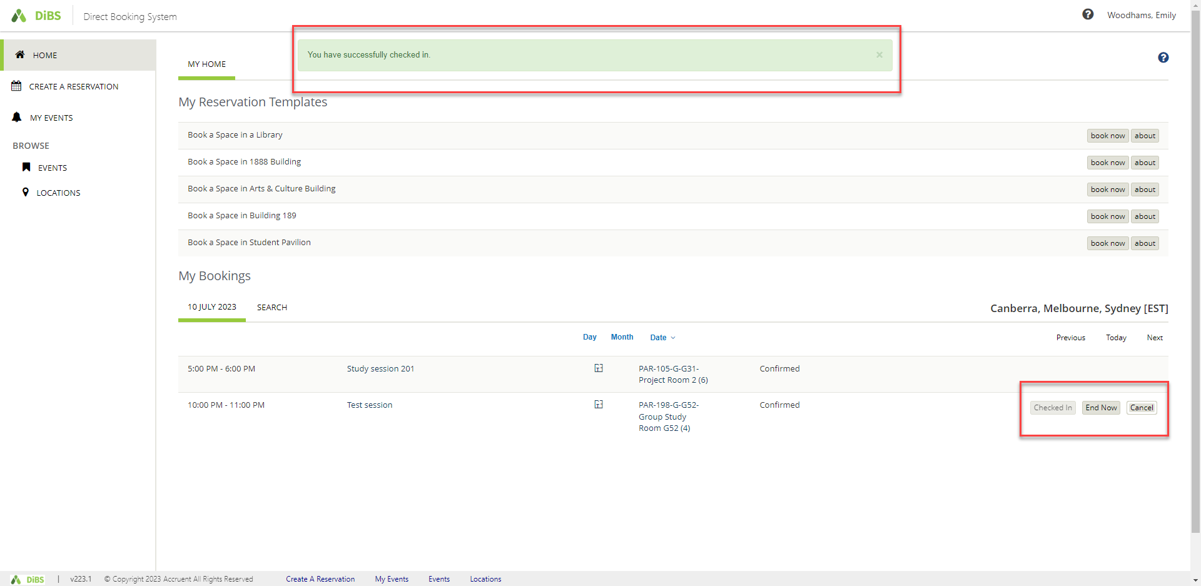
8.3 | An alternative way to check in is via the email notification. You will receive a Check In email notification prior to your booking commencing. You can click on the links in the email to confirm whether you want to Check In or Cancel the booking.  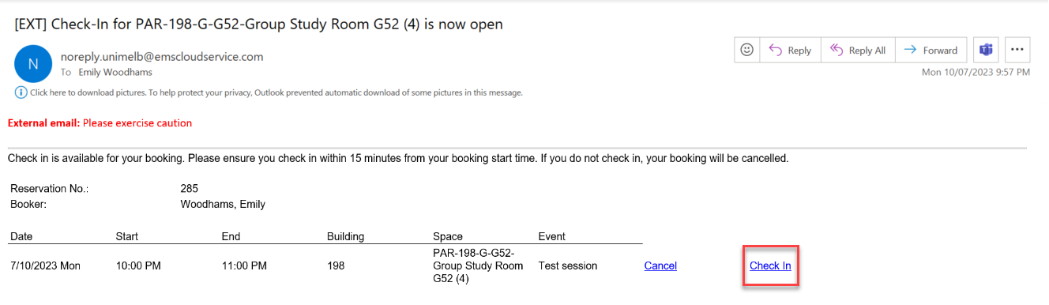

8.4 | Once you click on the Check In link in the email, you will be taken to DiBS and a pop-up notification will confirm that you have been checked in.  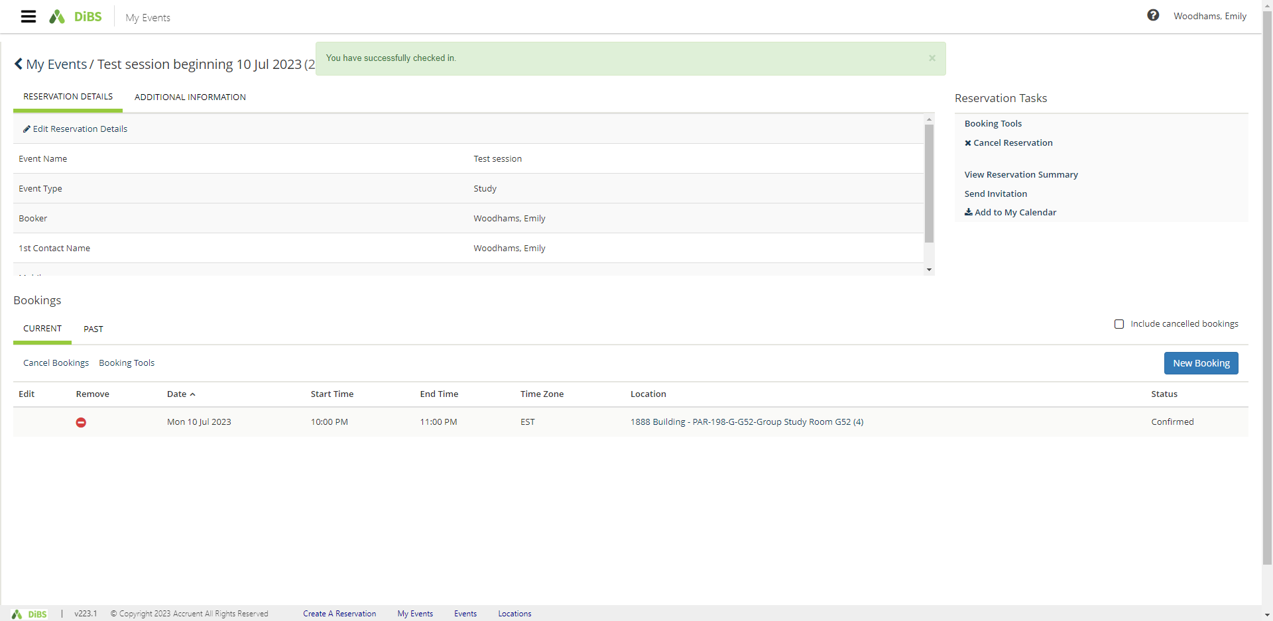
8.5 | You can also see that you have been checked in via the My Events section in DiBS.  