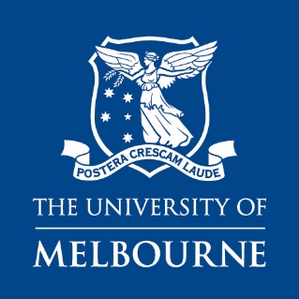 | ARCHIVES AND SPECIAL COLLECTIONS  GUIDELINES FOR DONORS

Are you interested in donating material to Archives and Special Collections?

Donation Guidelines:
University of Melbourne is grateful to those who offer gifts of cultural material to our Archives and Special Collections (ASC). We are obliged to make sure that every acquisition is in line with our Collection Development Strategy and that we have the resources to properly care for and store each item. As a result, it is not always possible for us to accept donations of material. However, if we cannot accommodate your gift we may be able to suggest an alternative recipient for you to approach.

If you wish to donate material please fill out our Donation Inquiry form. The more information you can provide the easier it is for us to properly consider your offer.

All offers of donations are assessed by the following criteria:
- The material’s cultural significance
- Relevance to our Collection Development Strategy
- Our current holdings of this type of material
- The material’s physical condition
- The material’s potential future use for research and display
- The material’s copyright status and any privacy considerations that may limit our ability to provide open access.

Please note we receive large numbers of offers which we take time to consider and process. We aim to get back to you within 6 weeks of receiving your completed Donation Inquiry form.

Things to consider before offering a donation:

- Before offering material, please discuss the matter with family members and relatives whose wishes should be considered.
- Please consider if material offered for donation is sensitive or may raise privacy concerns for other parties and discuss it with us. We make material held in our collections available to staff, students and the general public.
- A donation is finalized when the donor signs a Deed of Gift. This is a legal document and once a donation is finalized, no material can be returned to the donor.
- We cannot guarantee the display of any donated material but can arrange for it to be viewed by donors and their families by appointment.
- Please do not send any material to us unless we have requested it. We cannot take responsibility for unsolicited material sent to us.

